**TRƯỜNG ĐẠI HỌC TÀI NGUYÊN VÀ MÔI TRƯỜNG TP.HCM**

**KHOA CÔNG NGHỆ THÔNG TIN**



**TỔNG HỢP LAB LẬP TRÌNH DI ĐỘNG**

Giảng viên hướng dẫn: **ThS. Phạm Trọng Huynh**

Sinh viên thực hiện: **Cao Xuân Mai**

Mã số sinh viên: 1150070028

Lớp**: 11_ĐH_TTMT**

Khoá**: 2022 - 2026**

***TP. Hồ Chí Minh, tháng 12 năm 2025***

**TRƯỜNG ĐẠI HỌC TÀI NGUYÊN VÀ MÔI TRƯỜNG TP.HCM**

**KHOA CÔNG NGHỆ THÔNG TIN**



**TỔNG HỢP LAB LẬP TRÌNH DI ĐỘNG**

Giảng viên hướng dẫn: **ThS. Phạm Trọng Huynh**

Sinh viên thực hiện: **Cao Xuân Mai**

Mã số sinh viên: 1150070028

Lớp**: 11_ĐH_TTMT**

Khoá**: 2022 - 2026**

***TP. Hồ Chí Minh, tháng 12 năm 2025***

**Mục Lục**

LAB1 1

I. Cơ bản với Android Studio 1

II. Tiếp tục: dự án sử dụng Camera 9

BÀI TẬP 1 — MÁY TÍNH (+, −, ×, ÷, %) 17

BÀI TẬP 2 — SỐ NGẪU NHIÊN & XÚC XẮC 19

BÀI TẬP 3 — GỌI ĐIỆN & NHẮN TIN 21

Thiết kế giao diện trên Android Studio UI DESIGH 41

Bài 1 – Splash random màu nền + icon 41

Bài 2 – Custom ProgressBar (Overlay Loading) 45

Bài 3 – Profile: bấm icon để mở quay số (Intent.ACTION_DIAL) 48

Bài 4 – Tạo màn chính Lab2 (điều hướng 3 bài) & liên kết với Lab1 52

LAB 2 61

Xây dựng ứng dụng Truyện Cười (P1) 61

Tạo giao diện login 86

LUYỆN TẬP 3 – EMOJI VUI NHỘN (DÙNG FRAGMENT) 109

LAB3 120

Layout and application 120

Xây dựng chương trình đổi tiền tệ 120

Xây dựng chương trình đổi độ dài 134

Custom controls 145

Bài 1 – Custom Button 146

Bài 2 – Custom Toast & Custom Dialog 160

Bài 3 – SeekBar chọn màu RGB & CMY (Custom SeekBar) 166

KẾT QUẢ 3 BÀI 174

LAB4 179

Ứng Dụng Truyện Cười 179

Ứng dụng 12 cung hoàng đạo 198

LAB5 216

I. TẠO DỰ ÁN MỚI TÊN MaiLab5 216

II. CHUẨN BỊ TÀI NGUYÊN (Drawable, Color, String) 216

III. THIẾT KẾ GIAO DIỆN (LAYOUT XML) 220

IV. THỰC HIỆN XỬ LÝ LOGIC ĐĂNG NHẬP / ĐĂNG KÝ BẰNG SHAREDPREFERENCES 227

V. TÌM HIỂU SHAREDPREFERENCES 235

VI. RUN 235

# LAB1

## Cơ bản với Android Studio

**1. Tạo dự án “Empty Activity”**

* File → New Project → Empty Views Activity

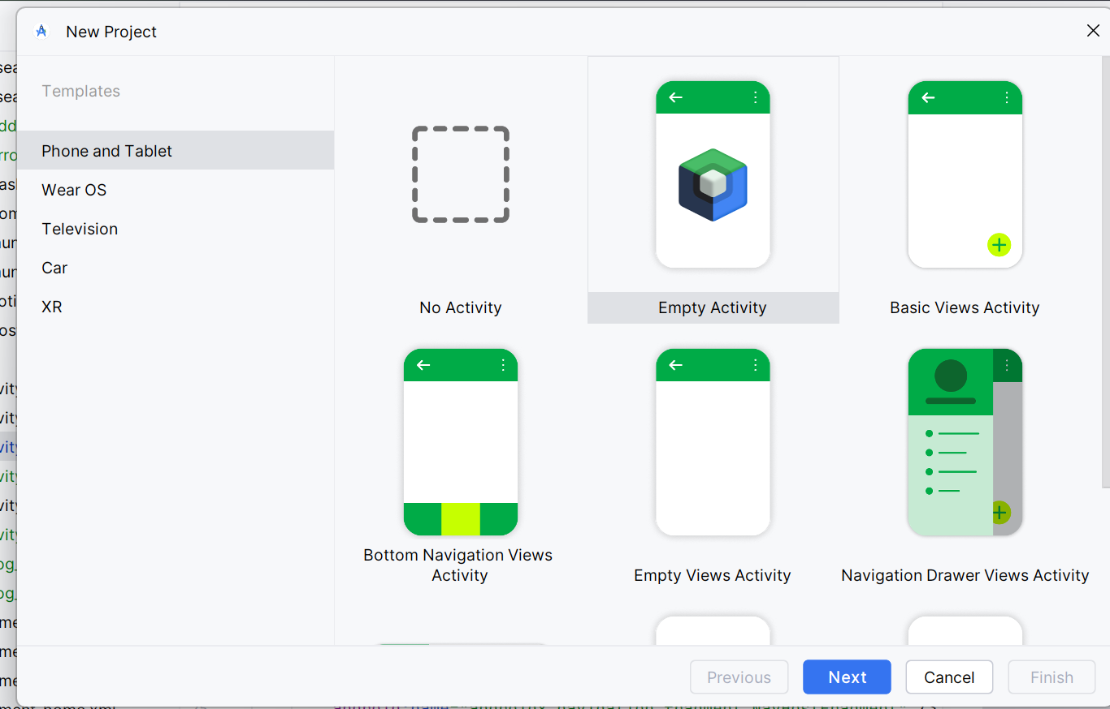

* Name: Mai
* Package name (gợi ý): com.example.mai
* Language: Java
* Minimum SDK: API 16 (Android 4.1)
* Nhấn Finish để Android Studio sinh dự án.

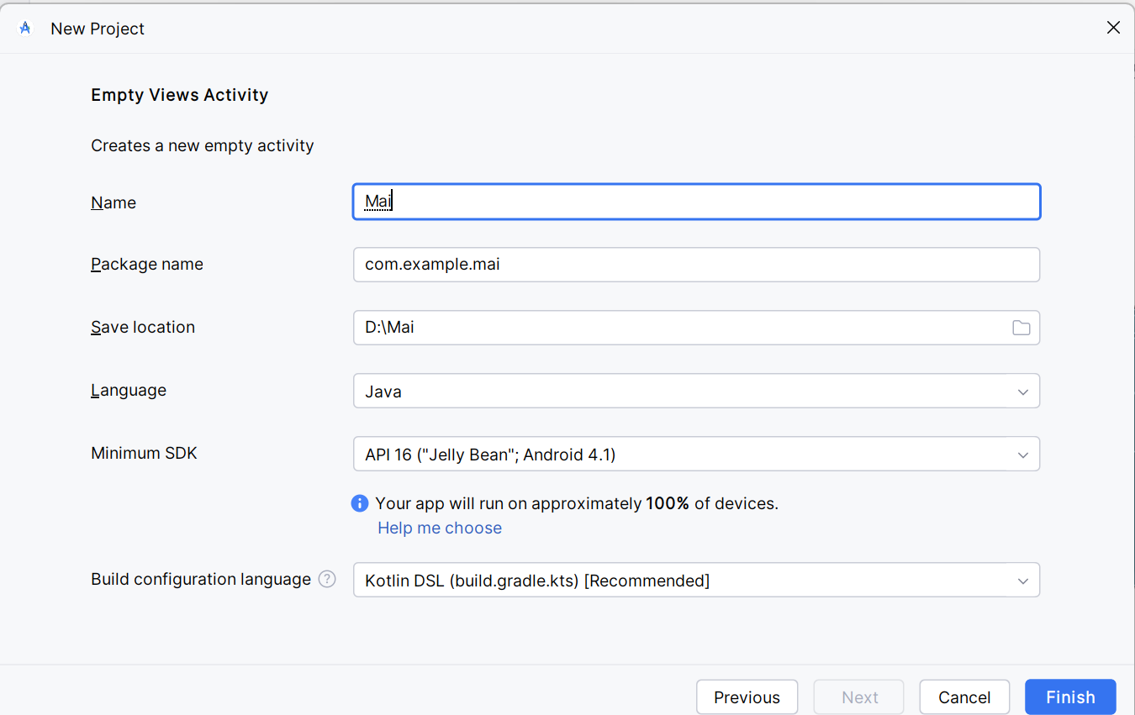

1. Thiết kế giao diện activity_main.xml

* Vào: app/src/main/res/layout/activity_main.xml → dán toàn bộ nội dung bên dưới

*<?*xml version="1.0" encoding="utf-8"*?>*<LinearLayout xmlns:android="http://schemas.android.com/apk/res/android"  
 android:layout_width="match_parent"  
 android:layout_height="match_parent"  
 android:orientation="vertical"  
 android:padding="16dp">  
  
 <EditText  
 android:id="@+id/edtSoA"  
 android:layout_width="match_parent"  
 android:layout_height="48dp"  
   
 android:inputType="numberDecimal"  
 android:layout_marginBottom="8dp" />  
  
 <EditText  
 android:id="@+id/edtSoB"  
 android:layout_width="match_parent"  
 android:layout_height="48dp"  
 android:inputType="numberDecimal"  
 android:layout_marginBottom="8dp" />  
  
 <TextView  
 android:id="@+id/tvKetQua"  
 android:layout_width="match_parent"  
 android:layout_height="56dp"  
 android:gravity="center"  
   
 android:textSize="16sp"  
 android:layout_marginBottom="8dp" />

* Thêm LinearLayout + 1 Button (nút “+”)
* Tiếp ngay bên dưới TextView ở trên, dán thêm (vẫn trong activity_main.xml):  
   <LinearLayout  
   android:layout_width="match_parent"  
   android:layout_height="56dp"  
   android:orientation="horizontal">  
    
   <Button  
   android:id="@+id/btnCong"  
   android:layout_width="48dp"  
   android:layout_height="48dp"  
   android:text="+"  
   android:textSize="18sp"  
   android:textColor="#FFFFFF"  
   android:background="#6200EE"  
   android:minWidth="0dp"  
   android:minHeight="0dp"  
   android:padding="0dp" />  
   </LinearLayout>  
    
   <LinearLayout  
   android:layout_width="match_parent"  
   android:layout_height="0dp"  
   android:layout_weight="1"  
   android:orientation="vertical" />  
  </LinearLayout>

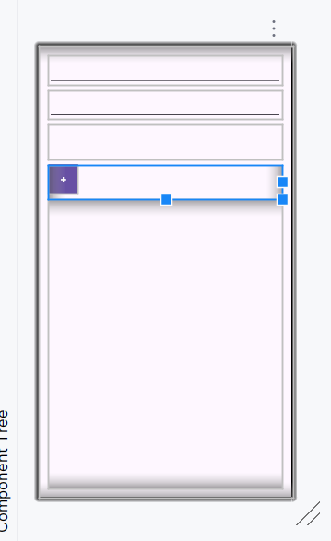

1. Khai báo biến & sự kiện trong MainActivity.java

Mở: app/src/main/java/<package>/MainActivity.java → xóa sạch → dán:

package com.example.mai;  
  
import androidx.appcompat.app.AppCompatActivity;  
import android.os.Bundle;  
import android.view.View;  
import android.widget.Button;  
import android.widget.EditText;  
import android.widget.TextView;  
import android.widget.Toast;  
  
public class MainActivity extends AppCompatActivity {  
  
 EditText txtX, txtY;  
 TextView txtResult;  
 Button btnPlus;  
  
 @Override  
 protected void onCreate(Bundle savedInstanceState) {  
 super.onCreate(savedInstanceState);  
 setContentView(R.layout.*activity_main*);  
  
 innitControl();  
  
 btnPlus.setOnClickListener(new View.OnClickListener() {  
 @Override  
 public void onClick(View v) {  
 String aStr = txtX.getText().toString().trim();  
 String bStr = txtY.getText().toString().trim();  
 if (aStr.isEmpty() || bStr.isEmpty()) {  
 Toast.*makeText*(MainActivity.this, "Nhập đủ hai số", Toast.*LENGTH_SHORT*).show();  
 return;  
 }  
 double a = Double.*parseDouble*(aStr);  
 double b = Double.*parseDouble*(bStr);  
 double kq = a + b;  
  
 txtResult.setText("Kết quả: " + kq);  
 }  
 });  
 }  
  
 private void innitControl(){  
 txtX = findViewById(R.id.*txtX*);  
 txtY = findViewById(R.id.*txtY*);  
 txtResult = findViewById(R.id.*txtResult*);  
 btnPlus = findViewById(R.id.*btnPlus*);  
 }  
}

Trong đó:

* Khai báo ở đầu class (MainActivity.java)

EditText txtX, txtY;  
TextView txtResult;  
Button btnPlus;

* Viết phương thức “cầu nối” (map Java ↔ XML)

private void innitControl(){  
 txtX = findViewById(R.id.*txtX*);  
 txtY = findViewById(R.id.*txtY*);  
 txtResult = findViewById(R.id.*txtResult*);  
 btnPlus = findViewById(R.id.*btnPlus*);  
}

* Gọi innitControl() trong onCreate(...) (sau setContentView)

@Override  
protected void onCreate(Bundle savedInstanceState) {  
 super.onCreate(savedInstanceState);  
 setContentView(R.layout.*activity_main*);  
  
 innitControl();

}

1. Tạo sự kiện nhấn nút +

btnCong.setOnClickListener(new View.OnClickListener() {  
 @Override  
 public void onClick(View v) {

}

});

1. Chạy ứng dụng

Dùng AVD Manager tạo máy ảo

Nhấn ▶ (Run) để cài và chạy.

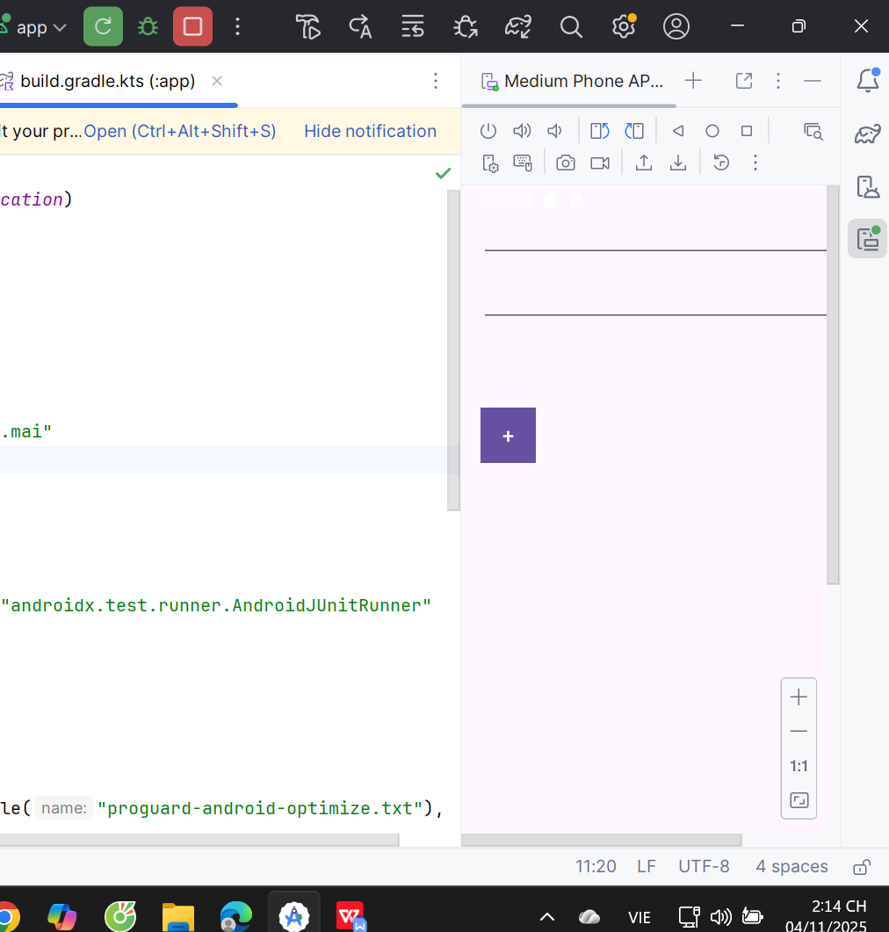

1. Khai báo chuỗi trong values/strings.xml

<resources>  
 <string name="app_name">Lab 1</string>  
 <string name="so_a">Nhập X</string>  
 <string name="so_b">Nhập Y</string>  
 <string name="ket_qua">Kết quả</string>  
</resources>

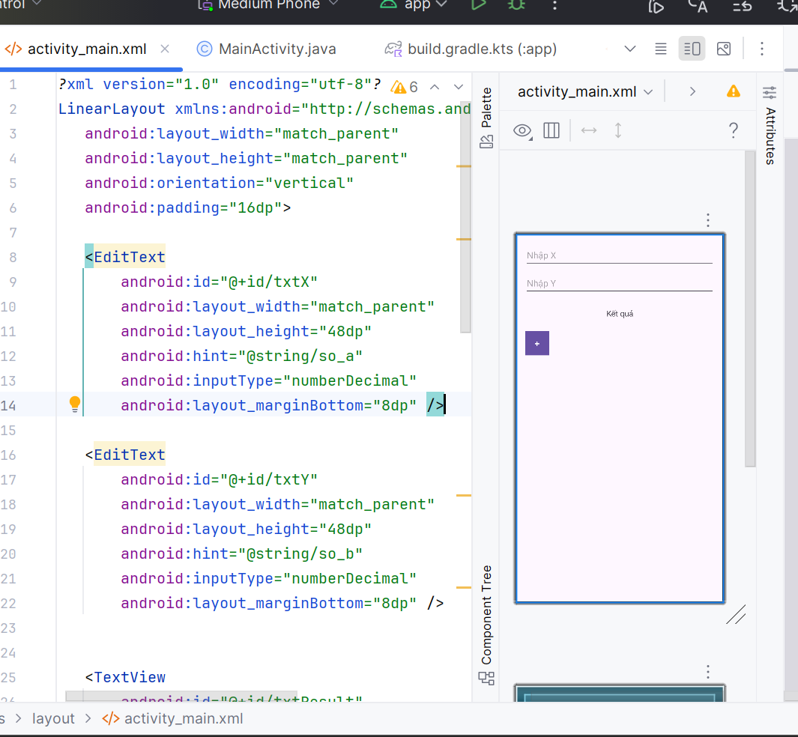

## Tiếp tục: dự án sử dụng Camera

1. **app/src/main/res/layout/activity_main.xml**

Dưới đây là toàn bộ layout (giữ nguyên phần máy tính + thêm Button chụp ảnh & ImageView ở cuối).

*<?*xml version="1.0" encoding="utf-8"*?>*<LinearLayout xmlns:android="http://schemas.android.com/apk/res/android"  
 android:layout_width="match_parent"  
 android:layout_height="match_parent"  
 android:orientation="vertical"  
 android:padding="16dp">  
   
 <EditText  
 android:id="@+id/txtX"  
 android:layout_width="match_parent"  
 android:layout_height="48dp"  
 android:hint="@string/so_a"  
 android:inputType="numberDecimal"  
 android:layout_marginBottom="8dp" />  
  
   
 <EditText  
 android:id="@+id/txtY"  
 android:layout_width="match_parent"  
 android:layout_height="48dp"  
 android:hint="@string/so_b"  
 android:inputType="numberDecimal"  
 android:layout_marginBottom="8dp" />  
   
 <TextView  
 android:id="@+id/txtResult"  
 android:layout_width="match_parent"  
 android:layout_height="56dp"  
 android:gravity="center"  
 android:text="@string/ket_qua"  
 android:textSize="16sp"  
 android:layout_marginBottom="8dp" />  
   
 <LinearLayout  
 android:layout_width="match_parent"  
 android:layout_height="56dp"  
 android:orientation="horizontal">  
  
 <Button  
 android:id="@+id/btnPlus"  
 android:layout_width="48dp"  
 android:layout_height="48dp"  
 android:text="+"  
 android:textSize="18sp"  
 android:textColor="#FFFFFF"  
 android:background="#6200EE"  
 android:minWidth="0dp"  
 android:minHeight="0dp"  
 android:padding="0dp" />  
 </LinearLayout>  
  
   
 <Button  
 android:id="@+id/btnChup"  
 android:layout_width="wrap_content"  
 android:layout_height="wrap_content"  
 android:text="@string/chup_anh"  
 android:layout_marginTop="12dp" />  
  
   
 <ImageView  
 android:id="@+id/imgPhoto"  
 android:layout_width="match_parent"  
 android:layout_height="300dp"  
 android:layout_marginTop="8dp"  
 android:scaleType="centerCrop"  
 android:src="@drawable/photo" />  
</LinearLayout>

1. **app/src/main/java/com/example/mai/MainActivity.java**

package com.example.mai;  
  
import androidx.appcompat.app.AppCompatActivity;  
import android.content.Intent;  
import android.graphics.Bitmap;  
import android.os.Bundle;  
import android.provider.MediaStore;  
import android.view.View;  
import android.widget.*;  
  
public class MainActivity extends AppCompatActivity {  
   
 EditText txtX, txtY;   
 TextView txtResult;   
 Button btnPlus;   
 Button btnChup;   
 ImageView imgPhoto;   
  
 private static final int *REQ_CAMERA* = 1001; *// request code cho camera* @Override  
 protected void onCreate(Bundle savedInstanceState) {  
 super.onCreate(savedInstanceState);  
 setContentView(R.layout.*activity_main*);  
   
 innitControl();  
   
 btnPlus.setOnClickListener(new View.OnClickListener() {  
 @Override  
 public void onClick(View v) {  
 String aStr = txtX.getText().toString().trim();  
 String bStr = txtY.getText().toString().trim();  
 if (aStr.isEmpty() || bStr.isEmpty()) {  
 Toast.*makeText*(MainActivity.this, "Nhập đủ hai số", Toast.*LENGTH_SHORT*).show();  
 return;  
 }  
 double a = Double.*parseDouble*(aStr);  
 double b = Double.*parseDouble*(bStr);  
 double kq = a + b;  
 txtResult.setText("Kết quả: " + kq);  
 }  
 });  
   
 btnChup.setOnClickListener(new View.OnClickListener() {  
 @Override  
 public void onClick(View v) {  
 Intent intent = new Intent(MediaStore.*ACTION_IMAGE_CAPTURE*);  
 startActivityForResult(intent, *REQ_CAMERA*);  
 }  
 });  
 }  
   
 private void innitControl(){  
 txtX = findViewById(R.id.*txtX*);  
 txtY = findViewById(R.id.*txtY*);  
 txtResult = findViewById(R.id.*txtResult*);  
 btnPlus = findViewById(R.id.*btnPlus*);  
   
 btnChup = findViewById(R.id.*btnChup*);  
 imgPhoto = findViewById(R.id.*imgPhoto*);  
 }  
   
 @Override  
 @SuppressWarnings("deprecation")  
 protected void onActivityResult(int requestCode, int resultCode, Intent data) {  
 super.onActivityResult(requestCode, resultCode, data);  
 if (requestCode == *REQ_CAMERA* && resultCode == *RESULT_OK* && data != null) {  
 Bundle extras = data.getExtras();  
 if (extras != null && extras.get("data") != null) {  
 Bitmap bmp = (Bitmap) extras.get("data"); *// thumbnail* imgPhoto.setImageBitmap(bmp);  
 }  
 }  
 }  
}

Trong đó:

* Khai báo đối tượng Button và ImageView như sau:

Button btnChup;  
ImageView imgPhoto;

* Viết mã lệnh trong phương thức innitControl():

public void onClick(View v) {  
 Intent intent = new Intent(MediaStore.*ACTION_IMAGE_CAPTURE*);  
 startActivityForResult(intent, *REQ_CAMERA*);  
}

* Viết lệnh để khởi động Camera lên:

btnChup.setOnClickListener(new View.OnClickListener() {  
 @Override  
 public void onClick(View v) {  
 Intent intent = new Intent(MediaStore.*ACTION_IMAGE_CAPTURE*);  
 startActivityForResult(intent, *REQ_CAMERA*);  
 }  
});

* Viết phương thức ngoài phương thức InnitControl() để nhận kết quả trả về khi chụp ảnh xong:

@Override  
@SuppressWarnings("deprecation")  
protected void onActivityResult(int requestCode, int resultCode, Intent data) {  
 super.onActivityResult(requestCode, resultCode, data);  
 if (requestCode == *REQ_CAMERA* && resultCode == *RESULT_OK* && data != null) {  
 Bundle extras = data.getExtras();  
 if (extras != null && extras.get("data") != null) {  
 Bitmap bmp = (Bitmap) extras.get("data"); *// thumbnail* imgPhoto.setImageBitmap(bmp);  
 }  
 }  
}

1. **app/src/main/AndroidManifest.xml**

Thêm bên ngoài thẻ <application> như sau.

<uses-permission android:name="android.permission.CAMERA" />  
<uses-feature android:name="android.hardware.camera" android:required="false" />

1. **Kết quả chạy ứng dụng**

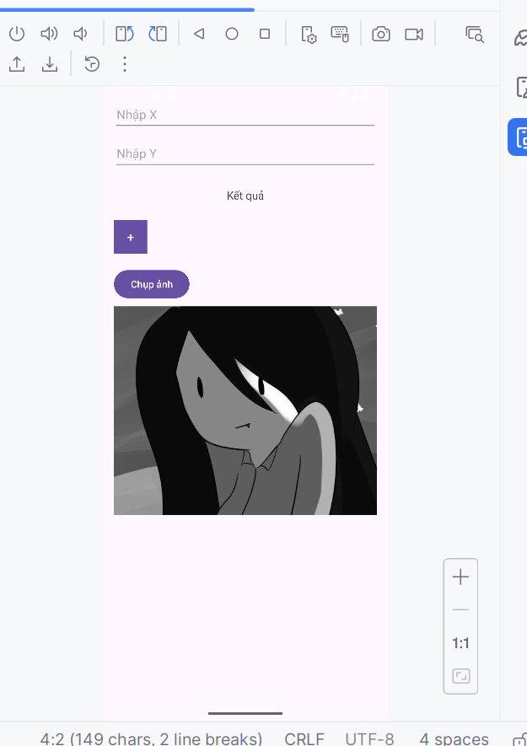

## BÀI TẬP 1 — MÁY TÍNH (+, −, ×, ÷, %)

1) Mục tiêu

* Nhập hai số A, B.
* Nhấn các nút: cộng, trừ, nhân, chia, chia dư → hiện kết quả.
* Chặn chia cho 0, định dạng kết quả gọn.

2) Giao diện cần có

Trong boxCalc phải có:

* EditText id edtA, edtB
* TextView id tvKQ
* 5 Button id btnAdd, btnSub, btnMul, btnDiv, btnMod

1. Code Java

Ràng buộc view (đã có ở bindViews())

edtA = findViewById(R.id.*edtA*);  
edtB = findViewById(R.id.*edtB*);  
tvKQ = findViewById(R.id.*tvKQ*);  
btnAdd = findViewById(R.id.*btnAdd*);  
btnSub = findViewById(R.id.*btnSub*);  
btnMul = findViewById(R.id.*btnMul*);  
btnDiv = findViewById(R.id.*btnDiv*);  
btnMod = findViewById(R.id.*btnMod*);

Gán sự kiện 5 nút (đã có ở setupCalc())

View.OnClickListener op = v -> {  
 String as = edtA.getText().toString().trim();  
 String bs = edtB.getText().toString().trim();  
 if (as.isEmpty() || bs.isEmpty()) { toast("Nhập đủ hai số"); return; }  
  
 double a, b;  
 try {  
 a = Double.*parseDouble*(as);  
 b = Double.*parseDouble*(bs);  
 } catch (NumberFormatException e) {  
 toast("Giá trị không hợp lệ"); return;  
 }  
  
 double kq;  
 if (v == btnAdd) kq = a + b;  
 else if (v == btnSub) kq = a - b;  
 else if (v == btnMul) kq = a * b;  
 else if (v == btnDiv) {  
 if (b == 0) { toast("Không thể chia cho 0"); return; }  
 kq = a / b;  
 } else { *// btnMod* if (b == 0) { toast("Không thể chia dư cho 0"); return; }  
 kq = a % b;  
 }  
  
 tvKQ.setText(String.format(Locale.*getDefault*(),"Kết quả: %s", trimTrailingZero(kq)));  
};  
  
btnAdd.setOnClickListener(op);  
btnSub.setOnClickListener(op);  
btnMul.setOnClickListener(op);  
btnDiv.setOnClickListener(op);  
btnMod.setOnClickListener(op);

Hàm định dạng

private String trimTrailingZero(double d) {  
 String s = String.*format*(Locale.*getDefault*(), "%.12f", d);  
 while (s.contains(".") && (s.endsWith("0") || s.endsWith("."))) {  
 s = s.substring(0, s.length() - 1);  
 }  
 return s;  
}

1. RUN

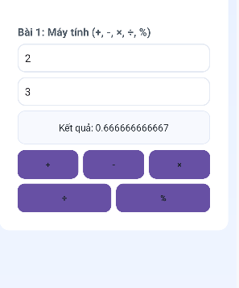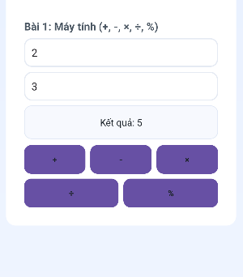

## BÀI TẬP 2 — SỐ NGẪU NHIÊN & XÚC XẮC

1) Mục tiêu

* Nhấn nút → sinh số 0..1000.
* Nhấn nút → hiện mặt xúc xắc (⚀..⚅) không cần ảnh.

1. Giao diện cần có

Trong boxRandom:

Button id btnRand (Xuất số)

TextView id tvRand (hiển thị số)

Button id btnDice (Tung xúc xắc)

TextView id tvDice (hiển thị ký tự xúc xắc)

1. Code Java

Khai báo biến & ràng buộc

Random rnd = new Random();  
btnRand = findViewById(R.id.*btnRand*);  
tvRand = findViewById(R.id.*tvRand*);  
btnDice = findViewById(R.id.*btnDice*);  
tvDice = findViewById(R.id.*tvDice*);

Gán sự kiện (đã có ở setupRandom())

btnRand.setOnClickListener(v -> {  
int val = rnd.nextInt(1001); *// 0..1000* tvRand.setText(String.valueOf(val));  
 });  
  
 btnDice.setOnClickListener(v -> {  
int face = 1 + rnd.nextInt(6);  
 tvDice.setText(getDiceUnicode(face));  
 });

Bản đồ mặt xúc xắc

private String getDiceUnicode(int n) {  
 switch (n) {  
 case 1: return "⚀";  
 case 2: return "⚁";  
 case 3: return "⚂";  
 case 4: return "⚃";  
 case 5: return "⚄";  
 default: return "⚅";  
 }  
}

1. RUN

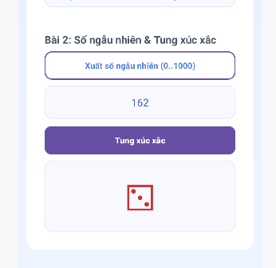

Nhấn “Xuất số ngẫu nhiên (0..1000)” vài lần → kiểm tra nằm trong [0..1000].

Nhấn “Tung xúc xắc” vài lần → thấy ký tự thay đổi trong tập {⚀..⚅}.

## BÀI TẬP 3 — GỌI ĐIỆN & NHẮN TIN

**1) Mục tiêu**

* Nhập số điện thoại.
* Gọi: mở trình quay số (an toàn, không cần quyền).
* SMS: mở ứng dụng nhắn tin, soạn sẵn nội dung (không cần quyền).

**2) Giao diện cần có**

Trong boxCall:

EditText id edtPhone

Button id btnDial

Button id btnSms

EditText id edtSms (nội dung SMS)

**3) Code Java**

Ràng buộc & sự kiện (trong setupCallSms())

btnDial.setOnClickListener(v -> {  
String phone = edtPhone.getText().toString().trim();  
 if (phone.isEmpty()) { toast("Nhập số điện thoại"); return; }  
Intent it = new Intent(Intent.*ACTION_DIAL*, Uri.*parse*("tel:" + phone));  
startActivity(it);  
});  
 btnSms.setOnClickListener(v -> {  
String phone = edtPhone.getText().toString().trim();  
String msg = edtSms.getText().toString().trim();  
 if (phone.isEmpty()) { toast("Nhập số điện thoại"); return; }  
Uri uri = Uri.*parse*("smsto:" + phone);  
Intent it = new Intent(Intent.*ACTION_SENDTO*, uri);  
 if (!msg.isEmpty()) it.putExtra("sms_body", msg);  
startActivity(it);  
});

Dùng ACTION_DIAL và ACTION_SENDTO (smsto:) nên không cần CALL_PHONE hay SEND_SMS.

**4) RUN**

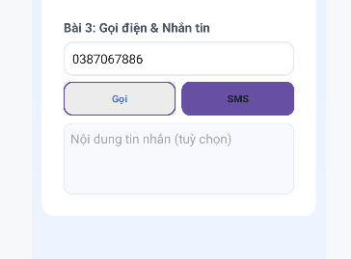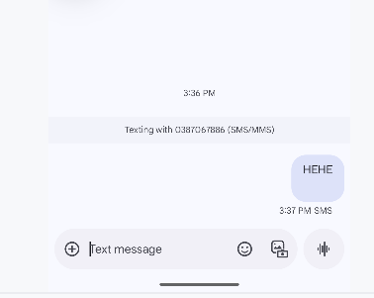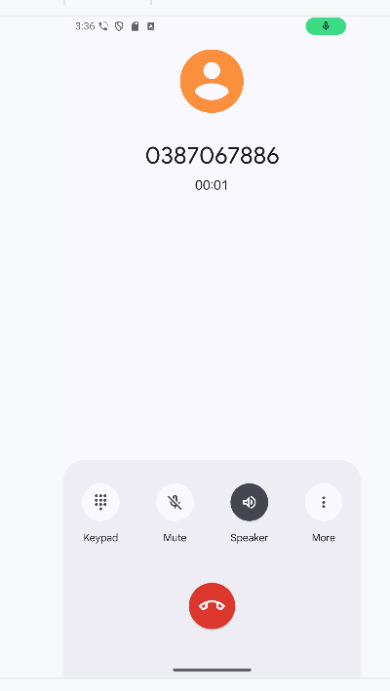

CHUYỂN TAB ( ĐỂ DÙNG ĐƯỢC 3 BÀI)

SAU ĐÂY LÀ TOÀN BỘ CODE

**MAINACTIVITY**

package com.example.mai;  
  
import androidx.appcompat.app.AppCompatActivity;  
  
import android.content.Intent;  
import android.graphics.Typeface;  
import android.net.Uri;  
import android.os.Bundle;  
import android.view.View;  
import android.widget.*;  
  
import java.util.Locale;  
import java.util.Random;  
  
public class MainActivity extends AppCompatActivity {  
  
 Button btnTabCalc, btnTabRandom, btnTabCall;  
 LinearLayout boxCalc, boxRandom, boxCall;  
  
 EditText edtA, edtB;  
 TextView tvKQ;  
 Button btnAdd, btnSub, btnMul, btnDiv, btnMod;  
  
 Button btnRand, btnDice;  
 TextView tvRand, tvDice;  
 Random rnd = new Random();  
  
 EditText edtPhone, edtSms;  
 Button btnDial, btnSms;  
  
 @Override  
 protected void onCreate(Bundle savedInstanceState) {  
 super.onCreate(savedInstanceState);  
 setContentView(R.layout.*activity_main*);  
  
 bindViews();  
 setupTabs();  
 setupCalc();  
 setupRandom();  
 setupCallSms();  
  
 switchTab(0);  
 }  
  
 private void bindViews() {  
 btnTabCalc = findViewById(R.id.*btnTabCalc*);  
 btnTabRandom = findViewById(R.id.*btnTabRandom*);  
 btnTabCall = findViewById(R.id.*btnTabCall*);  
boxCalc = findViewById(R.id.*boxCalc*);  
 boxRandom = findViewById(R.id.*boxRandom*);  
 boxCall = findViewById(R.id.*boxCall*);  
edtA = findViewById(R.id.*edtA*);  
 edtB = findViewById(R.id.*edtB*);  
 tvKQ = findViewById(R.id.*tvKQ*);  
 btnAdd = findViewById(R.id.*btnAdd*);  
 btnSub = findViewById(R.id.*btnSub*);  
 btnMul = findViewById(R.id.*btnMul*);  
 btnDiv = findViewById(R.id.*btnDiv*);  
 btnMod = findViewById(R.id.*btnMod*);  
btnRand = findViewById(R.id.*btnRand*);  
 tvRand = findViewById(R.id.*tvRand*);  
 btnDice = findViewById(R.id.*btnDice*);  
 tvDice = findViewById(R.id.*tvDice*);  
edtPhone = findViewById(R.id.*edtPhone*);  
 edtSms = findViewById(R.id.*edtSms*);  
 btnDial = findViewById(R.id.*btnDial*);  
 btnSms = findViewById(R.id.*btnSms*);  
 }  
  
 private void setupTabs() {  
 View.OnClickListener tabListener = v -> {  
 if (v == btnTabCalc) switchTab(0);  
 else if (v == btnTabRandom) switchTab(1);  
 else if (v == btnTabCall) switchTab(2);  
 };  
 btnTabCalc.setOnClickListener(tabListener);  
 btnTabRandom.setOnClickListener(tabListener);  
 btnTabCall.setOnClickListener(tabListener);  
 }  
  
 private void switchTab(int idx) {boxCalc.setVisibility( idx == 0 ? View.*VISIBLE* : View.*GONE*);  
 boxRandom.setVisibility(idx == 1 ? View.*VISIBLE* : View.*GONE*);  
 boxCall.setVisibility( idx == 2 ? View.*VISIBLE* : View.*GONE*);  
btnTabCalc.setTypeface(null, idx == 0 ? Typeface.*BOLD* : Typeface.*NORMAL*);  
 btnTabRandom.setTypeface(null, idx == 1 ? Typeface.*BOLD* : Typeface.*NORMAL*);  
 btnTabCall.setTypeface(null, idx == 2 ? Typeface.*BOLD* : Typeface.*NORMAL*);  
setTabSelected(idx);  
 }  
  
 private void setTabSelected(int idx) {  
 btnTabCalc.setSelected(idx == 0);  
 btnTabRandom.setSelected(idx == 1);  
 btnTabCall.setSelected(idx == 2);  
 }  
private void setupCalc() {  
 View.OnClickListener op = v -> {  
 String as = edtA.getText().toString().trim();  
 String bs = edtB.getText().toString().trim();  
 if (as.isEmpty() || bs.isEmpty()) {  
 toast("Nhập đủ hai số");  
 return;  
 }  
 double a, b;  
 try {  
 a = Double.*parseDouble*(as);  
 b = Double.*parseDouble*(bs);  
 } catch (NumberFormatException e) {  
 toast("Giá trị không hợp lệ");  
 return;  
 }  
 double kq;  
 if (v == btnAdd) kq = a + b;  
 else if (v == btnSub) kq = a - b;  
 else if (v == btnMul) kq = a * b;  
 else if (v == btnDiv) {  
 if (b == 0) { toast("Không thể chia cho 0"); return; }  
 kq = a / b;  
 } else {

if (b == 0) { toast("Không thể chia dư cho 0"); return; }  
 kq = a % b;  
 }  
 tvKQ.setText(String.*format*(Locale.*getDefault*(), "Kết quả: %s", trimTrailingZero(kq)));  
 };  
  
 btnAdd.setOnClickListener(op);  
 btnSub.setOnClickListener(op);  
 btnMul.setOnClickListener(op);  
 btnDiv.setOnClickListener(op);  
 btnMod.setOnClickListener(op);  
 }  
  
 private void setupRandom() {  
 btnRand.setOnClickListener(v -> {  
 int val = rnd.nextInt(1001);

tvRand.setText(String.*valueOf*(val));  
 });  
  
 btnDice.setOnClickListener(v -> {  
 int face = 1 + rnd.nextInt(6);  
 tvDice.setText(getDiceUnicode(face));  
 });  
 }  
  
 private String getDiceUnicode(int n) {  
 switch (n) {  
 case 1: return "⚀";  
 case 2: return "⚁";  
 case 3: return "⚂";  
 case 4: return "⚃";  
 case 5: return "⚄";  
 default: return "⚅";  
 }  
 }  
  
 private void setupCallSms() {  
 btnDial.setOnClickListener(v -> {  
 String phone = edtPhone.getText().toString().trim();  
 if (phone.isEmpty()) { toast("Nhập số điện thoại"); return; }  
 Intent it = new Intent(Intent.*ACTION_DIAL*, Uri.*parse*("tel:" + phone));  
 startActivity(it);  
 });  
  
 btnSms.setOnClickListener(v -> {  
 String phone = edtPhone.getText().toString().trim();  
 String msg = edtSms.getText().toString().trim();  
 if (phone.isEmpty()) { toast("Nhập số điện thoại"); return; }  
 Uri uri = Uri.*parse*("smsto:" + phone);  
 Intent it = new Intent(Intent.*ACTION_SENDTO*, uri);  
 if (!msg.isEmpty()) it.putExtra("sms_body", msg);  
 startActivity(it);  
 });  
 }  
  
 private void toast(String s) {  
 Toast.*makeText*(this, s, Toast.*LENGTH_SHORT*).show();  
 }  
  
 private String trimTrailingZero(double d) {  
 String s = String.*format*(Locale.*getDefault*(), "%.12f", d);  
 while (s.contains(".") && (s.endsWith("0") || s.endsWith("."))) {  
 s = s.substring(0, s.length() - 1);  
 }  
 return s;  
 }  
}  
  
**ACTIVITY_MAIN.XML**

*<?*xml version="1.0" encoding="utf-8"*?>*<LinearLayout xmlns:android="http://schemas.android.com/apk/res/android"  
 android:layout_width="match_parent"  
 android:layout_height="match_parent"  
 android:orientation="vertical"  
 android:padding="14dp"  
 android:background="@drawable/bg_header">  
  
 <LinearLayout  
 android:layout_width="match_parent"  
 android:layout_height="wrap_content"  
 android:background="@drawable/bg_card"  
 android:orientation="vertical"  
 android:padding="16dp">  
  
 *<!-- Tiêu đề -->* <TextView  
 android:id="@+id/tvTitle"  
 android:layout_width="match_parent"  
 android:layout_height="wrap_content"  
 android:text="Lab 1 - 3 Bài"  
 android:textSize="22sp"  
 android:textStyle="bold"  
 android:textColor="@color/ink"  
 android:paddingBottom="12dp" />  
  
  
 <LinearLayout  
 android:layout_width="match_parent"  
 android:layout_height="48dp"  
 android:orientation="horizontal"  
 android:background="@drawable/bg_tabbar"  
 android:padding="6dp">  
  
 <Space android:layout_width="6dp" android:layout_height="match_parent"/>  
  
 <Button  
 android:id="@+id/btnTabCalc"  
 android:layout_width="0dp"  
 android:layout_height="match_parent"  
 android:layout_weight="1"  
 android:background="@drawable/btn_tab_selector"  
 android:text="Bài 1"  
 android:textColor="@color/tab_text_color"  
 android:textStyle="bold"/>  
  
 <Space android:layout_width="6dp" android:layout_height="match_parent"/>  
  
 <Button  
 android:id="@+id/btnTabRandom"  
 android:layout_width="0dp"  
 android:layout_height="match_parent"  
 android:layout_weight="1"  
 android:background="@drawable/btn_tab_selector"  
 android:text="Bài 2"  
 android:textColor="@color/tab_text_color"  
 android:textStyle="bold"/>  
  
 <Space android:layout_width="6dp" android:layout_height="match_parent"/>  
  
 <Button  
 android:id="@+id/btnTabCall"  
 android:layout_width="0dp"  
 android:layout_height="match_parent"  
 android:layout_weight="1"  
 android:background="@drawable/btn_tab_selector"  
 android:text="Bài 3"  
 android:textColor="@color/tab_text_color"  
 android:textStyle="bold"/>  
 </LinearLayout>  
  
 <LinearLayout  
 android:id="@+id/boxDemo"  
 android:layout_width="match_parent"  
 android:layout_height="wrap_content"  
 android:orientation="vertical"  
 android:background="@drawable/bg_section"  
 android:padding="14dp"  
 android:layout_marginTop="14dp">  
  
 </LinearLayout>  
  
 <LinearLayout  
 android:id="@+id/boxCalc"  
 android:layout_width="match_parent"  
 android:layout_height="wrap_content"  
 android:orientation="vertical"  
 android:background="@drawable/bg_section"  
 android:padding="14dp"  
 android:layout_marginTop="14dp"  
 android:visibility="gone">  
  
 <TextView  
 android:layout_width="match_parent"  
 android:layout_height="wrap_content"  
 android:text="Bài 1: Máy tính (+, -, ×, ÷, %)"  
 android:textStyle="bold"  
 android:textSize="18sp"  
 android:textColor="@color/ink_soft"  
 android:layout_marginBottom="8dp"/>  
  
 <EditText  
 android:id="@+id/edtA"  
 android:layout_width="match_parent"  
 android:layout_height="48dp"  
 android:hint="Nhập số A"  
 android:inputType="numberDecimal"  
 android:background="@drawable/bg_edittext"  
 android:paddingLeft="12dp"  
 android:layout_marginBottom="8dp" />  
  
 <EditText  
 android:id="@+id/edtB"  
 android:layout_width="match_parent"  
 android:layout_height="48dp"  
 android:hint="Nhập số B"  
 android:inputType="numberDecimal"  
 android:background="@drawable/bg_edittext"  
 android:paddingLeft="12dp"  
 android:layout_marginBottom="8dp" />  
  
 <TextView  
 android:id="@+id/tvKQ"  
 android:layout_width="match_parent"  
 android:layout_height="56dp"  
 android:text="Kết quả"  
 android:textSize="16sp"  
 android:gravity="center"  
 android:textColor="@color/ink"  
 android:background="@drawable/bg_textarea"  
 android:layout_marginBottom="10dp"/>  
  
 <LinearLayout  
 android:layout_width="match_parent"  
 android:layout_height="wrap_content"  
 android:orientation="horizontal">  
  
 <Button  
 android:id="@+id/btnAdd"  
 android:layout_width="0dp"  
 android:layout_height="48dp"  
 android:layout_weight="1"  
 android:background="@drawable/btn_secondary_selector"  
 android:text="+"  
 android:textColor="@color/ink"  
 android:textStyle="bold"/>  
  
 <Space android:layout_width="8dp" android:layout_height="match_parent"/>  
  
 <Button  
 android:id="@+id/btnSub"  
 android:layout_width="0dp"  
 android:layout_height="48dp"  
 android:layout_weight="1"  
 android:background="@drawable/btn_secondary_selector"  
 android:text="-"  
 android:textColor="@color/ink"  
 android:textStyle="bold"/>  
  
 <Space android:layout_width="8dp" android:layout_height="match_parent"/>  
  
 <Button  
 android:id="@+id/btnMul"  
 android:layout_width="0dp"  
 android:layout_height="48dp"  
 android:layout_weight="1"  
 android:background="@drawable/btn_secondary_selector"  
 android:text="×"  
 android:textColor="@color/ink"  
 android:textStyle="bold"/>  
 </LinearLayout>  
  
 <Space android:layout_width="match_parent" android:layout_height="8dp"/>  
  
 <LinearLayout  
 android:layout_width="match_parent"  
 android:layout_height="wrap_content"  
 android:orientation="horizontal">  
  
 <Button  
 android:id="@+id/btnDiv"  
 android:layout_width="0dp"  
 android:layout_height="48dp"  
 android:layout_weight="1"  
 android:background="@drawable/btn_secondary_selector"  
 android:text="÷"  
 android:textColor="@color/ink"  
 android:textStyle="bold"/>  
  
 <Space android:layout_width="8dp" android:layout_height="match_parent"/>  
  
 <Button  
 android:id="@+id/btnMod"  
 android:layout_width="0dp"  
 android:layout_height="48dp"  
 android:layout_weight="1"  
 android:background="@drawable/btn_secondary_selector"  
 android:text="%"  
 android:textColor="@color/ink"  
 android:textStyle="bold"/>  
 </LinearLayout>  
 </LinearLayout>  
  
 <LinearLayout  
 android:id="@+id/boxRandom"  
 android:layout_width="match_parent"  
 android:layout_height="wrap_content"  
 android:orientation="vertical"  
 android:background="@drawable/bg_section"  
 android:padding="14dp"  
 android:layout_marginTop="14dp"  
 android:visibility="gone">  
  
 <TextView  
 android:layout_width="match_parent"  
 android:layout_height="wrap_content"  
 android:text="Bài 2: Số ngẫu nhiên &amp; Tung xúc xắc"  
 android:textStyle="bold"  
 android:textSize="18sp"  
 android:textColor="@color/ink_soft"  
 android:layout_marginBottom="8dp"/>  
  
 <Button  
 android:id="@+id/btnRand"  
 android:layout_width="match_parent"  
 android:layout_height="48dp"  
 android:background="@drawable/btn_primary_outline_selector"  
 android:text="Xuất số ngẫu nhiên (0..1000)"  
 android:textColor="@color/brand"  
 android:textStyle="bold"/>  
  
 <TextView  
 android:id="@+id/tvRand"  
 android:layout_width="match_parent"  
 android:layout_height="56dp"  
 android:text="..."  
 android:textSize="18sp"  
 android:gravity="center"  
 android:textColor="@color/brand_dark"  
 android:background="@drawable/bg_textarea"  
 android:layout_marginTop="10dp"/>  
  
 <Space android:layout_width="match_parent" android:layout_height="12dp"/>  
  
 <Button  
 android:id="@+id/btnDice"  
 android:layout_width="match_parent"  
 android:layout_height="48dp"  
 android:background="@drawable/btn_primary_selector"  
 android:text="Tung xúc xắc"  
 android:textColor="@android:color/white"  
 android:textStyle="bold"/>  
  
 <TextView  
 android:id="@+id/tvDice"  
 android:layout_width="match_parent"  
 android:layout_height="120dp"  
 android:text="⚀"  
 android:textSize="64sp"  
 android:gravity="center"  
 android:textColor="@color/danger"  
 android:background="@drawable/bg_textarea"  
 android:layout_marginTop="10dp"/>  
 </LinearLayout>  
  
 <LinearLayout  
 android:id="@+id/boxCall"  
 android:layout_width="match_parent"  
 android:layout_height="wrap_content"  
 android:orientation="vertical"  
 android:background="@drawable/bg_section"  
 android:padding="14dp"  
 android:layout_marginTop="14dp"  
 android:visibility="gone">  
  
 <TextView  
 android:layout_width="match_parent"  
 android:layout_height="wrap_content"  
 android:text="Bài 3: Gọi điện &amp; Nhắn tin"  
 android:textStyle="bold"  
 android:textSize="18sp"  
 android:textColor="@color/ink_soft"  
 android:layout_marginBottom="8dp"/>  
  
 <EditText  
 android:id="@+id/edtPhone"  
 android:layout_width="match_parent"  
 android:layout_height="48dp"  
 android:hint="Số điện thoại"  
 android:inputType="phone"  
 android:background="@drawable/bg_edittext"  
 android:paddingLeft="12dp"  
 android:layout_marginBottom="8dp"/>  
  
 <LinearLayout  
 android:layout_width="match_parent"  
 android:layout_height="wrap_content"  
 android:orientation="horizontal">  
  
 <Button  
 android:id="@+id/btnDial"  
 android:layout_width="0dp"  
 android:layout_height="48dp"  
 android:layout_weight="1"  
 android:background="@drawable/btn_primary_outline_selector"  
 android:text="Gọi"  
 android:textColor="@color/brand"  
 android:textStyle="bold"/>  
  
 <Space android:layout_width="8dp" android:layout_height="match_parent"/>  
  
 <Button  
 android:id="@+id/btnSms"  
 android:layout_width="0dp"  
 android:layout_height="48dp"  
 android:layout_weight="1"  
 android:background="@drawable/btn_secondary_selector"  
 android:text="SMS"  
 android:textColor="@color/ink"  
 android:textStyle="bold"/>  
 </LinearLayout>  
  
 <EditText  
 android:id="@+id/edtSms"  
 android:layout_width="match_parent"  
 android:layout_height="100dp"  
 android:hint="Nội dung tin nhắn (tuỳ chọn)"  
 android:gravity="top"  
 android:inputType="textMultiLine"  
 android:background="@drawable/bg_textarea"  
 android:padding="10dp"  
 android:layout_marginTop="10dp"/>  
 </LinearLayout>  
  
 </LinearLayout>  
</LinearLayout>

## Thiết kế giao diện trên Android Studio UI DESIGH

### Bài 1 – Splash random màu nền + icon

Mục tiêu: Mỗi lần mở Splash, nền và icon hiển thị ngẫu nhiên.

1.1) Tạo/điều chỉnh file res/values/arrays.xml

*<?*xml version="1.0" encoding="utf-8"*?>*<resources>  
<string-array name="splash_colors">  
 <item>#303F9F</item>  
 <item>#455A64</item>  
 <item>#6A1B9A</item>  
 <item>#1565C0</item>  
 <item>#2E7D32</item>  
 <item>#D32F2F</item>  
 <item>#B71C1C</item>  
</string-array>  
  
<array name="splash_icons">  
 <item>@drawable/ic_penguin</item>  
 <item>@drawable/ic_cat</item>  
 <item>@drawable/ic_dog</item>  
</array>  
</resources>

1.2) Layout Splash: res/layout/m001_act_splash.xml

*<?*xml version="1.0" encoding="utf-8"*?>*<FrameLayout xmlns:android="http://schemas.android.com/apk/res/android"  
 android:id="@+id/splashRoot"  
 android:layout_width="match_parent"  
 android:layout_height="match_parent"  
 android:background="#303F9F">  
  
 <LinearLayout  
 android:layout_width="match_parent"  
 android:layout_height="match_parent"  
 android:gravity="center"  
 android:orientation="vertical">  
  
 <ImageView  
 android:id="@+id/imgSplash"  
 android:layout_width="128dp"  
 android:layout_height="128dp"  
 android:src="@drawable/ic_penguin" />  
  
 <TextView  
 android:layout_width="wrap_content"  
 android:layout_height="wrap_content"  
 android:layout_marginTop="10dp"  
 android:text="Animal sound"  
 android:textColor="#FFFFFF"  
 android:textSize="24sp" />  
 </LinearLayout>  
  
 <include  
 android:id="@+id/loading_overlay"  
 layout="@layout/item_loading" />  
</FrameLayout>

1.3) Activity Splash: java/com/example/mai/M000ActSplash.java

package com.example.mai;  
  
import android.content.Intent;  
import android.content.res.TypedArray;  
import android.graphics.Color;  
import android.os.Bundle;  
import android.os.Handler;  
import android.view.View;  
import android.widget.FrameLayout;  
import android.widget.ImageView;  
import androidx.appcompat.app.AppCompatActivity;  
import java.util.Random;  
  
public class M000ActSplash extends AppCompatActivity {  
  
 private final Random rnd = new Random();  
  
 @Override  
 protected void onCreate(Bundle savedInstanceState) {  
 super.onCreate(savedInstanceState);  
 setContentView(R.layout.*m001_act_splash*);  
  
 FrameLayout root = findViewById(R.id.*splashRoot*);  
 ImageView img = findViewById(R.id.*imgSplash*);  
 View overlay = findViewById(R.id.*loading_overlay*);  
  
 String[] colorHex = getResources().getStringArray(R.array.*splash_colors*);  
 if (colorHex != null && colorHex.length > 0) {  
 String pick = colorHex[rnd.nextInt(colorHex.length)];  
 try { root.setBackgroundColor(Color.*parseColor*(pick)); }  
 catch (IllegalArgumentException ignore) { root.setBackgroundColor(Color.*parseColor*("#303F9F")); }  
 } else root.setBackgroundColor(Color.*parseColor*("#303F9F"));  
  
 int[] iconIds = getDrawableArray(R.array.*splash_icons*);  
 if (iconIds.length > 0) img.setImageResource(iconIds[rnd.nextInt(iconIds.length)]);  
  
 overlay.setVisibility(View.*VISIBLE*);  
  
 final String next = getIntent().getStringExtra("NEXT");  
 new Handler().postDelayed(() -> {  
 overlay.setVisibility(View.*GONE*);  
 if ("LAB2".equals(next)) {  
 startActivity(new Intent(this, Lab2Activity.class));  
 } else {  
 startActivity(new Intent(this, MainActivity.class));  
 }  
 finish();  
 }, 1200);  
 }  
 private int[] getDrawableArray(int resId) {  
 TypedArray ta = getResources().obtainTypedArray(resId);  
 int[] ids = new int[ta.length()];  
 for (int i = 0; i < ta.length(); i++) ids[i] = ta.getResourceId(i, 0);  
 ta.recycle();  
 return ids;  
 }  
}  
**KẾT QUẢ CHẠY**

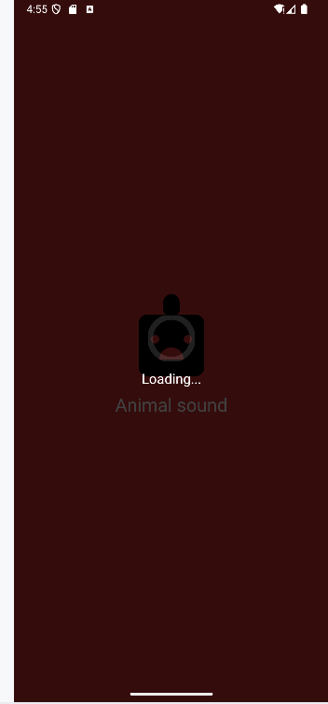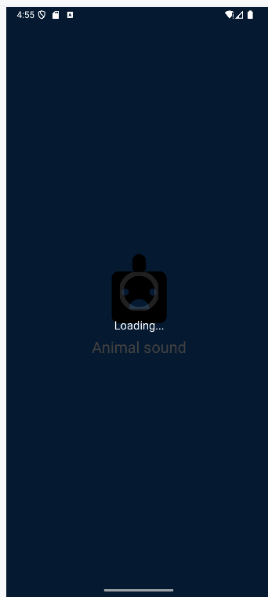

### Bài 2 – Custom ProgressBar (Overlay Loading)

Mục tiêu: Tạo overlay Loading đẹp, có thể tái sử dụng ở Splash hoặc nơi khác.

2.1) Drawable vòng quay: res/drawable/progress_circular.xml

*<?*xml version="1.0" encoding="utf-8"*?>*<layer-list xmlns:android="http://schemas.android.com/apk/res/android">  
<item>  
 <shape android:shape="ring"  
 android:useLevel="false"  
 android:thicknessRatio="8"  
 android:innerRadiusRatio="2.5">  
 <size android:width="60dp" android:height="60dp"/>  
 <solid android:color="#20FFFFFF"/>  
 </shape>  
</item>  
<item>  
 <rotate  
 android:fromDegrees="0"  
 android:toDegrees="360"  
 android:pivotX="50%"  
 android:pivotY="50%"  
 android:duration="900"  
 android:repeatCount="infinite">  
 <shape android:shape="ring"  
 android:useLevel="false"  
 android:thicknessRatio="8"  
 android:innerRadiusRatio="2.5">  
 <size android:width="60dp" android:height="60dp"/>  
 <sweepGradient  
 android:useLevel="false"  
 android:startColor="#FFFFFFFF"  
 android:endColor="#00FFFFFF"/>  
 </shape>  
 </rotate>  
</item>  
</layer-list>

2.2) Layout overlay dùng chung: res/layout/item_loading.xml

*<?*xml version="1.0" encoding="utf-8"*?>*<LinearLayout xmlns:android="http://schemas.android.com/apk/res/android"  
android:layout_width="match_parent"  
android:layout_height="match_parent"  
android:background="#BF000000"  
android:gravity="center"  
android:orientation="vertical">  
  
<ProgressBar  
 android:layout_width="60dp"  
 android:layout_height="60dp"  
 android:indeterminate="true"  
 android:indeterminateDrawable="@drawable/progress_circular" />  
  
<TextView  
 android:layout_width="wrap_content"  
 android:layout_height="wrap_content"  
 android:text="Loading..."  
 android:textColor="#FFFFFF"  
 android:textSize="18sp"  
 android:layout_marginTop="10dp"/>  
</LinearLayout>

2.3) Demo hiện/tắt overlay trong Lab2Activity

// Trong Lab2Activity.java

l2Overlay = findViewById(R.id.l2_overlay);

btnShowOverlay.setOnClickListener(v -> {

l2Overlay.setVisibility(View.VISIBLE);

new Handler().postDelayed(() -> l2Overlay.setVisibility(View.GONE), 2000);

});

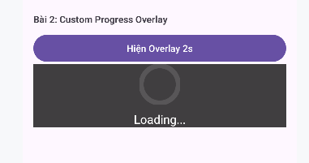

### Bài 3 – Profile: bấm icon để mở quay số (Intent.ACTION_DIAL)

Mục tiêu: Tạo màn Profile; khi bấm icon điện thoại sẽ mở trình quay số.

3.1) res/drawable/bg_oval.xml (nền tròn cho icon)

*<?*xml version="1.0" encoding="utf-8"*?>*<shape xmlns:android="http://schemas.android.com/apk/res/android" android:shape="oval">  
<solid android:color="#FF4181"/>  
</shape>

3.2) Layout Profile: res/layout/m001_act_profile.xml

*<?*xml version="1.0" encoding="utf-8"*?>*<LinearLayout xmlns:android="http://schemas.android.com/apk/res/android"  
xmlns:app="http://schemas.android.com/apk/res-auto"  
android:layout_width="match_parent"  
android:layout_height="match_parent"  
android:background="#FAFAFA"  
android:orientation="vertical">  
  
<FrameLayout  
 android:layout_width="match_parent"  
 android:layout_height="220dp">  
  
 <ImageView  
 android:layout_width="match_parent"  
 android:layout_height="220dp"  
 android:scaleType="centerCrop"  
 android:src="@drawable/bg_avatar" />  
  
 <TextView  
 android:layout_width="wrap_content"  
 android:layout_height="wrap_content"  
 android:layout_gravity="bottom|start"  
 android:layout_marginStart="20dp"  
 android:layout_marginBottom="20dp"  
 android:text="Ali Connors"  
 android:textColor="#FFFFFF"  
 android:textSize="28sp"  
 android:textStyle="bold"/>  
</FrameLayout>  
  
<LinearLayout  
 android:layout_width="match_parent"  
 android:layout_height="wrap_content"  
 android:padding="16dp"  
 android:orientation="horizontal">  
  
 <ImageView  
 android:id="@+id/icPhone"  
 android:layout_width="56dp"  
 android:layout_height="56dp"  
 android:background="@drawable/bg_oval"  
 android:padding="12dp"  
 android:src="@drawable/ic_phone"  
 app:tint="#FFFFFF"  
 android:contentDescription="@string/app_name" />  
  
 <LinearLayout  
 android:layout_width="0dp"  
 android:layout_height="wrap_content"  
 android:layout_marginStart="16dp"  
 android:layout_weight="1"  
 android:orientation="vertical">  
  
 <TextView  
 android:id="@+id/tvPhone1"  
 android:layout_width="match_parent"  
 android:layout_height="wrap_content"  
 android:text="(650) 555-1234"  
 android:textColor="#333333"  
 android:textSize="18sp"  
 android:textStyle="bold"/>  
  
 <TextView  
 android:layout_width="match_parent"  
 android:layout_height="wrap_content"  
 android:text="Mobile"  
 android:textColor="#888888"  
 android:textSize="14sp"/>  
 </LinearLayout>  
</LinearLayout>  
</LinearLayout>

3.3) Activity Profile: java/com/example/mai/M001ActProfile.java

package com.example.mai;  
  
import android.content.Intent;  
import android.net.Uri;  
import android.os.Bundle;  
import android.widget.ImageView;  
import android.widget.TextView;  
  
import androidx.appcompat.app.AppCompatActivity;  
  
public class M001ActProfile extends AppCompatActivity {  
  
 @Override  
 protected void onCreate(Bundle savedInstanceState) {  
 super.onCreate(savedInstanceState);  
 setContentView(R.layout.*m001_act_profile*);  
  
 ImageView icPhone = findViewById(R.id.*icPhone*);  
 TextView tvPhone1 = findViewById(R.id.*tvPhone1*);  
  
 icPhone.setOnClickListener(v -> {  
 String raw = tvPhone1.getText().toString().trim();  
 String phone = raw.replaceAll("[^0-9+]", "");  
 if (phone.isEmpty()) phone = "0901234567"; Intent it = new Intent(Intent.*ACTION_DIAL*, Uri.*parse*("tel:" + phone));  
 startActivity(it);  
 });  
 }  
}

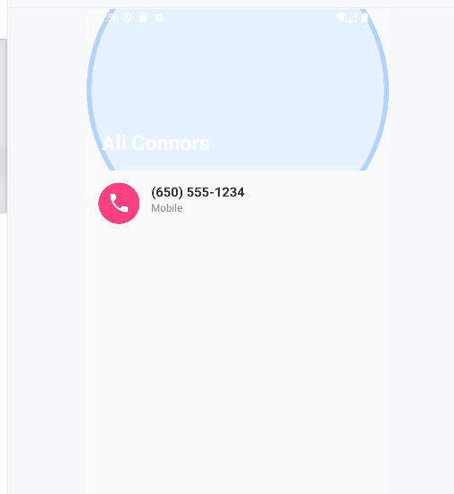

### Bài 4 – Tạo màn chính Lab2 (điều hướng 3 bài) & liên kết với Lab1

Mục tiêu: Có Activity riêng cho Lab 2 (3 tab), và từ Lab 1 có thể mở sang Lab 2 theo từng bài, cũng như quay lại Lab 1.

4.1) Layout Lab 2: res/layout/activity_lab2.xml  
 *<?*xml version="1.0" encoding="utf-8"*?>*<LinearLayout xmlns:android="http://schemas.android.com/apk/res/android"  
android:orientation="vertical" android:padding="16dp"  
android:layout_width="match_parent" android:layout_height="match_parent">  
  
<LinearLayout  
 android:layout_width="match_parent"  
 android:layout_height="48dp"  
 android:orientation="horizontal">  
  
 <Button  
 android:id="@+id/btnL2Tab1"  
 android:layout_width="0dp"  
 android:layout_height="match_parent"  
 android:layout_weight="1"  
 android:text="Bài 1 (Splash)"/>  
  
 <Space android:layout_width="8dp" android:layout_height="match_parent"/>  
  
 <Button  
 android:id="@+id/btnL2Tab2"  
 android:layout_width="0dp"  
 android:layout_height="match_parent"  
 android:layout_weight="1"  
 android:text="Bài 2 (Progress)"/>  
  
 <Space android:layout_width="8dp" android:layout_height="match_parent"/>  
  
 <Button  
 android:id="@+id/btnL2Tab3"  
 android:layout_width="0dp"  
 android:layout_height="match_parent"  
 android:layout_weight="1"  
 android:text="Bài 3 (Profile)"/>  
</LinearLayout>  
  
<Button  
 android:id="@+id/btnBackLab1"  
 android:layout_width="match_parent"  
 android:layout_height="48dp"  
 android:text="Về Lab 1 (MainActivity)"  
 android:layout_marginTop="10dp"/>  
  
<LinearLayout  
 android:id="@+id/boxL2_1"  
 android:layout_width="match_parent"  
 android:layout_height="wrap_content"  
 android:orientation="vertical"  
 android:paddingTop="16dp">  
  
 <TextView  
 android:layout_width="match_parent"  
 android:layout_height="wrap_content"  
 android:text="Bài 1: Mỗi lần chạy Splash random màu nền + icon"  
 android:textStyle="bold"/>  
  
 <Button  
 android:id="@+id/btnRunSplash"  
 android:layout_width="match_parent"  
 android:layout_height="48dp"  
 android:text="Chạy Splash (quay lại Lab 2 sau 1.2s)"  
 android:layout_marginTop="10dp"/>  
</LinearLayout>  
  
<LinearLayout  
 android:id="@+id/boxL2_2"  
 android:layout_width="match_parent"  
 android:layout_height="wrap_content"  
 android:orientation="vertical"  
 android:paddingTop="16dp"  
 android:visibility="gone">  
  
 <TextView  
 android:layout_width="match_parent"  
 android:layout_height="wrap_content"  
 android:text="Bài 2: Custom Progress Overlay"  
 android:textStyle="bold"/>  
  
 <Button  
 android:id="@+id/btnShowOverlay"  
 android:layout_width="match_parent"  
 android:layout_height="48dp"  
 android:text="Hiện Overlay 2s"  
 android:layout_marginTop="10dp"/>  
  
 <include  
 android:id="@+id/l2_overlay"  
 layout="@layout/item_loading"  
 android:visibility="gone"/>  
</LinearLayout>  
  
<LinearLayout  
 android:id="@+id/boxL2_3"  
 android:layout_width="match_parent"  
 android:layout_height="wrap_content"  
 android:orientation="vertical"  
 android:paddingTop="16dp"  
 android:visibility="gone">  
  
 <TextView  
 android:layout_width="match_parent"  
 android:layout_height="wrap_content"  
 android:text="Bài 3: Bấm icon trong Profile để mở quay số"  
 android:textStyle="bold"/>  
  
 <Button  
 android:id="@+id/btnOpenProfile"  
 android:layout_width="match_parent"  
 android:layout_height="48dp"  
 android:text="Mở Profile"/>  
</LinearLayout>  
</LinearLayout>

4.2) Activity Lab 2: java/com/example/mai/Lab2Activity.java

package com.example.mai;  
  
import android.content.Intent;  
import android.os.Bundle;  
import android.os.Handler;  
import android.view.View;  
import android.widget.Button;  
import android.widget.LinearLayout;  
  
import androidx.appcompat.app.AppCompatActivity;  
  
public class Lab2Activity extends AppCompatActivity {  
  
 Button btnL2Tab1, btnL2Tab2, btnL2Tab3, btnBackLab1;  
 LinearLayout box1, box2, box3;  
 View l2Overlay;  
 Button btnRunSplash, btnShowOverlay, btnOpenProfile;  
  
 @Override  
 protected void onCreate(Bundle savedInstanceState) {  
 super.onCreate(savedInstanceState);  
 setContentView(R.layout.*activity_lab2*);  
  
 bindViews();  
 setupTabs();  
 setupActions();  
  
 int tab = getIntent().getIntExtra("TAB", 0);  
 switchTab(tab);  
 }  
  
 private void bindViews() {  
 btnL2Tab1 = findViewById(R.id.btnL2Tab1);  
 btnL2Tab2 = findViewById(R.id.btnL2Tab2);  
 btnL2Tab3 = findViewById(R.id.btnL2Tab3);  
 btnBackLab1 = findViewById(R.id.btnBackLab1);  
  
 box1 = findViewById(R.id.boxL2_1);  
 box2 = findViewById(R.id.boxL2_2);  
 box3 = findViewById(R.id.boxL2_3);  
  
 l2Overlay = findViewById(R.id.l2_overlay);  
  
 btnRunSplash = findViewById(R.id.btnRunSplash);  
 btnShowOverlay = findViewById(R.id.btnShowOverlay);  
 btnOpenProfile = findViewById(R.id.btnOpenProfile);  
 }  
  
 private void setupTabs() {  
 View.OnClickListener t = v -> {  
 if (v == btnL2Tab1) switchTab(0);  
 else if (v == btnL2Tab2) switchTab(1);  
 else if (v == btnL2Tab3) switchTab(2);  
 };  
 btnL2Tab1.setOnClickListener(t);  
 btnL2Tab2.setOnClickListener(t);  
 btnL2Tab3.setOnClickListener(t);  
 }  
  
 private void switchTab(int idx) {  
 box1.setVisibility(idx == 0 ? View.*VISIBLE* : View.*GONE*);  
 box2.setVisibility(idx == 1 ? View.*VISIBLE* : View.*GONE*);  
 box3.setVisibility(idx == 2 ? View.*VISIBLE* : View.*GONE*);  
 }  
  
 private void setupActions() {btnBackLab1.setOnClickListener(v ->  
 startActivity(new Intent(this, MainActivity.class)));  
btnRunSplash.setOnClickListener(v -> {  
 Intent it = new Intent(this, M000ActSplash.class);  
 it.putExtra("NEXT", "LAB2");  
 startActivity(it);  
 });  
btnShowOverlay.setOnClickListener(v -> {  
 l2Overlay.setVisibility(View.*VISIBLE*);  
 new Handler().postDelayed(() -> l2Overlay.setVisibility(View.*GONE*), 2000);  
 });  
btnOpenProfile.setOnClickListener(v ->  
 startActivity(new Intent(this, M001ActProfile.class)));  
 }  
}

4.3) Điều hướng từ Lab 1 sang Lab 2 theo từng bài (MainActivity)

// Trong MainActivity.java, sau khi findViewById 2 nút btnLab2Splash, btnLab2Profile:  
btnLab2Splash.setOnClickListener(v -> {  
Intent it = new Intent(this, Lab2Activity.class);  
 it.putExtra("TAB", 0);

startActivity(it);  
});  
 btnLab2Profile.setOnClickListener(v -> {  
Intent it = new Intent(this, Lab2Activity.class);  
 it.putExtra("TAB", 2);

startActivity(it);  
});

4.4) AndroidManifest.xml (bên trong <application>...</application>)

<activity  
android:name=".MainActivity"  
android:exported="true">  
<intent-filter>  
 <action android:name="android.intent.action.MAIN" />  
 <category android:name="android.intent.category.LAUNCHER" />  
</intent-filter>  
</activity>  
  
<activity android:name=".Lab2Activity" android:exported="false" />  
<activity android:name=".M000ActSplash" android:exported="false" />  
<activity android:name=".M001ActProfile" android:exported="false" />

KẾT QUẢ

Giao diện điêu hướng 3 bài tập thiết kế giao diện

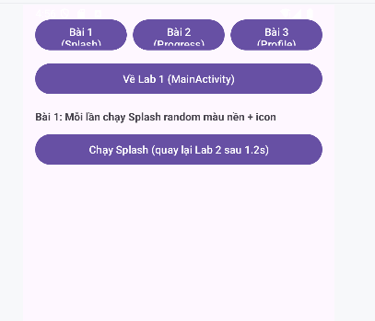

Giao diện điều hướng 3 bài Lab1 và lab2 ở trên

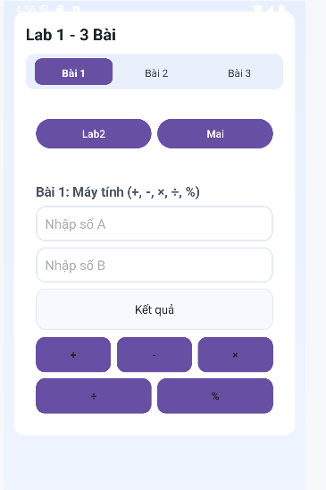

# LAB 2

## Xây dựng ứng dụng Truyện Cười (P1)

**I. Tạo dự án Android Studio**

1) File → New → New Project → Empty Views Activity.

**II. Cấu hình màu & theme (MaterialComponents, NoActionBar)**

**Mở res/values/colors.xml thêm các màu:**

*<?*xml version="1.0" encoding="utf-8"*?>*<resources>  
<color name="purple_200">#FFBB86FC</color>  
<color name="purple_500">#FF6200EE</color>  
<color name="purple_700">#FF3700B3</color>  
<color name="teal_200">#FF03DAC5</color>  
<color name="teal_700">#FF018786</color>  
<color name="black">#FF000000</color>  
<color name="white">#FFFFFFFF</color>  
<color name="greenMid">#478942</color>  
<color name="greenLight">#62BC5B</color>  
<color name="greenSuperLight">#EFFFEE</color>  
</resources>

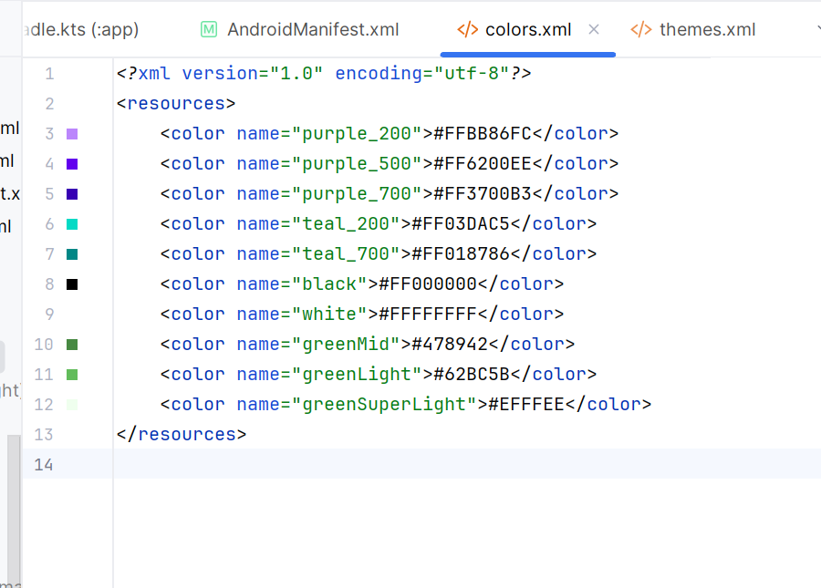

**Mở res/values/themes.xml cấu hình Theme.MaterialComponents.DayNight.NoActionBar:**

*<?*xml version="1.0" encoding="utf-8"*?>*<resources xmlns:tools="http://schemas.android.com/tools">  
<style name="Theme.Demo" parent="Theme.MaterialComponents.DayNight.NoActionBar">  
 <item name="colorPrimary">@color/purple_500</item>  
 <item name="colorPrimaryVariant">@color/purple_700</item>  
 <item name="colorOnPrimary">@color/white</item>  
 <item name="colorSecondary">@color/teal_200</item>  
 <item name="colorSecondaryVariant">@color/teal_700</item>  
 <item name="colorOnSecondary">@color/black</item>  
 <item name="android:statusBarColor" tools:targetApi="l">?attr/colorPrimaryVariant</item>  
</style>  
</resources>

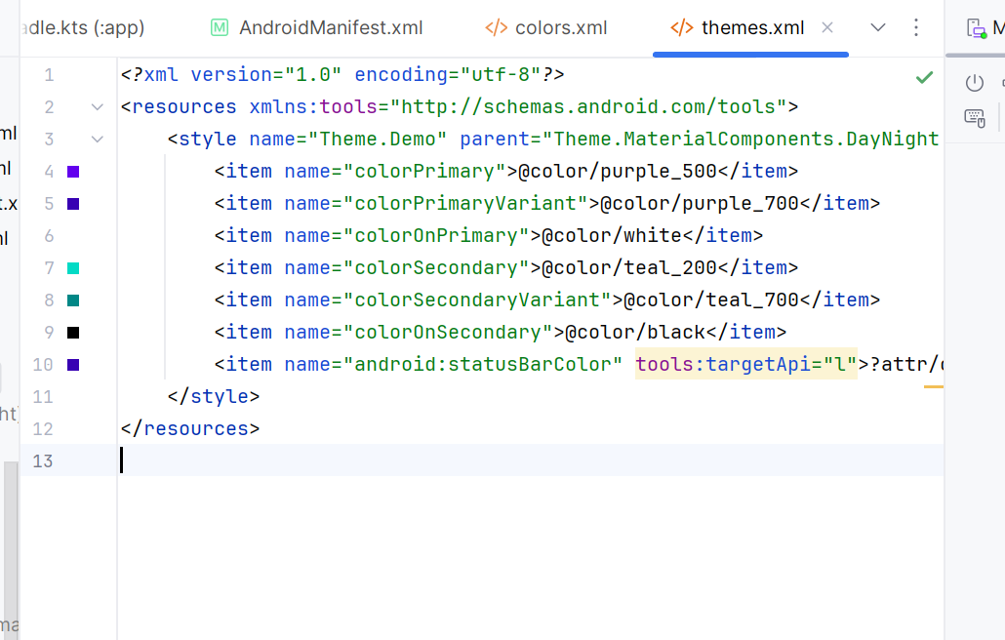

**III. Khai báo đa ngôn ngữ (strings.xml)**

**A) res/values/strings.xml (tiếng Anh)**

*<?*xml version="1.0" encoding="utf-8"*?>*<resources>  
<string name="app_name">TruyenCuoi</string>  
<string name="txt_topics">Topics</string>  
<string name="topic_family">Family</string>  
<string name="topic_school">School</string>  
<string name="topic_work">Work</string>  
<string name="topic_misc">Misc</string>  
<string name="txt_stories_of">Stories of %1$s</string>  
<string name="btn_prev">Previous</string>  
<string name="btn_next">Next</string>  
<string name="s1_title">Dad’s Logic</string>  
<string name="s1_content">When I asked dad for money, he said: If money grew on trees...</string>  
<string name="s2_title">Mom’s Secret</string>  
<string name="s2_content">Mom said she had a secret recipe...</string>  
<string name="s3_title">Exam Strategy</string>  
<string name="s3_content">Teacher: Why are you looking at your watch...</string>  
<string name="s4_title">Office Humor</string>  
<string name="s4_content">Boss: Do you believe in life after work?</string>  
<string name="s5_title">Random Joke</string>  
<string name="s5_content">I told my phone I lost my sense of humor...</string>  
<string name="txt_story1">Funny story #1</string>  
<string name="txt_story2">Funny story #2</string>  
<string name="txt_name">Rabbit</string>  
<string name="txt_desc">Rabbits are small mammals with long ears.</string>  
</resources>

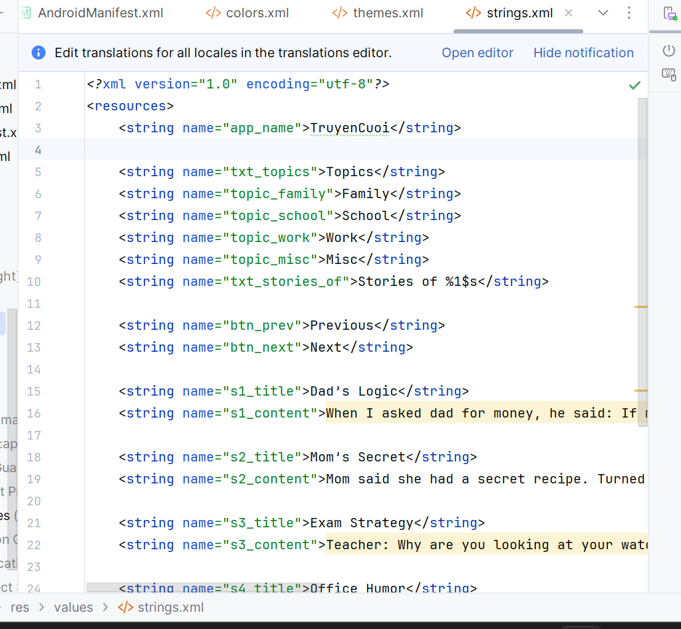

**B) Tạo thư mục res/values-vi-rVN/strings.xml (tiếng Việt):**

*<?*xml version="1.0" encoding="utf-8"*?>*<resources>  
<string name="app_name">Truyện Cười</string>  
<string name="txt_topics">Chủ đề</string>  
<string name="topic_family">Gia đình</string>  
<string name="topic_school">Trường lớp</string>  
<string name="topic_work">Công việc</string>  
<string name="topic_misc">Tổng hợp</string>  
<string name="txt_stories_of">Truyện của %1$s</string>  
<string name="btn_prev">Trước</string>  
<string name="btn_next">Sau</string>  
<string name="s1_title">Logic của ba</string>  
<string name="s1_content">Khi xin tiền, ba bảo: Nếu tiền mọc trên cây...</string>  
<string name="s2_title">Bí kíp của mẹ</string>  
<string name="s2_content">Mẹ nói có bí kíp nấu ăn...</string>  
<string name="s3_title">Chiến thuật thi cử</string>  
<string name="s3_content">Cô: Sao em nhìn đồng hồ khi làm bài?</string>  
<string name="s4_title">Chuyện công sở</string>  
<string name="s4_content">Sếp: Em có tin vào cuộc sống sau giờ làm không?</string>  
<string name="s5_title">Cười ngẫu hứng</string>  
<string name="s5_content">Tôi nói điện thoại là tôi mất khiếu hài hước...</string>  
<string name="txt_story1">Truyện cười số 1</string>  
<string name="txt_story2">Truyện cười số 2</string>  
<string name="txt_name">Thỏ</string>  
<string name="txt_desc">Thỏ là động vật có vú nhỏ với tai dài.</string>  
</resources>

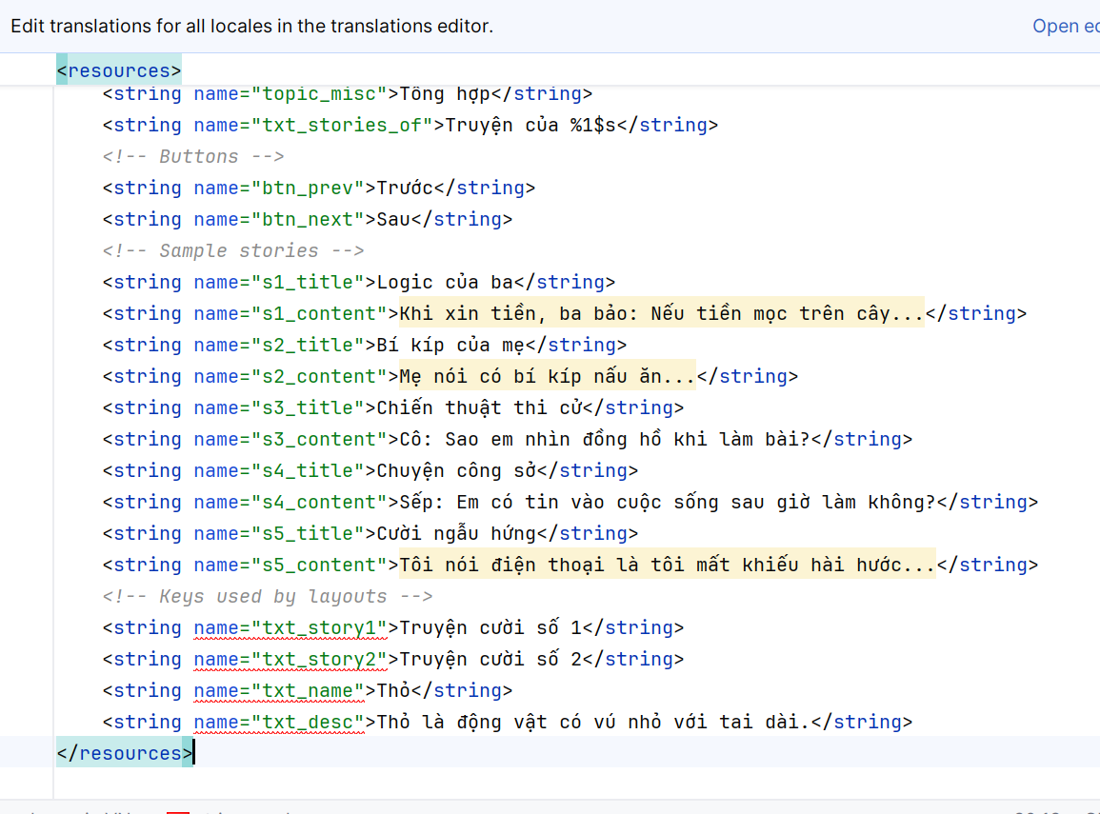

**IV. Giao diện & Điều hướng (Layouts)**

**1) res/layout/activity_main.xml (container cho Fragment)**

*<?*xml version="1.0" encoding="utf-8"*?>*<LinearLayout xmlns:android="http://schemas.android.com/apk/res/android"  
android:id="@+id/ln_main"  
android:layout_width="match_parent"  
android:layout_height="match_parent"  
android:orientation="horizontal"/>

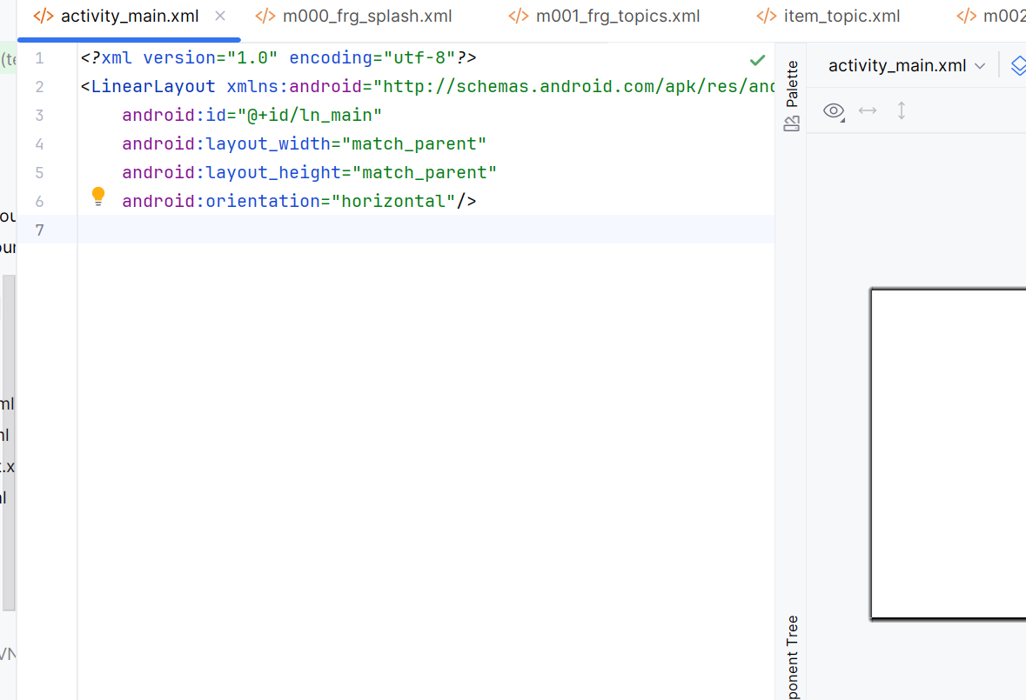

**2) res/layout/m000_frg_splash.xml**

*<?*xml version="1.0" encoding="utf-8"*?>*<FrameLayout xmlns:android="http://schemas.android.com/apk/res/android"  
android:layout_width="match_parent"  
android:layout_height="match_parent"  
android:background="@color/greenMid">  
<ImageView  
 android:layout_width="200dp"  
 android:layout_height="100dp"  
 android:layout_gravity="center"  
 android:src="@drawable/ic_splash" />  
</FrameLayout>

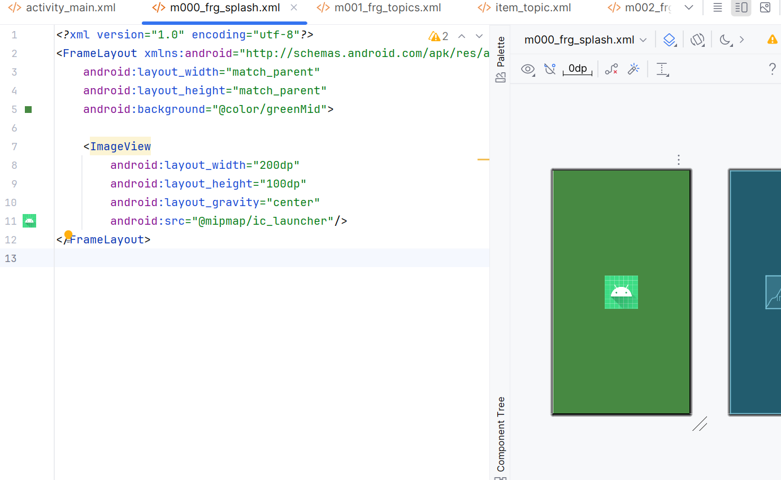

**3) res/layout/m001_frg_topics.xml + res/layout/item_topic.xml**

*<?*xml version="1.0" encoding="utf-8"*?>* <LinearLayout xmlns:android="http://schemas.android.com/apk/res/android"  
android:layout_width="match_parent"  
android:layout_height="match_parent"  
android:orientation="vertical"  
android:background="@color/greenSuperLight"  
android:padding="16dp">  
<TextView  
 android:id="@+id/tv_title"  
 android:layout_width="match_parent"  
 android:layout_height="wrap_content"  
 android:text="@string/txt_topics"  
 android:textSize="22sp"  
 android:textStyle="bold"  
 android:textColor="@color/greenMid"/>  
<androidx.recyclerview.widget.RecyclerView  
 android:id="@+id/rv_topics"  
 android:layout_width="match_parent"  
 android:layout_height="match_parent"  
 android:paddingTop="8dp"/>  
</LinearLayout>  
  
 <LinearLayout xmlns:android="http://schemas.android.com/apk/res/android"  
android:layout_width="match_parent"  
android:layout_height="wrap_content"  
android:padding="8dp">  
<TextView  
 android:id="@+id/tv_topic"  
 android:layout_width="match_parent"  
 android:layout_height="wrap_content"  
 android:background="@drawable/bg_radius"  
 android:text="Gia đình"  
 android:textColor="@android:color/white"  
 android:textSize="18sp"  
 android:paddingHorizontal="16dp"  
 android:paddingVertical="10dp"/>  
</LinearLayout>

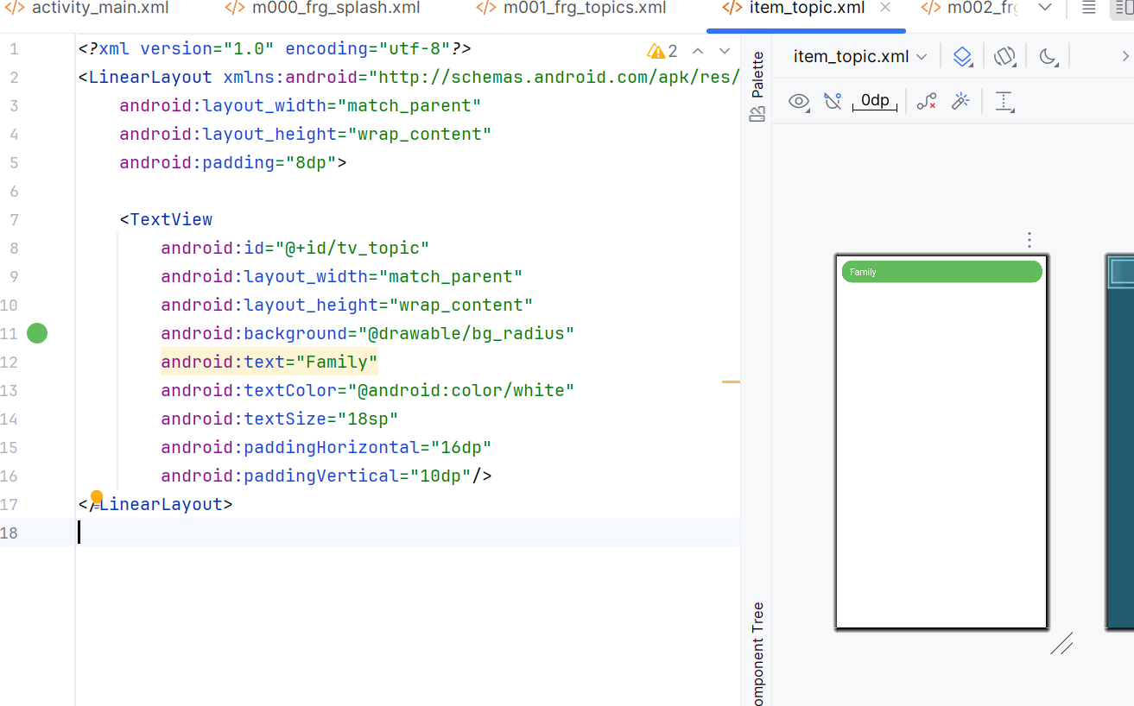

**4)res/layout/m002_frg_story_list.xml + res/layout/item_story.xml**

res/layout/m002_frg_story_list.xml

*<?*xml version="1.0" encoding="utf-8"*?>* <LinearLayout xmlns:android="http://schemas.android.com/apk/res/android"  
android:layout_width="match_parent"  
android:layout_height="match_parent"  
android:orientation="vertical"  
android:background="@color/greenSuperLight"  
android:padding="16dp">  
<TextView  
 android:id="@+id/tv_topic_header"  
 android:layout_width="match_parent"  
 android:layout_height="wrap_content"  
 android:text="Topic"  
 android:textStyle="bold"  
 android:textSize="20sp"  
 android:textColor="@color/greenMid"  
 android:paddingBottom="8dp"/>  
<androidx.recyclerview.widget.RecyclerView  
 android:id="@+id/rv_stories"  
 android:layout_width="match_parent"  
 android:layout_height="match_parent"/>  
</LinearLayout>

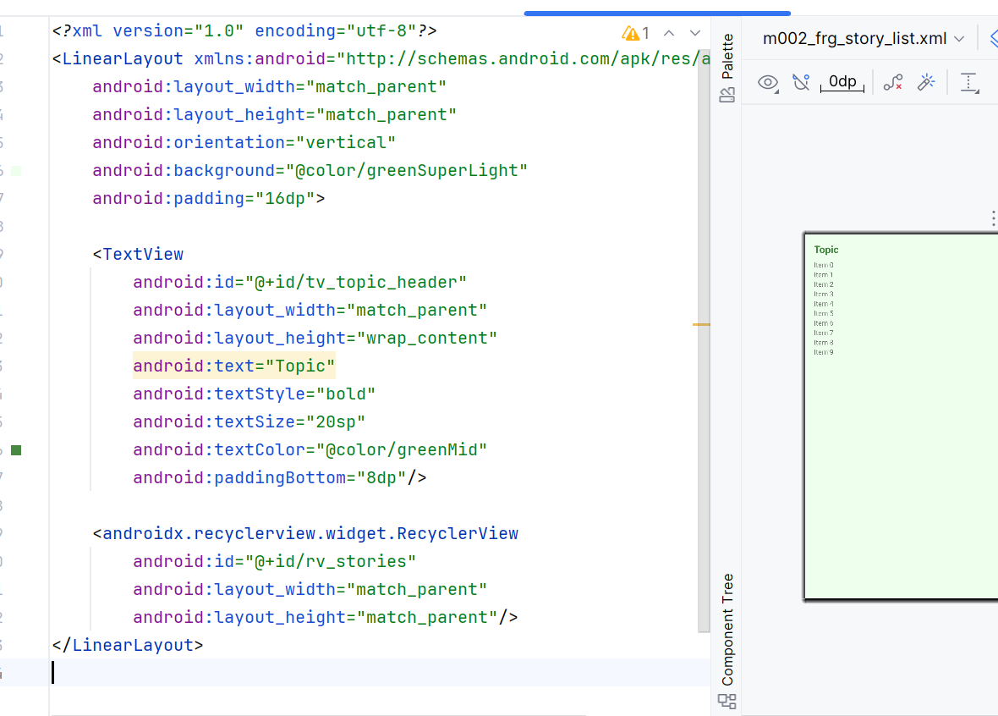  
res/layout/item_story.xml

<LinearLayout xmlns:android="http://schemas.android.com/apk/res/android"  
android:layout_width="match_parent"  
android:layout_height="wrap_content"  
android:padding="12dp"  
android:background="@android:color/white"  
android:orientation="vertical"  
android:layout_marginBottom="8dp">  
<TextView  
 android:id="@+id/tv_story_title"  
 android:layout_width="match_parent"  
 android:layout_height="wrap_content"  
 android:text="Tiêu đề"  
 android:textSize="18sp"  
 android:textStyle="bold"/>  
<TextView  
 android:id="@+id/tv_story_preview"  
 android:layout_width="match_parent"  
 android:layout_height="wrap_content"  
 android:text="Đoạn mở đầu..."  
 android:maxLines="2"  
 android:ellipsize="end"/>  
</LinearLayout>

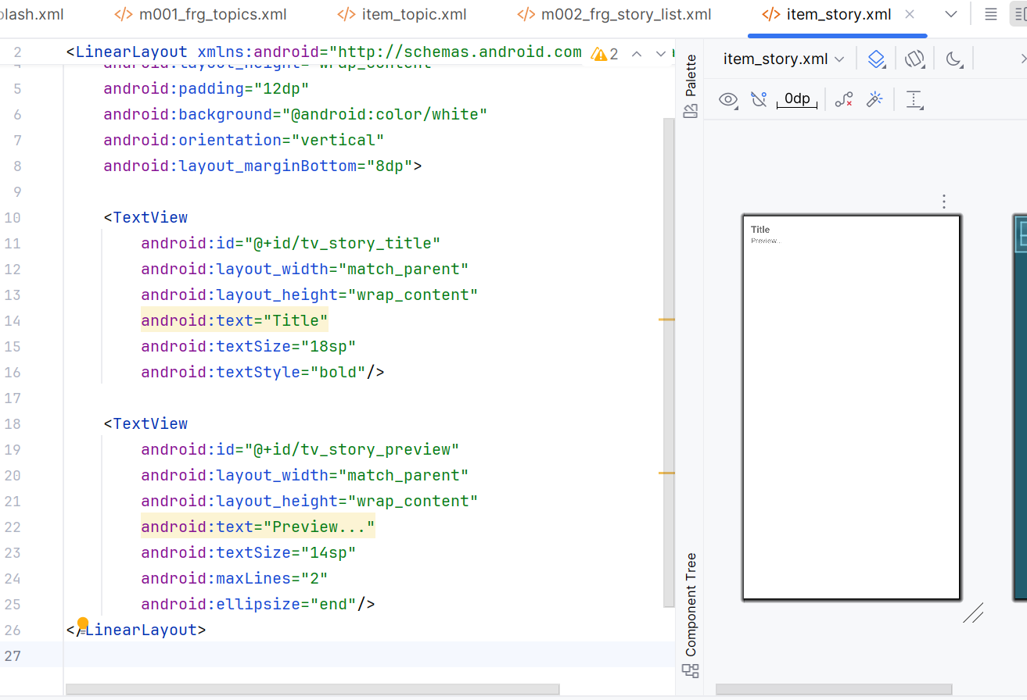

**5) res/layout/m003_frg_detail.xml**

*<?*xml version="1.0" encoding="utf-8"*?>*<LinearLayout xmlns:android="http://schemas.android.com/apk/res/android"  
android:layout_width="match_parent"  
android:layout_height="match_parent"  
android:orientation="vertical"  
android:padding="16dp"  
android:background="@android:color/white">  
<TextView  
 android:id="@+id/tv_story_title"  
 android:layout_width="match_parent"  
 android:layout_height="wrap_content"  
 android:text="Tiêu đề"  
 android:textStyle="bold"  
 android:textSize="20sp"  
 android:textColor="@color/greenMid"  
 android:paddingBottom="8dp"/>  
<ScrollView  
 android:layout_width="match_parent"  
 android:layout_height="0dp"  
 android:layout_weight="1">  
 <TextView  
 android:id="@+id/tv_story_content"  
 android:layout_width="match_parent"  
 android:layout_height="wrap_content"  
 android:text="Nội dung truyện..."  
 android:textSize="16sp"  
 android:lineSpacingExtra="4dp"/>  
</ScrollView>  
<LinearLayout  
 android:layout_width="match_parent"  
 android:layout_height="wrap_content"  
 android:orientation="horizontal"  
 android:paddingTop="8dp">  
 <TextView  
 android:id="@+id/btn_prev"  
 android:layout_width="0dp"  
 android:layout_height="48dp"  
 android:layout_weight="1"  
 android:gravity="center"  
 android:text="@string/btn_prev"  
 android:background="@drawable/bg_radius"  
 android:textColor="@android:color/white"/>  
 <View android:layout_width="12dp" android:layout_height="1dp"/>  
 <TextView  
 android:id="@+id/btn_next"  
 android:layout_width="0dp"  
 android:layout_height="48dp"  
 android:layout_weight="1"  
 android:gravity="center"  
 android:text="@string/btn_next"  
 android:background="@drawable/bg_radius"  
 android:textColor="@android:color/white"/>  
</LinearLayout>  
</LinearLayout>

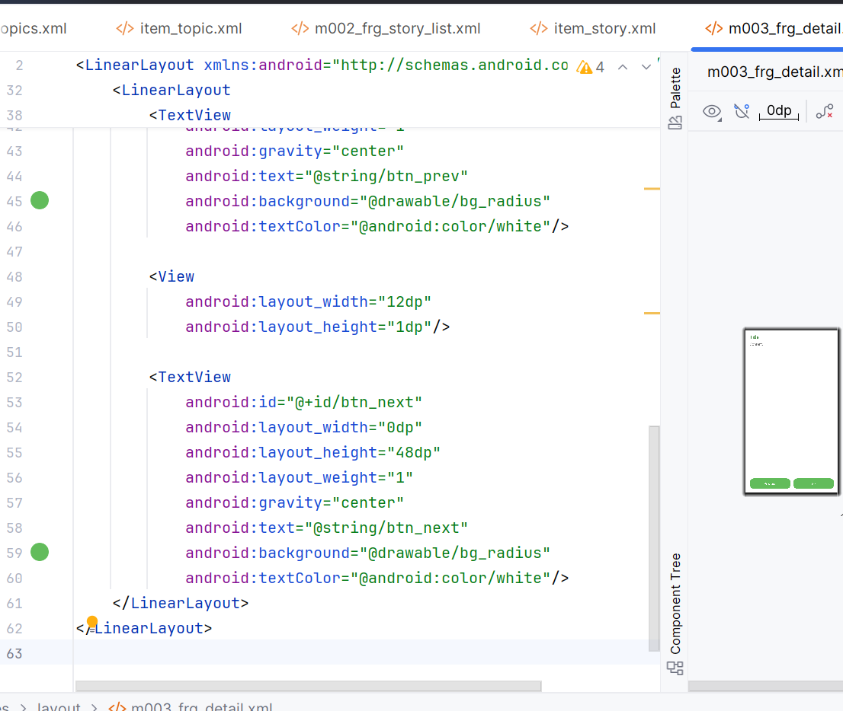

**Drawable bo góc: res/drawable/bg_radius.xml**

*<?*xml version="1.0" encoding="utf-8"*?>*<shape xmlns:android="http://schemas.android.com/apk/res/android">  
<corners android:radius="20dp"/>  
<solid android:color="@color/greenLight"/>  
</shape>

**V. Java code (package com.example.mailab2)**

**1) MainActivity.java**

package com.example.mailab2;  
  
 import android.os.Bundle;  
 import androidx.annotation.NonNull;  
 import androidx.appcompat.app.AppCompatActivity;  
 import androidx.fragment.app.Fragment;  
 import androidx.fragment.app.FragmentTransaction;  
 import java.util.ArrayList;  
  
public class MainActivity extends AppCompatActivity {  
 private ArrayList<StoryEntity> stories;  
 private StoryEntity currentStory;  
  
 @Override protected void onCreate(Bundle savedInstanceState) {  
 super.onCreate(savedInstanceState);  
 setContentView(R.layout.*activity_main*);  
 showFrg(new M000SplashFrg(), false);  
 }  
  
 public void showFrg(@NonNull Fragment frg, boolean addToBackStack) {  
 FragmentTransaction tx = getSupportFragmentManager()  
 .beginTransaction()  
 .replace(R.id.*ln_main*, frg, frg.getClass().getSimpleName());  
 if (addToBackStack) tx.addToBackStack(frg.getClass().getSimpleName());  
 tx.commit();  
 }  
  
 public void gotoM001Screen() { showFrg(new M001TopicListFrg(), false); }  
  
 public void gotoM002Screen(String topicName) {  
 M002StoryListFrg frg = M002StoryListFrg.newInstance(topicName);  
 showFrg(frg, true);  
 }  
  
 public void gotoM003Screen(ArrayList<StoryEntity> listStory, StoryEntity story) {  
 this.stories = listStory;  
 this.currentStory = story;  
 M003StoryDetailFrg frg = M003StoryDetailFrg.newInstance(listStory, story);  
 showFrg(frg, true);  
 }  
  
 public void openStoryAt(int index) {  
 if (stories == null || index < 0 || index >= stories.size()) return;  
 currentStory = stories.get(index);  
 M003StoryDetailFrg frg = M003StoryDetailFrg.newInstance(stories, currentStory);  
 showFrg(frg, false);  
 }  
}

**2) M000SplashFrg.java**

package com.example.mailab2;  
  
import android.app.Activity;  
import android.os.Bundle;  
import android.os.Handler;  
import android.os.Looper;  
import android.view.LayoutInflater;  
import android.view.View;  
import android.view.ViewGroup;  
import androidx.annotation.NonNull;  
import androidx.annotation.Nullable;  
import androidx.fragment.app.Fragment;  
  
public class M000SplashFrg extends Fragment {  
 @Nullable  
 @Override  
 public View onCreateView(@NonNull LayoutInflater inflater, @Nullable ViewGroup container, @Nullable Bundle savedInstanceState) {  
 return inflater.inflate(R.layout.m000_frg_splash, container, false);  
 }  
  
 @Override  
 public void onViewCreated(@NonNull View view, @Nullable Bundle savedInstanceState) {  
 super.onViewCreated(view, savedInstanceState);  
 new Handler(Looper.getMainLooper()).postDelayed(this::gotoM001Screen, 1500);  
 }  
  
 private void gotoM001Screen() {  
 Activity act = getActivity();  
 if (act instanceof MainActivity) ((MainActivity) act).gotoM001Screen();  
 }  
}

**3) Entity & Repo – StoryEntity.java, StoryRepo.java**

package com.example.mailab2;  
  
import android.content.Context;  
import java.util.ArrayList;  
  
public class StoryRepo {  
 public static ArrayList<StoryEntity> getStoriesByTopic(Context ctx, String topic){  
 ArrayList<StoryEntity> ls = new ArrayList<>();  
 if (topic.equals(ctx.getString(R.string.topic_family))) {  
 ls.add(new StoryEntity(1, ctx.getString(R.string.s1_title), ctx.getString(R.string.s1_content)));  
 ls.add(new StoryEntity(2, ctx.getString(R.string.s2_title), ctx.getString(R.string.s2_content)));  
 } else if (topic.equals(ctx.getString(R.string.topic_school))) {  
 ls.add(new StoryEntity(3, ctx.getString(R.string.s3_title), ctx.getString(R.string.s3_content)));  
 } else if (topic.equals(ctx.getString(R.string.topic_work))) {  
 ls.add(new StoryEntity(4, ctx.getString(R.string.s4_title), ctx.getString(R.string.s4_content)));  
 } else {  
 ls.add(new StoryEntity(5, ctx.getString(R.string.s5_title), ctx.getString(R.string.s5_content)));  
 }  
 return ls;  
 }  
}

**4) Topic list – M001TopicListFrg.java + TopicAdapter.java**

package com.example.mailab2;  
  
import android.os.Parcel;  
import android.os.Parcelable;  
  
public class StoryEntity implements Parcelable {  
 public int id; public String title; public String content;  
 public StoryEntity(int id, String title, String content){ this.id=id; this.title=title; this.content=content; }  
 protected StoryEntity(Parcel in){ id=in.readInt(); title=in.readString(); content=in.readString(); }  
 public static final Creator<StoryEntity> *CREATOR*=new Creator<StoryEntity>(){  
 public StoryEntity createFromParcel(Parcel in){ return new StoryEntity(in); }  
 public StoryEntity[] newArray(int size){ return new StoryEntity[size]; }  
 };  
 public int describeContents(){ return 0; }  
 public void writeToParcel(Parcel dest,int flags){ dest.writeInt(id); dest.writeString(title); dest.writeString(content); }  
}  
  
package com.example.mailab2;  
  
import android.os.Bundle;  
import android.view.LayoutInflater;  
import android.view.View;  
import android.view.ViewGroup;  
import androidx.annotation.NonNull;  
import androidx.annotation.Nullable;  
import androidx.fragment.app.Fragment;  
import androidx.recyclerview.widget.DividerItemDecoration;  
import androidx.recyclerview.widget.LinearLayoutManager;  
import androidx.recyclerview.widget.RecyclerView;  
import java.util.Arrays;  
import java.util.List;  
  
public class M001TopicListFrg extends Fragment {  
 @Nullable  
 @Override  
 public View onCreateView(@NonNull LayoutInflater inflater, @Nullable ViewGroup container, @Nullable Bundle savedInstanceState) {  
 return inflater.inflate(R.layout.m001_frg_topics, container, false);  
 }  
  
 @Override  
 public void onViewCreated(@NonNull View v, @Nullable Bundle s) {  
 super.onViewCreated(v, s);  
 RecyclerView rv = v.findViewById(R.id.rv_topics);  
 rv.setLayoutManager(new LinearLayoutManager(getContext()));  
 rv.addItemDecoration(new DividerItemDecoration(getContext(), RecyclerView.VERTICAL));  
 List<String> topics = Arrays.asList(  
 getString(R.string.topic_family),  
 getString(R.string.topic_school),  
 getString(R.string.topic_work),  
 getString(R.string.topic_misc)  
 );  
 rv.setAdapter(new TopicAdapter(topics, topic -> ((MainActivity) requireActivity()).gotoM002Screen(topic)));  
 }  
}  
  
package com.example.mailab2;  
  
import android.view.LayoutInflater;  
import android.view.View;  
import android.view.ViewGroup;  
import android.widget.TextView;  
import androidx.annotation.NonNull;  
import androidx.recyclerview.widget.RecyclerView;  
import java.util.List;  
  
public class TopicAdapter extends RecyclerView.Adapter<TopicAdapter.VH> {  
 public interface OnTopicClick { void onClick(String topic); }  
 private final List<String> data; private final OnTopicClick listener;  
 public TopicAdapter(List<String> data, OnTopicClick listener){ this.data=data; this.listener=listener; }  
  
 @NonNull @Override public VH onCreateViewHolder(@NonNull ViewGroup parent,int viewType){  
 View v= LayoutInflater.from(parent.getContext()).inflate(R.layout.item_topic, parent,false);  
 return new VH(v);  
 }  
 @Override public void onBindViewHolder(@NonNull VH h,int pos){  
 String topic=data.get(pos); h.tv.setText(topic);  
 h.itemView.setOnClickListener(v -> { if (listener!=null) listener.onClick(topic); });  
 }  
 @Override public int getItemCount(){ return data.size(); }  
 static class VH extends RecyclerView.ViewHolder{  
 TextView tv; VH(@NonNull View itemView){ super(itemView); tv=itemView.findViewById(R.id.tv_topic); }  
 }  
}

**5) Story list – M002StoryListFrg.java + StoryAdapter.java**

package com.example.mailab2;  
  
import android.os.Bundle;  
import android.view.LayoutInflater;  
import android.view.View;  
import android.view.ViewGroup;  
import android.widget.TextView;  
import androidx.annotation.NonNull;  
import androidx.annotation.Nullable;  
import androidx.fragment.app.Fragment;  
import androidx.recyclerview.widget.LinearLayoutManager;  
import androidx.recyclerview.widget.RecyclerView;  
import java.util.ArrayList;  
  
public class M002StoryListFrg extends Fragment {  
 private static final String *ARG_TOPIC* = "arg_topic";  
 public static M002StoryListFrg newInstance(String topic){  
 Bundle b=new Bundle(); b.putString(*ARG_TOPIC*, topic);  
 M002StoryListFrg f=new M002StoryListFrg(); f.setArguments(b); return f;  
 }  
 @Nullable @Override  
 public View onCreateView(@NonNull LayoutInflater inflater,@Nullable ViewGroup container,@Nullable Bundle s){  
 return inflater.inflate(R.layout.m002_frg_story_list, container,false);  
 }  
 @Override public void onViewCreated(@NonNull View v,@Nullable Bundle s){  
 super.onViewCreated(v,s);  
 String topic=getArguments()!=null?getArguments().getString(*ARG_TOPIC*):"";  
 ((TextView)v.findViewById(R.id.tv_topic_header)).setText(getString(R.string.txt_stories_of, topic));  
 RecyclerView rv=v.findViewById(R.id.rv_stories);  
 rv.setLayoutManager(new LinearLayoutManager(getContext()));  
 ArrayList<StoryEntity> list=StoryRepo.getStoriesByTopic(getContext(), topic);  
 rv.setAdapter(new StoryAdapter(list,(story,pos)->((MainActivity)requireActivity()).gotoM003Screen(list, story)));  
 }  
}  
  
package com.example.mailab2;  
  
import android.view.LayoutInflater;  
import android.view.View;  
import android.view.ViewGroup;  
import android.widget.TextView;  
import androidx.annotation.NonNull;  
import androidx.recyclerview.widget.RecyclerView;  
import java.util.ArrayList;  
  
public class StoryAdapter extends RecyclerView.Adapter<StoryAdapter.VH> {  
 public interface OnStoryClick { void onClick(StoryEntity story,int position); }  
 private final ArrayList<StoryEntity> data; private final OnStoryClick listener;  
 public StoryAdapter(ArrayList<StoryEntity> data, OnStoryClick listener){ this.data=data; this.listener=listener; }  
  
 @NonNull @Override public VH onCreateViewHolder(@NonNull ViewGroup parent,int viewType){  
 View v= LayoutInflater.from(parent.getContext()).inflate(R.layout.item_story,parent,false);  
 return new VH(v);  
 }  
 @Override public void onBindViewHolder(@NonNull VH h,int pos){  
 StoryEntity s=data.get(pos);  
 h.tvTitle.setText(s.title);  
 String preview=s.content.length()>80?s.content.substring(0,80)+"...":s.content;  
 h.tvPreview.setText(preview);  
 h.itemView.setOnClickListener(v->{ if(listener!=null) listener.onClick(s,h.getBindingAdapterPosition()); });  
 }  
 @Override public int getItemCount(){ return data.size(); }  
 static class VH extends RecyclerView.ViewHolder{  
 TextView tvTitle,tvPreview; VH(@NonNull View itemView){  
 super(itemView); tvTitle=itemView.findViewById(R.id.tv_story_title); tvPreview=itemView.findViewById(R.id.tv_story_preview); }  
 }  
}

**6) Detail – M003StoryDetailFrg.java (vuốt trái/phải)**  
package com.example.mailab2;  
  
import android.os.Bundle;  
import android.view.GestureDetector;  
import android.view.LayoutInflater;  
import android.view.MotionEvent;  
import android.view.View;  
import android.view.ViewGroup;  
import android.widget.TextView;  
import androidx.annotation.NonNull;  
import androidx.annotation.Nullable;  
import androidx.fragment.app.Fragment;  
import java.util.ArrayList;  
  
public class M003StoryDetailFrg extends Fragment {  
 private static final String *ARG_LIST* = "arg_list";  
 private static final String *ARG_CURR* = "arg_curr";  
 private ArrayList<StoryEntity> list; private StoryEntity current; private int currentIndex;  
  
 public static M003StoryDetailFrg newInstance(ArrayList<StoryEntity> list, StoryEntity current){  
 Bundle b=new Bundle(); b.putParcelableArrayList(*ARG_LIST*, list); b.putParcelable(*ARG_CURR*, current);  
 M003StoryDetailFrg f=new M003StoryDetailFrg(); f.setArguments(b); return f;  
 }  
  
 @Nullable @Override public View onCreateView(@NonNull LayoutInflater inflater,@Nullable ViewGroup container,@Nullable Bundle s){  
 return inflater.inflate(R.layout.m003_frg_detail, container,false);  
 }  
  
 @Override public void onViewCreated(@NonNull View v,@Nullable Bundle s){  
 super.onViewCreated(v,s);  
 list=getArguments().getParcelableArrayList(*ARG_LIST*);  
 current=getArguments().getParcelable(*ARG_CURR*);  
 currentIndex=0; for(int i=0;i<list.size();i++) if(list.get(i).id==current.id){ currentIndex=i; break; }  
 TextView tvTitle=v.findViewById(R.id.tv_story_title);  
 TextView tvContent=v.findViewById(R.id.tv_story_content);  
 tvTitle.setText(current.title); tvContent.setText(current.content);  
 v.findViewById(R.id.btn_prev).setOnClickListener(view->goPrev());  
 v.findViewById(R.id.btn_next).setOnClickListener(view->goNext());  
  
 GestureDetector detector=new GestureDetector(getContext(), new GestureDetector.SimpleOnGestureListener(){  
 private static final int *SWIPE_THRESHOLD*=120, *SWIPE_VELOCITY_THRESHOLD*=120;  
 @Override public boolean onFling(MotionEvent e1, MotionEvent e2,float vX,float vY){  
 float dx=e2.getX()-e1.getX();  
 if (Math.*abs*(dx)>Math.abs(e2.getY()-e1.getY())){  
 if (Math.*abs*(dx)>*SWIPE_THRESHOLD* && Math.*abs*(vX)>*SWIPE_VELOCITY_THRESHOLD*){  
 if (dx<0) goNext(); else goPrev(); return true;  
 }  
 }  
 return false;  
 }  
 });  
 v.setOnTouchListener((vv,ev)->detector.onTouchEvent(ev));  
 }  
  
 private void goPrev(){ if(currentIndex<=0) return; currentIndex--; ((MainActivity)requireActivity()).openStoryAt(currentIndex); }  
 private void goNext(){ if(list==null) return; if(currentIndex>=list.size()-1) return; currentIndex++; ((MainActivity)requireActivity()).openStoryAt(currentIndex); }  
}

## Tạo giao diện login

**A. TẠO PROJECT MỚI**

1. Mở Android Studio → New Project

2. Chọn Empty Views Activity

3. Đặt tên:

- Package name: com.example.lab4ui

- Language: Java

- Minimum SDK: API 24 (Android 7.0)

- Build configuration: Dùng Java 11

4. Bấm Finish

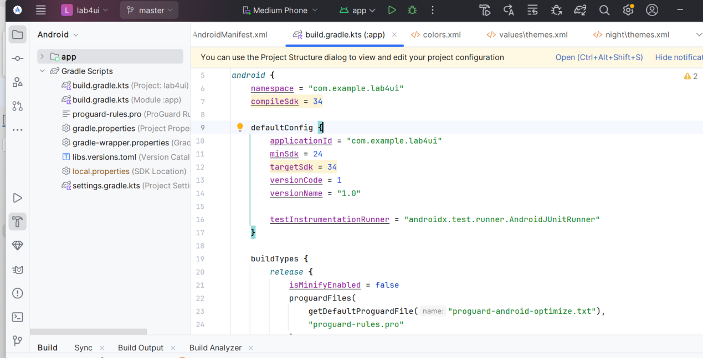

**A1. TẮT ACTIONBAR**

Mở file: res/values/themes.xml

<style name="Theme.Lab4UI" parent="Theme.Material3.Light.NoActionBar">  
</style>

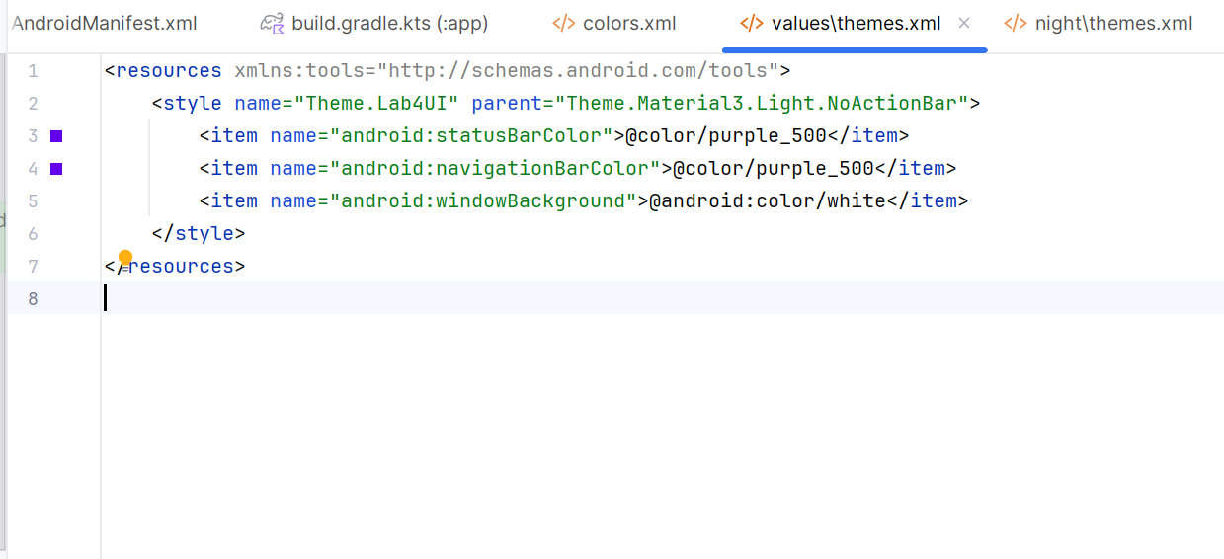

Rồi vào AndroidManifest.xml, sửa theme của ứng dụng:

<application  
android:theme="@style/Theme.Lab4UI" >

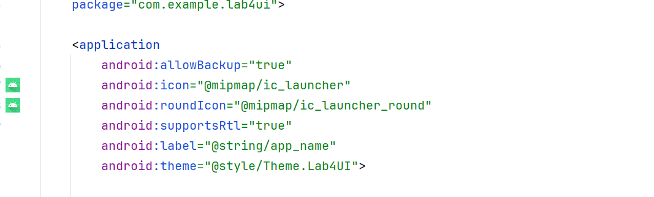

Giờ giao diện sẽ không còn thanh ActionBar mặc định nữa.

**B. LUYỆN TẬP 1 – MÀN HÌNH LOGIN + TOAST XỊN**

**B1. THÊM MÀU & CHUỖI VĂN BẢN**

res/values/colors.xml  
<color name="black">#FF000000</color>  
<color name="white">#FFFFFFFF</color>  
<color name="gray">#EAE5E3</color>  
<color name="orange">#FB8C00</color>  
<color name="orangeMid">#F4511E</color>

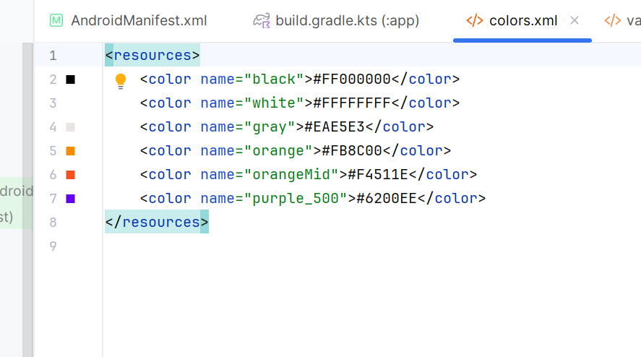

res/values/strings.xml

<string name="app_name">Lab4UI</string>  
<string name="txt_login">Login</string>  
<string name="hint_email">Email</string>  
<string name="hint_password">Password</string>  
<string name="txt_forgot_pass">Forgot password?</string>  
<string name="txt_no_account">Don't have an account?</string>  
<string name="txt_register">Register</string>

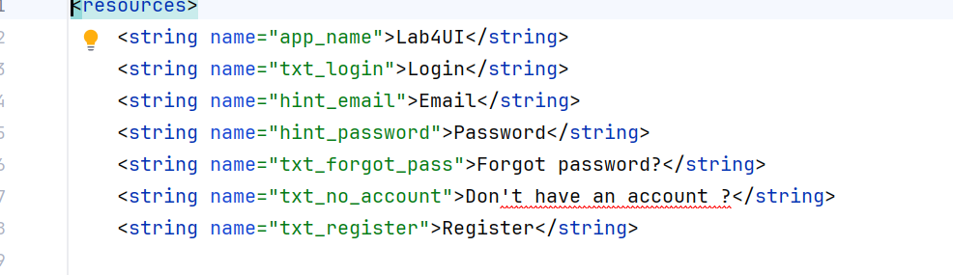

**B2. TẠO HÌNH NỀN & BO GÓC**

Tạo 3 file trong res/drawable/:

bg_rect.png

Dùng 1 ảnh nền mờ (có thể để trống hoặc dùng ảnh nhạt).

bg_radius.xml – Ô nhập liệu bo tròn

*<?*xml version="1.0" encoding="utf-8"*?>*<layer-list xmlns:android="http://schemas.android.com/apk/res/android">  
<item android:drawable="@drawable/bg_rect" />  
<item android:bottom="3dp">  
 <shape>  
 <corners android:radius="20dp" />  
 <solid android:color="#ffffff" />  
 </shape>  
</item>  
</layer-list>

bg_login.xml – Nút Login đẹp

*<?*xml version="1.0" encoding="utf-8"*?>*<layer-list xmlns:android="http://schemas.android.com/apk/res/android">  
<item android:drawable="@drawable/bg_rect" />  
<item android:bottom="3dp">  
 <shape>  
 <corners android:radius="20dp" />  
 <gradient  
 android:angle="180"  
 android:startColor="@color/orangeMid"  
 android:endColor="@color/orange"/>  
 </shape>  
</item>  
</layer-list>

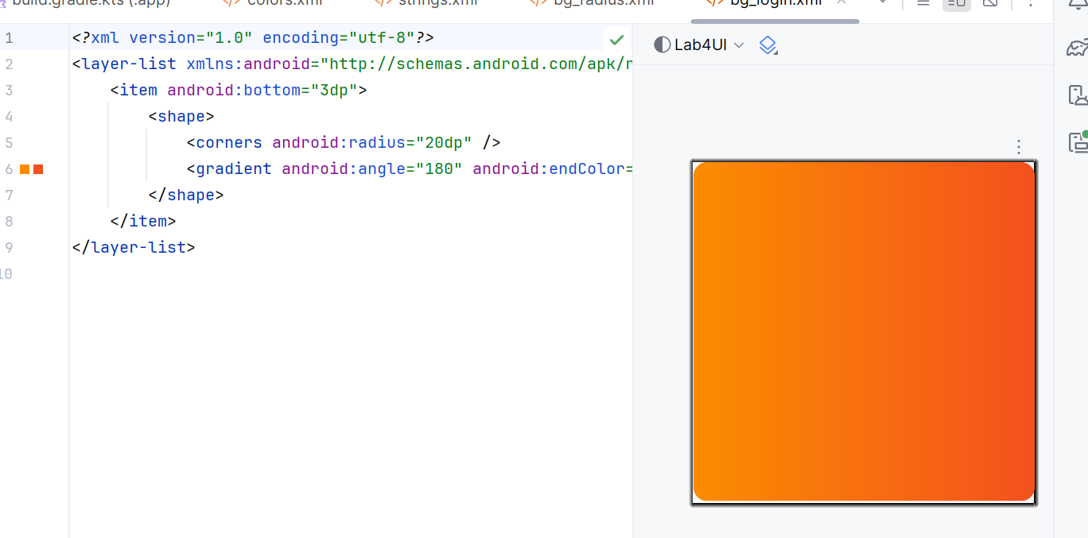

bg_top.xml – Phần đầu cong cong

*<?*xml version="1.0" encoding="utf-8"*?>*<shape xmlns:android="http://schemas.android.com/apk/res/android">  
<corners android:bottomLeftRadius="100dp" />  
<gradient  
 android:angle="145"  
 android:startColor="@color/orangeMid"  
 android:endColor="@color/orange"/>  
</shape>

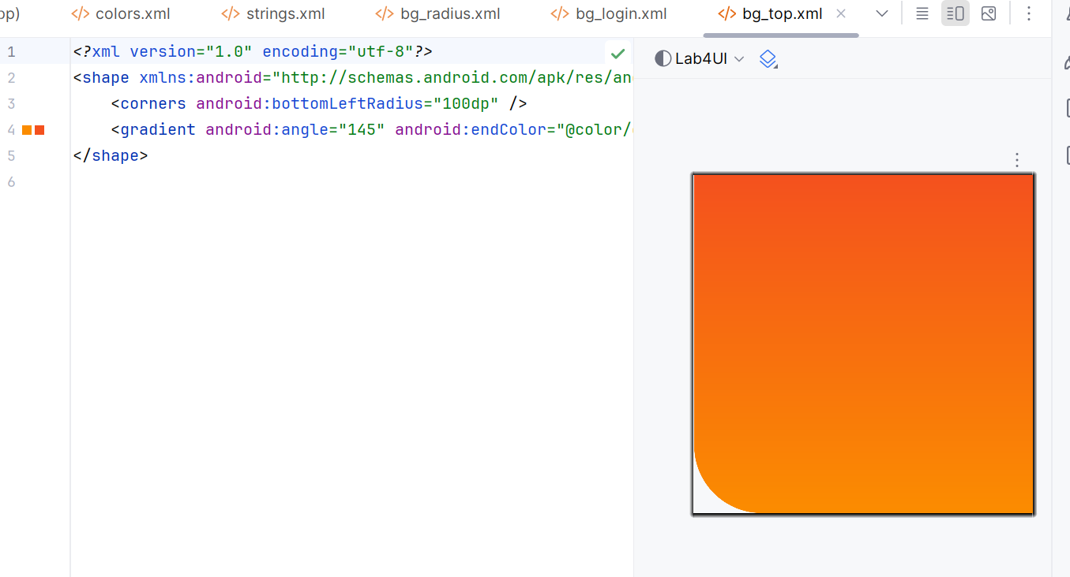

**B3. THÊM ICON VECTOR**

Vào Android Studio:

Right-click drawable → New → Vector Asset

→ Tìm:

- mail → Lưu thành ic_mail.xml

- vpn_key (hoặc key) → Lưu thành ic_key.xml

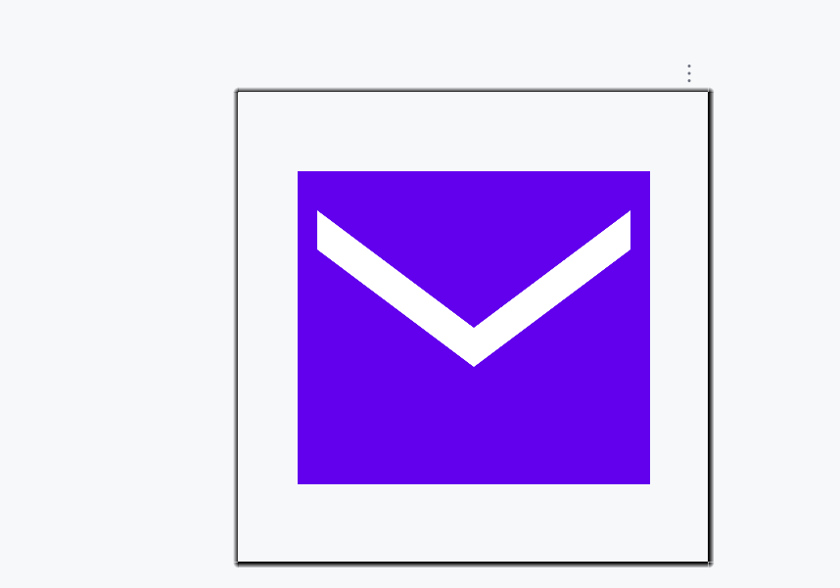

**B4. THIẾT KẾ GIAO DIỆN LOGIN**

Tạo file: res/layout/m001_act_login.xml

*<?*xml version="1.0" encoding="utf-8"*?>*<LinearLayout xmlns:android="http://schemas.android.com/apk/res/android"  
android:layout_width="match_parent"  
android:layout_height="match_parent"  
android:orientation="vertical"  
android:background="@color/gray">  
  
<FrameLayout  
 android:layout_width="match_parent"  
 android:layout_height="wrap_content">  
  
 <View  
 android:layout_width="match_parent"  
 android:layout_height="300dp"  
 android:background="@drawable/bg_top"/>  
  
 <TextView  
 android:layout_width="wrap_content"  
 android:layout_height="wrap_content"  
 android:layout_gravity="end"  
 android:layout_marginTop="220dp"  
 android:layout_marginEnd="30dp"  
 android:text="@string/txt_login"  
 android:textColor="@color/white"  
 android:textSize="20sp"/>  
</FrameLayout>  
  
<EditText  
 android:id="@+id/edtEmail"  
 android:layout_width="match_parent"  
 android:layout_height="50dp"  
 android:layout_marginHorizontal="30dp"  
 android:layout_marginTop="50dp"  
 android:layout_marginBottom="3dp"  
 android:background="@drawable/bg_radius"  
 android:drawableStart="@drawable/ic_mail"  
 android:drawablePadding="10dp"  
 android:hint="@string/hint_email"  
 android:padding="10dp"  
 android:inputType="textEmailAddress"  
 android:textSize="18sp"/>  
  
<EditText  
 android:id="@+id/edtPass"  
 android:layout_width="match_parent"  
 android:layout_height="50dp"  
 android:layout_marginHorizontal="30dp"  
 android:layout_marginTop="20dp"  
 android:layout_marginBottom="3dp"  
 android:background="@drawable/bg_radius"  
 android:drawableStart="@drawable/ic_key"  
 android:drawablePadding="10dp"  
 android:hint="@string/hint_password"  
 android:padding="10dp"  
 android:inputType="textPassword"  
 android:textSize="18sp"/>  
  
<TextView  
 android:layout_width="wrap_content"  
 android:layout_height="wrap_content"  
 android:layout_gravity="end"  
 android:layout_marginTop="10dp"  
 android:layout_marginEnd="30dp"  
 android:text="@string/txt_forgot_pass"  
 android:textColor="@color/black"  
 android:textSize="18sp"/>  
  
<TextView  
 android:id="@+id/btnLogin"  
 android:layout_width="match_parent"  
 android:layout_height="50dp"  
 android:layout_marginHorizontal="30dp"  
 android:layout_marginTop="50dp"  
 android:background="@drawable/bg_login"  
 android:gravity="center"  
 android:text="@string/txt_login"  
 android:textColor="@color/white"  
 android:textSize="18sp"/>  
  
<TableRow  
 android:layout_width="match_parent"  
 android:layout_height="wrap_content"  
 android:layout_marginTop="50dp"  
 android:gravity="center">  
  
 <TextView  
 android:layout_width="wrap_content"  
 android:layout_height="wrap_content"  
 android:text="@string/txt_no_account"  
 android:textColor="@color/black"  
 android:textSize="14sp"/>  
  
 <TextView  
 android:layout_width="wrap_content"  
 android:layout_height="wrap_content"  
 android:layout_marginStart="6dp"  
 android:text="@string/txt_register"  
 android:textColor="@color/orange"  
 android:textSize="14sp"  
 android:textStyle="bold"/>  
</TableRow>  
</LinearLayout>

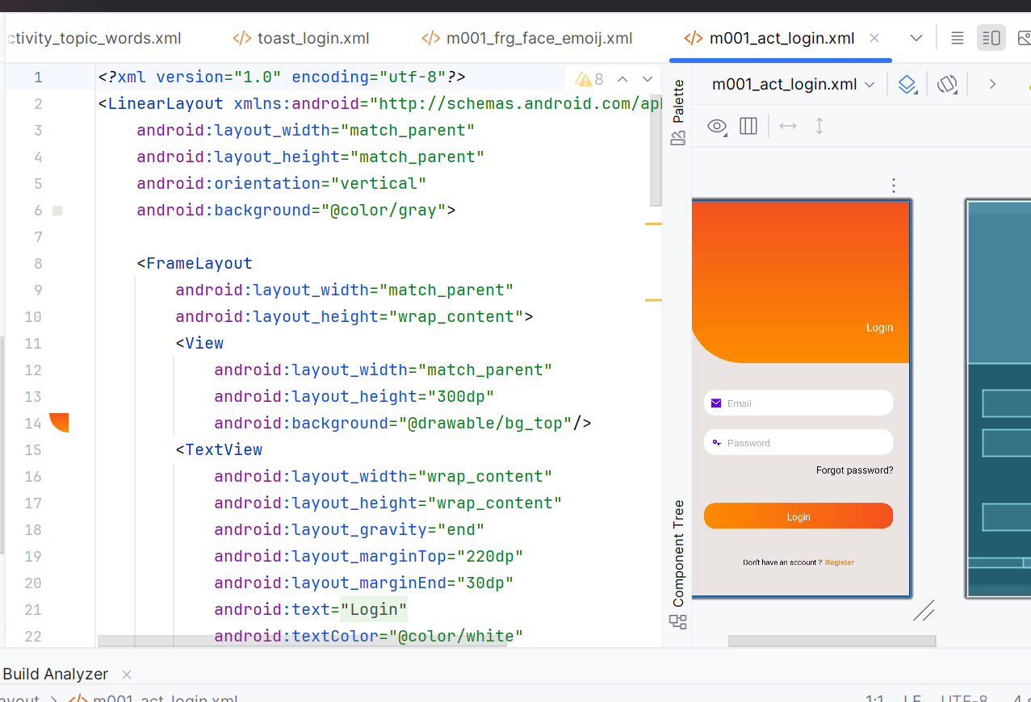

**B5. TẠO CUSTOM TOAST KHI ĐĂNG NHẬP**

Tạo layout Toast: res/layout/toast_login.xml

*<?*xml version="1.0" encoding="utf-8"*?>*<LinearLayout xmlns:android="http://schemas.android.com/apk/res/android"  
 android:orientation="horizontal"  
 android:padding="12dp"  
 android:background="@drawable/bg_radius"  
 android:layout_width="wrap_content"  
 android:layout_height="wrap_content">  
 <ImageView  
 android:layout_width="24dp"  
 android:layout_height="24dp"  
 android:src="@drawable/ic_key"/>  
 <TextView  
 android:id="@+id/tvToast"  
 android:layout_width="wrap_content"  
 android:layout_height="wrap_content"  
 android:layout_marginStart="8dp"  
 android:textColor="@color/black"  
 android:textSize="14sp"/>  
</LinearLayout>

Tạo Activity: LoginActivity.java

package com.example.lab4ui;  
  
import android.content.Intent;  
import android.os.Bundle;  
import android.view.Gravity;  
import android.view.LayoutInflater;  
import android.view.View;  
import android.widget.EditText;  
import android.widget.TextView;  
import android.widget.Toast;  
  
import androidx.appcompat.app.AppCompatActivity;  
  
public class LoginActivity extends AppCompatActivity {  
 private EditText edtEmail, edtPass;  
  
 @Override  
 protected void onCreate(Bundle savedInstanceState) {  
 super.onCreate(savedInstanceState);  
 setContentView(R.layout.*m001_act_login*);  
 edtEmail = findViewById(R.id.*edtEmail*);  
 edtPass = findViewById(R.id.*edtPass*);  
 findViewById(R.id.*btnLogin*).setOnClickListener(v -> showLoginToast());  
 }  
  
 private void showLoginToast() {  
 String email = edtEmail.getText().toString().trim();  
 String pass = edtPass.getText().toString().trim();  
 View toastView = LayoutInflater.*from*(this).inflate(R.layout.*toast_login*, null, false);  
 TextView tv = toastView.findViewById(R.id.*tvToast*);  
 tv.setText("Bạn đã đăng nhập thành công với email: " + email + " và mật khẩu: " + pass);  
  
 Toast t = new Toast(this);  
 t.setView(toastView);  
 t.setDuration(Toast.*LENGTH_SHORT*);  
 t.setGravity(Gravity.*BOTTOM*, 0, 120);  
 t.show();  
  
 startActivity(new Intent(this, HomeActivity.class));  
  
 }  
}

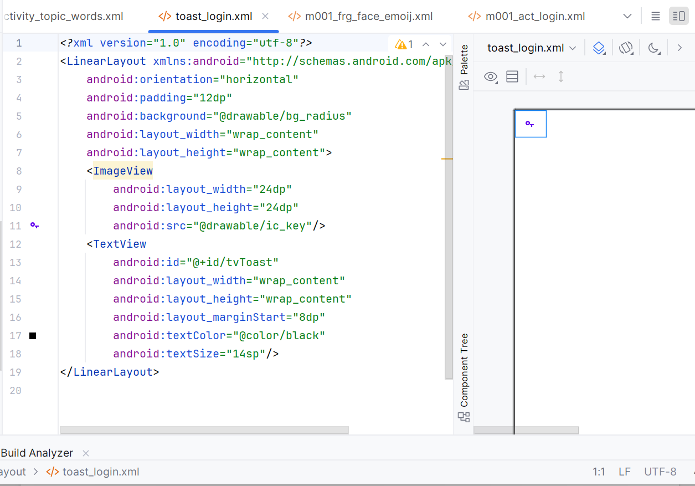

Khai báo trong AndroidManifest.xml

<activity  
 android:name=".LoginActivity"  
 android:exported="true">  
 <intent-filter>  
 <action android:name="android.intent.action.MAIN" />  
 <category android:name="android.intent.category.LAUNCHER" />  
 </intent-filter>  
</activity>

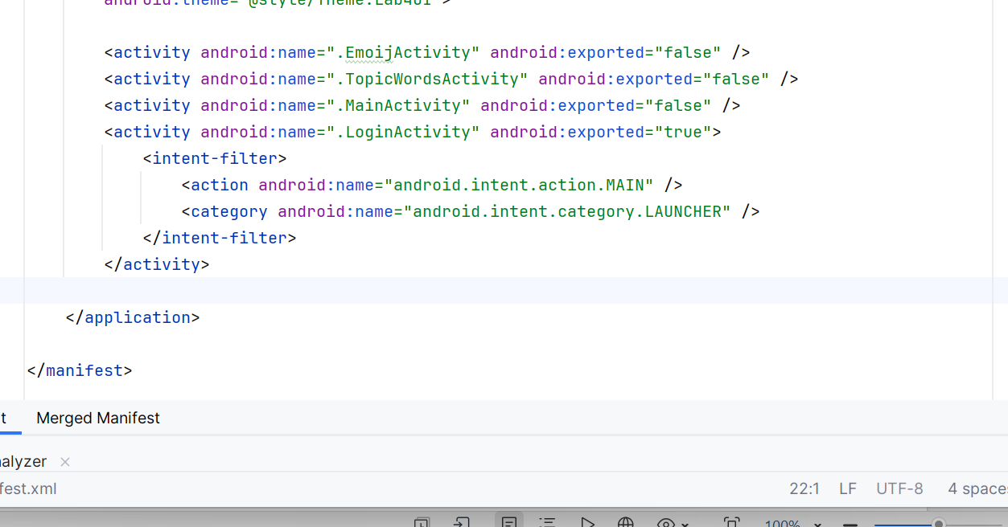

**C. LUYỆN TẬP 2 – MENU CHỦ ĐỀ + LISTVIEW TỪ VỰNG**

**C1. THÊM CHUỖI CHỦ ĐỀ**

Thêm vào strings.xml:

<string name="txt_mess">Essentials</string>  
<string name="txt_flight">While Traveling</string>  
<string name="txt_hospital">Help / Medical</string>  
<string name="txt_hotel">At the hotel</string>  
<string name="txt_restaurant">At the Restaurant</string>  
<string name="txt_coctail">At the Bar</string>  
<string name="txt_store">At the Store</string>  
<string name="txt_work">Work</string>  
<string name="txt_time">Time</string>  
<string name="txt_education">Education</string>  
<string name="txt_movie">Entertainment</string>

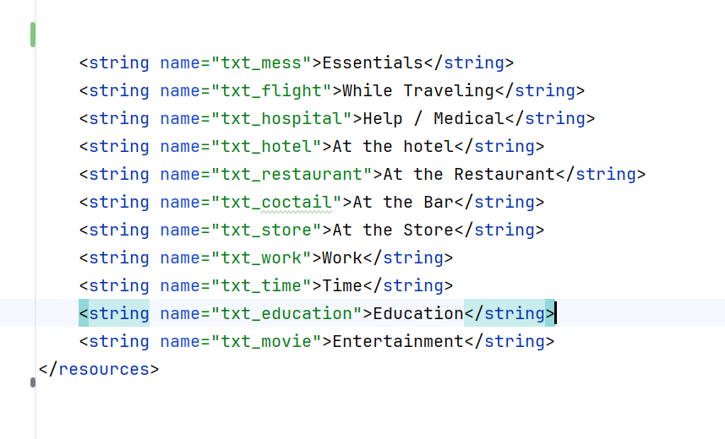

**C2. LAYOUT ITEM & ACTIONBAR**

item_topic.xml

*<?*xml version="1.0" encoding="utf-8"*?>*<LinearLayout xmlns:android="http://schemas.android.com/apk/res/android"  
 xmlns:tools="http://schemas.android.com/tools"  
 android:layout_width="match_parent"  
 android:layout_height="72dp"  
 android:orientation="horizontal"  
 android:paddingHorizontal="10dp"  
 android:gravity="center_vertical">  
  
 <ImageView  
 android:id="@+id/iv_topic"  
 android:layout_width="64dp"  
 android:layout_height="64dp"  
 android:src="@mipmap/ic_launcher"  
 tools:ignore="ContentDescription" />  
  
 <TextView  
 android:id="@+id/tv_topic"  
 android:layout_width="match_parent"  
 android:layout_height="wrap_content"  
 android:layout_marginStart="10dp"  
 android:text="Topic"  
 android:textColor="@color/black"  
 android:textSize="18sp" />  
</LinearLayout>

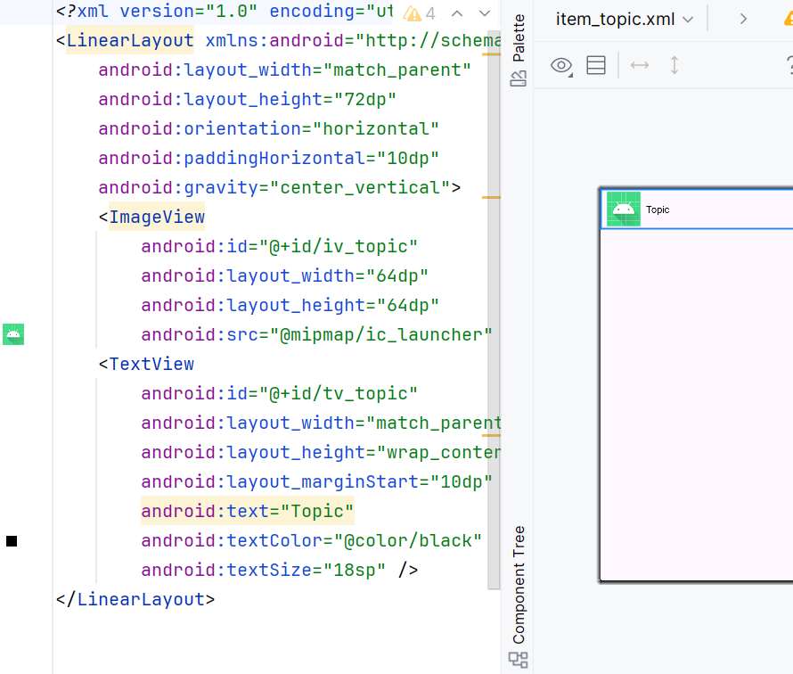

actionbar_home.xml

*<?*xml version="1.0" encoding="utf-8"*?>*<LinearLayout xmlns:android="http://schemas.android.com/apk/res/android"  
android:layout_width="match_parent"  
android:layout_height="56dp"  
android:background="@color/purple_500"  
android:orientation="horizontal"  
android:gravity="center_vertical"  
android:paddingHorizontal="10dp">  
  
<TextView  
 android:layout_width="0dp"  
 android:layout_height="match_parent"  
 android:layout_weight="1"  
 android:gravity="center_vertical"  
 android:text="@string/app_name"  
 android:textColor="@color/white"  
 android:textSize="22sp" />  
</LinearLayout>

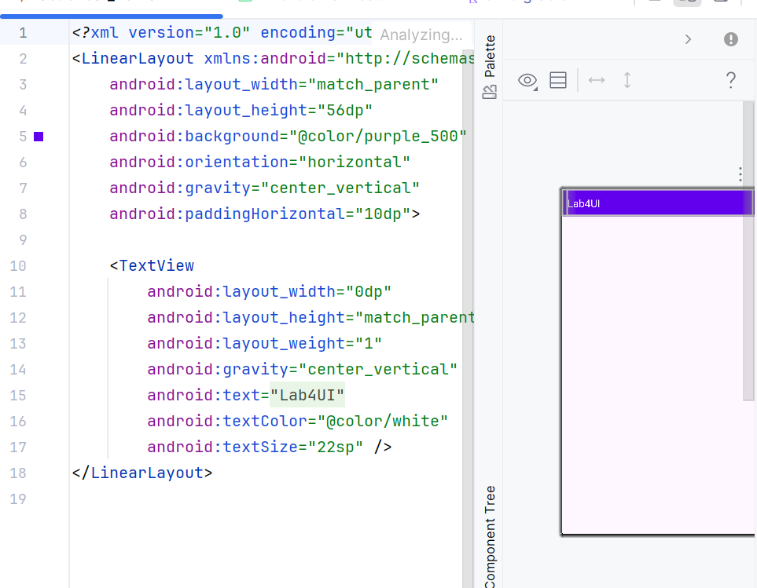

activity_main.xml

*<?*xml version="1.0" encoding="utf-8"*?>*<LinearLayout xmlns:android="http://schemas.android.com/apk/res/android"  
 android:orientation="vertical"  
 android:layout_width="match_parent"  
 android:layout_height="match_parent">  
  
 <include layout="@layout/actionbar_home" />  
  
 <LinearLayout  
 android:id="@+id/ln_main"  
 android:layout_width="match_parent"  
 android:layout_height="match_parent"  
 android:padding="10dp"  
 android:orientation="vertical"/>  
</LinearLayout>

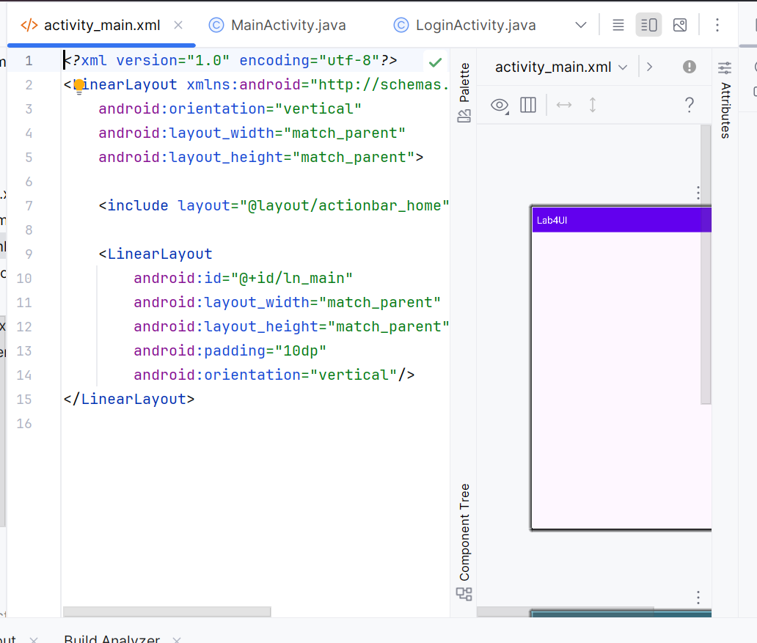

**C3. TẠO DANH SÁCH CHỦ ĐỀ ĐỘNG**

MainActivity.java

package com.example.lab4ui;  
  
import android.content.Intent;  
import android.os.Bundle;  
import android.view.LayoutInflater;  
import android.view.View;  
import android.widget.LinearLayout;  
import android.widget.TextView;  
import android.widget.Toast;  
import androidx.appcompat.app.AppCompatActivity;  
  
public class MainActivity extends AppCompatActivity {  
 private static final int[] *ID_TEXTS* = {  
 R.string.*txt_mess*, R.string.*txt_flight*, R.string.*txt_hospital*,  
 R.string.*txt_hotel*, R.string.*txt_restaurant*, R.string.*txt_coctail*,  
 R.string.*txt_store*, R.string.*txt_work*, R.string.*txt_time*,  
 R.string.*txt_education*, R.string.*txt_movie* };  
  
 @Override  
 protected void onCreate(Bundle savedInstanceState) {  
 super.onCreate(savedInstanceState);  
 setContentView(R.layout.*activity_main*);  
 initView();  
 }  
  
 private void initView() {  
 LinearLayout lnMain = findViewById(R.id.*ln_main*);  
 lnMain.removeAllViews();  
  
 for (int i = 0; i < *ID_TEXTS*.length; i++) {  
 final int index = i;  
 View v = LayoutInflater.*from*(this).inflate(R.layout.*item_topic*, lnMain, false);  
 TextView tvTopic = v.findViewById(R.id.*tv_topic*);  
 tvTopic.setText(*ID_TEXTS*[i]);  
  
 v.setOnClickListener(view -> {  
 Toast.*makeText*(this, sampleWords(index), Toast.*LENGTH_SHORT*).show();  
 Intent it = new Intent(this, TopicWordsActivity.class);  
 it.putExtra("topicIndex", index);  
 startActivity(it);  
 });  
  
 lnMain.addView(v);  
 }  
 }  
  
 private String sampleWords(int idx) {  
 String[][] data = *sampleData*();  
 int n = Math.*min*(3, data[idx].length);  
 StringBuilder sb = new StringBuilder("Từ vựng: ");  
 for (int i = 0; i < n; i++) {  
 if (i > 0) sb.append(", ");  
 sb.append(data[idx][i]);  
 }  
 return sb.toString();  
 }  
  
 public static String[][] sampleData() {  
 return new String[][] {  
 {"hello","thanks","sorry"},  
 {"ticket","passport","luggage"},  
 {"doctor","medicine","clinic"},  
 {"reception","room","key"},  
 {"menu","bill","waiter"},  
 {"cocktail","wine","beer"},  
 {"price","discount","cashier"},  
 {"office","meeting","deadline"},  
 {"hour","minute","second"},  
 {"school","teacher","student"},  
 {"movie","cinema","actor"}  
 };  
 }  
}

activity_topic_words.xml

*<?*xml version="1.0" encoding="utf-8"*?>*<LinearLayout xmlns:android="http://schemas.android.com/apk/res/android"  
 android:layout_width="match_parent"  
 android:layout_height="match_parent"  
 android:orientation="vertical"  
 android:padding="10dp">  
  
 <ListView  
 android:id="@+id/lvWords"  
 android:layout_width="match_parent"  
 android:layout_height="match_parent"/>  
</LinearLayout>

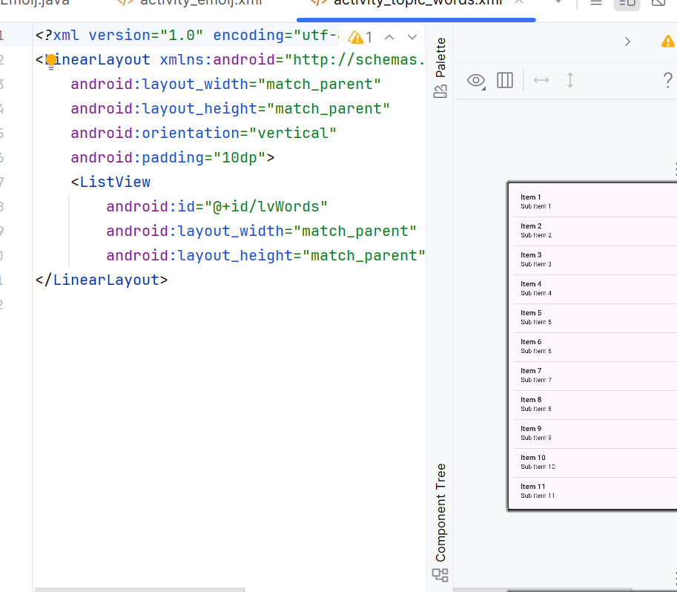

TopicWordsActivity.java

package com.example.lab4ui;  
  
import android.os.Bundle;  
import android.widget.ArrayAdapter;  
import android.widget.ListView;  
import androidx.appcompat.app.AppCompatActivity;  
  
public class TopicWordsActivity extends AppCompatActivity {  
 @Override  
 protected void onCreate(Bundle savedInstanceState) {  
 super.onCreate(savedInstanceState);  
 setContentView(R.layout.*activity_topic_words*);  
  
 int topicIndex = getIntent().getIntExtra("topicIndex", 0);  
 String[][] data = MainActivity.*sampleData*();  
  
 ListView lv = findViewById(R.id.*lvWords*);  
 lv.setAdapter(new ArrayAdapter<>(this,  
 android.R.layout.*simple_list_item_1*, data[topicIndex]));  
 }  
}

Thêm vào AndroidManifest.xml

<activity android:name=".TopicWordsActivity" android:exported="false"/>

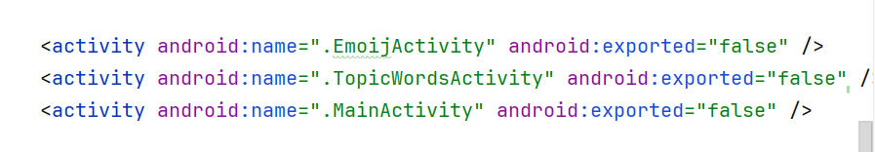

KẾT QUẢ

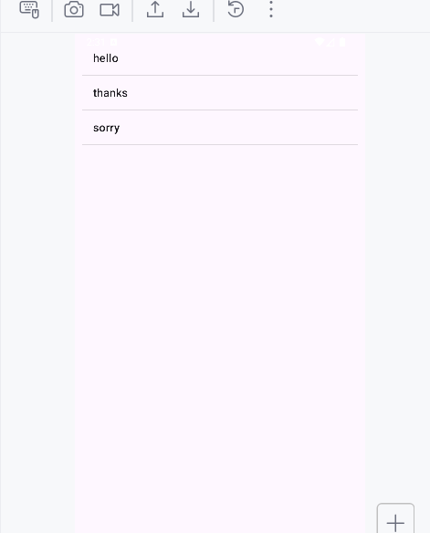

## LUYỆN TẬP 3 – EMOJI VUI NHỘN (DÙNG FRAGMENT)

**1. CHUẨN BỊ ICON**

Tải 9 icon PNG:

ic_angry.png, ic_baffle.png, ..., ic_tire.png

→ Đặt vào res/drawable/

**2. LAYOUT FRAGMENT**

m001_frg_face_emoij.xml

*<?*xml version="1.0" encoding="utf-8"*?>*<FrameLayout xmlns:android="http://schemas.android.com/apk/res/android"  
 android:layout_width="match_parent"  
 android:layout_height="match_parent">  
  
 <LinearLayout  
 android:layout_width="match_parent"  
 android:layout_height="match_parent"  
 android:orientation="vertical"  
 android:padding="10dp">  
  
 <LinearLayout  
 android:layout_width="match_parent"  
 android:layout_height="wrap_content"  
 android:gravity="center">  
  
 <ImageView android:id="@+id/iv_face1"  
 android:layout_width="100dp" android:layout_height="100dp"  
 android:background="@drawable/bg_radius" android:padding="10dp"  
 android:src="@drawable/ic_angry"/>  
 <ImageView android:id="@+id/iv_face2"  
 android:layout_width="100dp" android:layout_height="100dp"  
 android:layout_marginStart="10dp"  
 android:background="@drawable/bg_radius" android:padding="10dp"  
 android:src="@drawable/ic_baffle"/>  
 <ImageView android:id="@+id/iv_face3"  
 android:layout_width="100dp" android:layout_height="100dp"  
 android:layout_marginStart="10dp"  
 android:background="@drawable/bg_radius" android:padding="10dp"  
 android:src="@drawable/ic_beauty"/>  
 </LinearLayout>  
  
 <LinearLayout  
 android:layout_width="match_parent"  
 android:layout_height="wrap_content"  
 android:layout_marginTop="10dp"  
 android:gravity="center">  
  
 <ImageView android:id="@+id/iv_face4"  
 android:layout_width="100dp" android:layout_height="100dp"  
 android:background="@drawable/bg_radius" android:padding="10dp"  
 android:src="@drawable/ic_boss"/>  
 <ImageView android:id="@+id/iv_face5"  
 android:layout_width="100dp" android:layout_height="100dp"  
 android:layout_marginStart="10dp"  
 android:background="@drawable/bg_radius" android:padding="10dp"  
 android:src="@drawable/ic_choler"/>  
 <ImageView android:id="@+id/iv_face6"  
 android:layout_width="100dp" android:layout_height="100dp"  
 android:layout_marginStart="10dp"  
 android:background="@drawable/bg_radius" android:padding="10dp"  
 android:src="@drawable/ic_dribble"/>  
 </LinearLayout>  
  
 <LinearLayout  
 android:layout_width="match_parent"  
 android:layout_height="wrap_content"  
 android:layout_marginTop="10dp"  
 android:gravity="center">  
  
 <ImageView android:id="@+id/iv_face7"  
 android:layout_width="100dp" android:layout_height="100dp"  
 android:background="@drawable/bg_radius" android:padding="10dp"  
 android:src="@drawable/ic_look_down"/>  
 <ImageView android:id="@+id/iv_face8"  
 android:layout_width="100dp" android:layout_height="100dp"  
 android:layout_marginStart="10dp"  
 android:background="@drawable/bg_radius" android:padding="10dp"  
 android:src="@drawable/ic_sure"/>  
 <ImageView android:id="@+id/iv_face9"  
 android:layout_width="100dp" android:layout_height="100dp"  
 android:layout_marginStart="10dp"  
 android:background="@drawable/bg_radius" android:padding="10dp"  
 android:src="@drawable/ic_tire"/>  
 </LinearLayout>  
  
 <TextView  
 android:id="@+id/btnRandom"  
 android:layout_width="match_parent"  
 android:layout_height="48dp"  
 android:layout_marginTop="16dp"  
 android:gravity="center"  
 android:text="Random 3 Icon"  
 android:textSize="16sp"  
 android:textColor="@color/white"  
 android:background="@color/purple_500"/>  
 </LinearLayout>  
</FrameLayout>

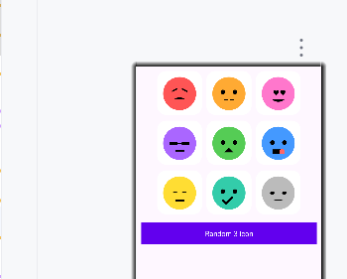

**3. FRAGMENT & ACTIVITY**

FragmentFaceEmoij.java

package com.example.lab4ui;  
  
import android.graphics.drawable.Drawable;  
import android.os.Bundle;  
import android.view.LayoutInflater;  
import android.view.View;  
import android.view.ViewGroup;  
import android.widget.ImageView;  
import android.widget.Toast;  
import androidx.fragment.app.Fragment;  
import java.util.Random;  
  
public class FragmentFaceEmoij extends Fragment implements View.OnClickListener {  
 private static final int[] *IDs* = {  
 R.id.*iv_face1*, R.id.*iv_face2*, R.id.*iv_face3*,  
 R.id.*iv_face4*, R.id.*iv_face5*, R.id.*iv_face6*,  
 R.id.*iv_face7*, R.id.*iv_face8*, R.id.*iv_face9* };  
  
 @Override  
 public View onCreateView(LayoutInflater inflater, ViewGroup container, Bundle savedInstanceState) {  
 View root = inflater.inflate(R.layout.*m001_frg_face_emoij*, container, false);  
 for (int id : *IDs*) root.findViewById(id).setOnClickListener(this);  
 root.findViewById(R.id.*btnRandom*).setOnClickListener(v -> randomize(root));  
 return root;  
 }  
  
 @Override  
 public void onClick(View v) {  
 ImageView iv = (ImageView) v;  
 showToast(iv.getDrawable());  
 }  
  
 private void showToast(Drawable d) {  
 if (getContext() == null) return;  
 Toast t = new Toast(getContext());  
 ImageView iv = new ImageView(getContext());  
 iv.setImageDrawable(d);  
 t.setView(iv);  
 t.setDuration(Toast.*LENGTH_SHORT*);  
 t.show();  
 }  
  
 private void randomize(View root) {  
 int[] drawables = {  
 R.drawable.*ic_angry*, R.drawable.*ic_baffle*, R.drawable.*ic_beauty*,  
 R.drawable.*ic_boss*, R.drawable.*ic_choler*, R.drawable.*ic_dribble*,  
 R.drawable.*ic_look_down*, R.drawable.*ic_sure*, R.drawable.*ic_tire* };  
 ImageView[] targets = {  
 root.findViewById(R.id.*iv_face1*),  
 root.findViewById(R.id.*iv_face2*),  
 root.findViewById(R.id.*iv_face3*)  
 };  
 Random r = new Random();  
 for (ImageView iv : targets) {  
 iv.setImageResource(drawables[r.nextInt(drawables.length)]);  
 }  
 }  
}

activity_emoij.xml

*<?*xml version="1.0" encoding="utf-8"*?>*<FrameLayout xmlns:android="http://schemas.android.com/apk/res/android"  
 android:layout_width="match_parent"  
 android:layout_height="match_parent">  
  
 <fragment  
 android:id="@+id/frg_face_emoij"  
 class="com.example.lab4ui.FragmentFaceEmoij"  
 android:layout_width="match_parent"  
 android:layout_height="match_parent"/>  
</FrameLayout>

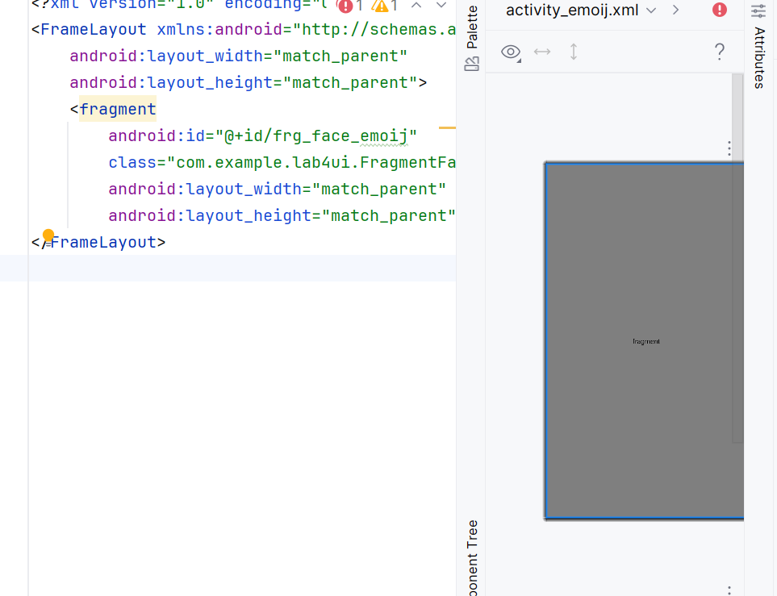

EmoijActivity.java

package com.example.lab4ui;  
  
import android.os.Bundle;  
import androidx.appcompat.app.AppCompatActivity;  
  
public class EmoijActivity extends AppCompatActivity {  
 @Override  
 protected void onCreate(Bundle savedInstanceState) {  
 super.onCreate(savedInstanceState);  
 setContentView(R.layout.*activity_emoij*);  
 }  
}

Thêm vào AndroidManifest.xml

<activity android:name=".EmoijActivity" android:exported="false"/>

HOÀN TẤT!

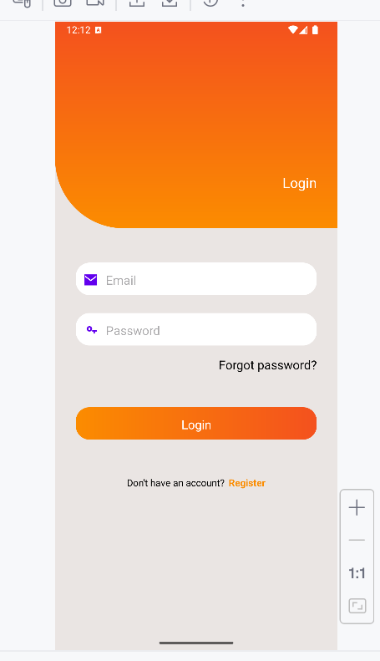

Khi nhấn nút Login thì sẽ hiện Toast:

“Bạn đã đăng nhập thành công với email: ... và mật khẩu ....”.

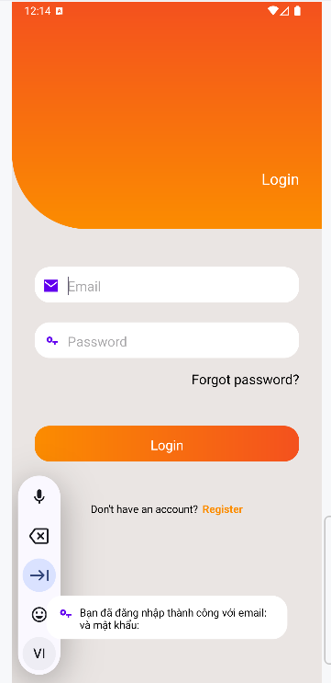

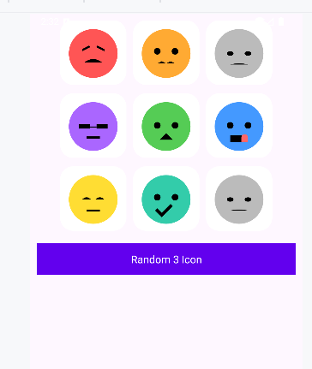

Bấm nút, các Icon được lấy ngẫu nhiên trong 10 icon và hiển thị lên màn hình.

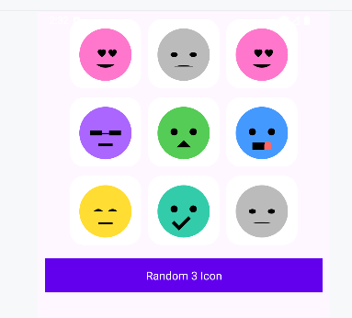

**LAB3**

## Layout and application

### Xây dựng chương trình đổi tiền tệ

Bước 1 – Tạo Project Android mới

Các bước thực hiện:

1. Mở Android Studio → chọn New Project.
2. Chọn mẫu Empty Activity.

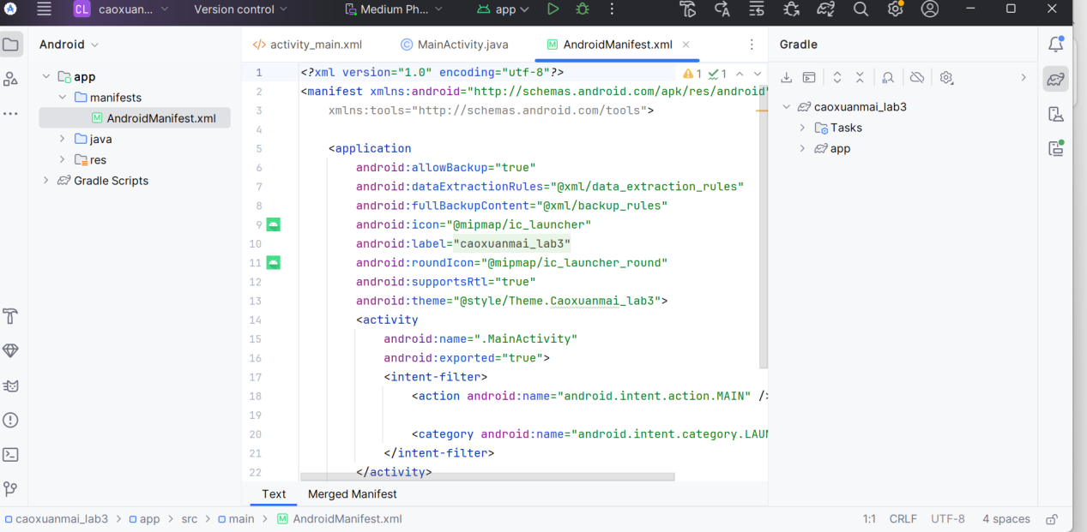

Bước 2 – Khai báo chuỗi trong strings.xml

Ý nghĩa:

Tất cả các text dùng trong giao diện (tên tiền, đơn vị, gợi ý, tên tác giả, tên máy…) phải được khai báo trong res/values/strings.xml để dễ quản lý và thay đổi.

Các bước:

1. Mở file:

app/src/main/res/values/strings.xml

1. Thêm các chuỗi theo bảng thầy cho trong Lab:

<resources>  
 <string name="app_name">Chương trình đổi tiền</string>  
   
 <string name="author">Cao Xuân Mai</string>  
 <string name="computer">Máy: HP</string>  
   
 <string name="textbox_hint">Nhập số tiền</string>  
 <string name="btn_convert">ĐỔI TIỀN</string>  
 <string name="from_label">Từ tiền tệ</string>  
 <string name="to_label">Sang tiền tệ</string>  
 <string name="result_label">Kết quả</string>  
   
 <string name="usd_name">American Dollar</string>  
 <string name="eur_name">European Cash</string>  
 <string name="gbp_name">Great Britain Pound</string>  
 <string name="aud_name">Australia Dollar</string>  
 <string name="cad_name">Canadian Dollar</string>  
 <string name="zar_name">South Africa Rand</string>  
 <string name="nzd_name">New Zealand Dollar</string>  
 <string name="jpy_name">Yên Nhật</string>  
 <string name="inr_name">Indian Rupee</string>  
 <string name="vnd_name">Việt Nam Đồng</string>  
   
 <string name="usd_unit">USD</string>  
 <string name="eur_unit">EUR</string>  
 <string name="gbp_unit">GBP</string>  
 <string name="aud_unit">AUD</string>  
 <string name="cad_unit">CAD</string>  
 <string name="zar_unit">ZAR</string>  
 <string name="nzd_unit">NZD</string>  
 <string name="jpy_unit">JPY</string>  
 <string name="inr_unit">INR</string>  
 <string name="vnd_unit">VND</string>  
</resources>

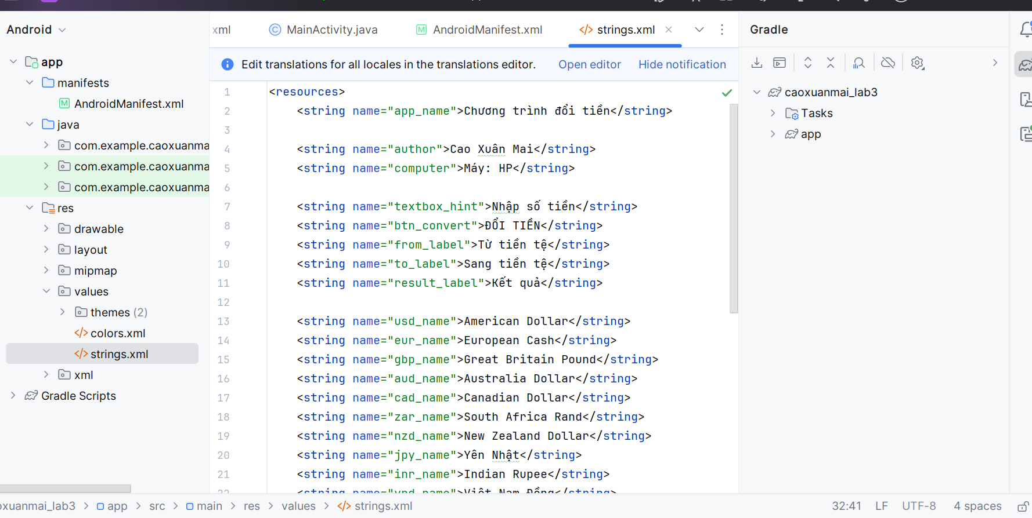

Bước 3 – Chuẩn bị hình lá cờ trong thư mục drawable

Ý nghĩa:

Spinner có thể hiển thị icon quốc kỳ tương ứng với mỗi loại tiền tệ

Các bước làm:

1. Trong Android Studio, mở thư mục:

app/src/main/res/drawable/

Chuẩn bị hình lá cờ trong thư mục drawable

1. Copy toàn bộ các file hình cờ (vd: flag_us.png, flag_eu.png, flag_gb.png, …) vào thư mục drawable.

* flag_us – Mỹ – USD
* flag_eu – Liên minh châu Âu – EUR
* flag_gb – Anh – GBP
* flag_in – Ấn Độ – INR
* flag_au – Úc – AUD
* flag_ca – Canada – CAD
* flag_za – Nam Phi – ZAR
* flag_nz – New Zealand – NZD
* flag_jp – Nhật – JPY
* flag_vn – Việt Nam – VND

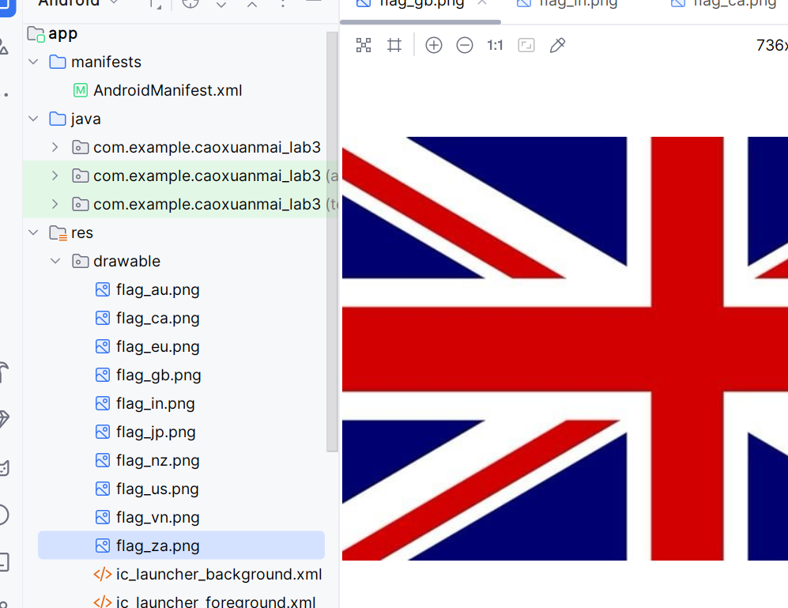

Bước 4 – Thiết kế giao diện activity_main.xml

Mục tiêu: tạo giao diện giống hình mẫu:

* Dòng trên: EditText nhập số tiền (trái) + Spinner chọn tiền gốc (phải).
* Phần dưới: ListView hiển thị danh sách tỉ giá.

Các bước:

1. Mở file app/src/main/res/layout/activity_main.xml.
2. Chuyển sang tab Code, thay nội dung bằng layout đã làm:

LinearLayout dọc bao ngoài.

Bên trong có:

LinearLayout ngang chứa EditText và Spinner với layout_weight = 1 cho mỗi bên → chia đôi màn hình ngang.

1. ListView bên dưới chiếm toàn bộ chiều cao còn lại nhờ layout_weight = 1.

*<?*xml version="1.0" encoding="utf-8"*?>*<LinearLayout xmlns:android="http://schemas.android.com/apk/res/android"  
 android:orientation="vertical"  
 android:layout_width="match_parent"  
 android:layout_height="match_parent"  
 android:padding="8dp">  
  
 <LinearLayout  
 android:orientation="horizontal"  
 android:layout_width="match_parent"  
 android:layout_height="wrap_content"  
 android:weightSum="2">  
  
 <EditText  
 android:id="@+id/edtAmount"  
 android:layout_width="0dp"  
 android:layout_height="wrap_content"  
 android:layout_weight="1"  
 android:hint="123"  
 android:inputType="numberDecimal"  
 android:padding="4dp" />  
  
 <Spinner  
 android:id="@+id/spBaseCurrency"  
 android:layout_width="0dp"  
 android:layout_height="wrap_content"  
 android:layout_weight="1" />  
 </LinearLayout>  
  
 <ListView  
 android:id="@+id/lvRates"  
 android:layout_width="match_parent"  
 android:layout_height="0dp"  
 android:layout_weight="1"  
 android:dividerHeight="1dp" />  
  
</LinearLayout>

Giải thích:

* Sử dụng LinearLayout vì giao diện khá đơn giản, chỉ cần xếp hàng ngang/dọc.
* Dùng weightSum = 2 và layout_weight = 1 để phân chia 50/50: nửa trái là ô nhập số, nửa phải là Spinner.
* Dùng ListView để hiển thị danh sách các dòng tỉ giá, mỗi dòng (item) sẽ được thiết kế riêng.

Bước 5– Thiết kế layout cho từng dòng ListView – item_currency_rate.xml

Mỗi dòng của danh sách sẽ hiển thị:

Hình lácờ (ImageView).

Mã tiền tệ (TextView).

Giá trị quy đổi (TextView).

Các bước:

Chuột phải vào layout → New → Layout resource file → đặt tên: item_currency_rate.

Dán nội dung:

*<?*xml version="1.0" encoding="utf-8"*?>*<LinearLayout xmlns:android="http://schemas.android.com/apk/res/android"  
 android:orientation="horizontal"  
 android:layout_width="match_parent"  
 android:layout_height="wrap_content"  
 android:padding="4dp">  
  
 <ImageView  
 android:id="@+id/imgFlag"  
 android:layout_width="32dp"  
 android:layout_height="20dp"  
 android:src="@drawable/flag_us"  
 android:contentDescription="@null" />  
  
 <TextView  
 android:id="@+id/tvCode"  
 android:layout_width="60dp"  
 android:layout_height="wrap_content"  
 android:layout_marginStart="8dp"  
 android:text="USD"  
 android:textStyle="bold" />  
  
 <TextView  
 android:id="@+id/tvValue"  
 android:layout_width="wrap_content"  
 android:layout_height="wrap_content"  
 android:layout_marginStart="8dp"  
 android:text="10.50543" />  
</LinearLayout>

LinearLayout ngang.

ImageView bên trái cho lá cờ.

TextView tvCode kế bên hiển thị mã tiền (USD, EUR, …).

TextView tvValue hiển thị số sau khi quy đổi.

Giải thích cho báo cáo:

* Dùng LinearLayout horizontal để các thành phần nằm trên một hàng, giống hình mẫu.
* ImageView để người dùng dễ nhận diện quốc gia qua lá cờ.
* TextView thứ hai (tvCode) dùng font đậm để phân biệt mã tiền tệ.
* TextView thứ ba (tvValue) hiển thị giá trị double, dùng layout_width wrap_content để nội dung tự giãn.

Bước 6 – Cài đặt logic trong MainActivity.java

Mục tiêu:

* Khai báo danh sách các loại tiền tệ.
* Khai báo ma trận tỉ giá.
* Đưa dữ liệu vào Spinner.
* Xử lý khi nhấn nút ĐỔI TIỀN.

Các bước:

1. Mở file: MainActivity.java
2. Thay nội dung như sau:

package com.example.caoxuanmai_lab3;  
  
import androidx.appcompat.app.AppCompatActivity;  
  
import android.os.Bundle;  
import android.text.Editable;  
import android.text.TextWatcher;  
import android.view.LayoutInflater;  
import android.view.View;  
import android.view.ViewGroup;  
import android.widget.AdapterView;  
import android.widget.BaseAdapter;  
import android.widget.EditText;  
import android.widget.ImageView;  
import android.widget.ListView;  
import android.widget.Spinner;  
import android.widget.ArrayAdapter;  
import android.widget.TextView;  
  
import java.util.ArrayList;  
  
public class MainActivity extends AppCompatActivity {  
  
 EditText edtAmount;  
 Spinner spBaseCurrency;  
 ListView lvRates;  
  
 String[] codes = {  
 "USD", "EUR", "GBP", "INR", "AUD",  
 "CAD", "ZAR", "NZD", "JPY", "VND"  
 };  
  
 int[] flagRes = {  
 R.drawable.flag_us,  
 R.drawable.flag_eu,  
 R.drawable.flag_gb,  
 R.drawable.flag_in,  
 R.drawable.flag_au,  
 R.drawable.flag_ca,  
 R.drawable.flag_za,  
 R.drawable.flag_nz,  
 R.drawable.flag_jp,  
 R.drawable.flag_vn  
 };  
  
 double[][] rate = {  
 {1, 0.80518, 0.64107, 63.318, 1.21828, 1.16236, 11.16236,1.2931, 118.337, 21385.7}, *// USD* {1.24172, 1, 0.79575, 78.6084,1.51366, 1.44314, 14.5371, 1.60576, 146.927, 26561.8}, *// EUR* {1.56044, 1.25667, 1, 98.7848,1.86133, 1.81355, 18.2683, 2.10791, 184.638, 33374.9}, *// GBP* {0.0158, 0.01272, 0.01012, 1, 0.01884, 0.01835, 0.183693,0.02043, 1.8691, 337.811}, *// INR* {0.82059, 0.66159, 0.5262, 52.086, 1, 0.95416, 9.61148, 1.06158, 97.112, 17567.9}, *// AUD* {0.86059, 0.69699, 0.55134, 54.5885,1.04805, 1, 10.0732, 1.11258, 101.777, 18401.7}, *// CAD* {0.08541, 0.06877, 0.05473, 5.40852,0.09924, 0.09924, 1, 0.11037, 10.0996, 1825.87}, *// ZAR* {0.77402, 0.62319, 0.49597, 49.0073,0.94191, 0.89891, 9.06754, 1, 91.5139, 16552.1}, *// NZD* {0.008486, 0.006406,0.005162,0.51844,0.0103, 0.00983, 0.09983, 0.01093, 1, 180.837}, *// JPY* {0.00005, 0.00004, 0.00003, 0.002962,0.00006,0.00005, 0.00055, 0.00006, 0.00553, 1} *// VND* };  
  
 ArrayList<Row> rows = new ArrayList<>();  
 RateAdapter adapter;  
  
 @Override  
 protected void onCreate(Bundle savedInstanceState) {  
 super.onCreate(savedInstanceState);  
 setContentView(R.layout.*activity_main*);  
  
 edtAmount = findViewById(R.id.*edtAmount*);  
 spBaseCurrency = findViewById(R.id.*spBaseCurrency*);  
 lvRates = findViewById(R.id.*lvRates*);  
  
 ArrayAdapter<String> spAdapter = new ArrayAdapter<>(  
 this,  
 android.R.layout.*simple_spinner_item*,  
 codes  
 );  
 spAdapter.setDropDownViewResource(android.R.layout.*simple_spinner_dropdown_item*);  
 spBaseCurrency.setAdapter(spAdapter);  
  
 adapter = new RateAdapter();  
 lvRates.setAdapter(adapter);  
  
 spBaseCurrency.setSelection(6); edtAmount.addTextChangedListener(new TextWatcher() {  
 @Override  
 public void beforeTextChanged(CharSequence s, int start, int count, int after) { }  
  
 @Override  
 public void onTextChanged(CharSequence s, int start, int before, int count) {  
 updateList();  
 }  
  
 @Override  
 public void afterTextChanged(Editable s) { }  
 });  
  
 spBaseCurrency.setOnItemSelectedListener(new AdapterView.OnItemSelectedListener() {  
 @Override  
 public void onItemSelected(AdapterView<?> parent, View view, int position, long id) {  
 updateList();  
 }  
  
 @Override  
 public void onNothingSelected(AdapterView<?> parent) { }  
 });  
 }  
  
 private void updateList() {  
 String sAmount = edtAmount.getText().toString().trim();  
 rows.clear();  
  
 if (sAmount.isEmpty()) {  
 adapter.notifyDataSetChanged();  
 return;  
 }  
  
 double amount = Double.parseDouble(sAmount);  
 int baseIndex = spBaseCurrency.getSelectedItemPosition();  
  
 for (int i = 0; i < codes.length; i++) {  
 double value = amount * rate[baseIndex][i];  
 rows.add(new Row(flagRes[i], codes[i], value));  
 }  
 adapter.notifyDataSetChanged();  
 }  
  
 private static class Row {  
 int flagResId;  
 String code;  
 double value;  
  
 Row(int flagResId, String code, double value) {  
 this.flagResId = flagResId;  
 this.code = code;  
 this.value = value;  
 }  
 }  
  
 private class RateAdapter extends BaseAdapter {  
  
 @Override  
 public int getCount() {  
 return rows.size();  
 }  
  
 @Override  
 public Object getItem(int position) {  
 return rows.get(position);  
 }  
  
 @Override  
 public long getItemId(int position) {  
 return position;  
 }  
  
 @Override  
 public View getView(int position, View convertView, ViewGroup parent) {  
 ViewHolder holder;  
 if (convertView == null) {  
 LayoutInflater inflater = LayoutInflater.from(MainActivity.this);  
 convertView = inflater.inflate(R.layout.item_currency_rate, parent, false);  
 holder = new ViewHolder();  
 holder.imgFlag = convertView.findViewById(R.id.imgFlag);  
 holder.tvCode = convertView.findViewById(R.id.tvCode);  
 holder.tvValue = convertView.findViewById(R.id.tvValue);  
 convertView.setTag(holder);  
 } else {  
 holder = (ViewHolder) convertView.getTag();  
 }  
  
 Row row = rows.get(position);  
 holder.imgFlag.setImageResource(row.flagResId);  
 holder.tvCode.setText(row.code);  
 holder.tvValue.setText(String.valueOf(row.value));  
  
 return convertView;  
 }  
  
 class ViewHolder {  
 ImageView imgFlag;  
 TextView tvCode;  
 TextView tvValue;  
 }  
 }  
}

Giải thích logic chương trình đổi tiền

1. Mảng currencyCodes

Chứa danh sách mã tiền tệ sẽ hiển thị trên Spinner: USD, EUR, GBP, …

1. Ma trận rate

rate[i][j] = 1 đơn vị tiền ở dòng i đổi được bao nhiêu đơn vị tiền ở cột j.

Ví dụ: rate[0][1] là 1 USD đổi được bao nhiêu EUR.

1. Trong onCreate()

Gọi setContentView() để gắn layout.

findViewById(...) để liên kết các biến Java với View trong XML.

Tạo ArrayAdapter từ currencyCodes để gắn vào 2 Spinner.

1. Hàm convertCurrency()

Lấy số tiền từ EditText. Nếu rỗng thì báo lỗi bằng Toast.

Lấy vị trí chọn của spFrom và spTo.

Tính result = amount * rate[fromIndex][toIndex].

Hiển thị kết quả cuối cùng lên tvResult theo format:  
100.00 USD = 2450000.00 VND

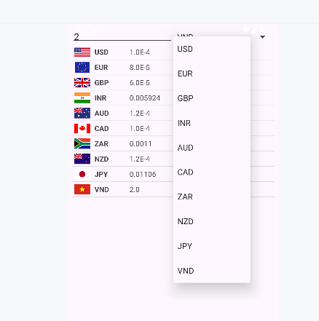

### Xây dựng chương trình đổi độ dài

Bước 1: Tạo file layout mới

Tạo file activity_length.xml

Cấu trúc rất giống activity_main.xml nhưng đơn giản hơn:

* TextView tiêu đề: “Bài tập: Chương trình đổi độ dài”.
* Hàng nhập liệu:
* EditText edtNumber: nhập con số cần đổi.
* Spinner spUnit: chọn đơn vị gốc.
* ListView lvResult: hiển thị kết quả quy đổi sang tất cả các đơn vị.

*<?*xml version="1.0" encoding="utf-8"*?>*<LinearLayout xmlns:android="http://schemas.android.com/apk/res/android"  
 android:orientation="vertical"  
 android:layout_width="match_parent"  
 android:layout_height="match_parent"  
 android:padding="8dp">  
  
 <TextView  
 android:id="@+id/tvTitleLength"  
 android:layout_width="match_parent"  
 android:layout_height="wrap_content"  
 android:text="Bài tập: Chương trình đổi độ dài"  
 android:textSize="18sp"  
 android:textStyle="bold"  
 android:gravity="center"  
 android:padding="4dp" />  
  
 <LinearLayout  
 android:orientation="horizontal"  
 android:layout_width="match_parent"  
 android:layout_height="wrap_content"  
 android:weightSum="2">  
  
 <EditText  
 android:id="@+id/edtNumber"  
 android:layout_width="0dp"  
 android:layout_height="wrap_content"  
 android:layout_weight="1"  
 android:hint="Nhập độ dài"  
 android:inputType="numberDecimal"  
 android:padding="4dp" />  
  
 <Spinner  
 android:id="@+id/spUnit"  
 android:layout_width="0dp"  
 android:layout_height="wrap_content"  
 android:layout_weight="1" />  
 </LinearLayout>  
  
 <ListView  
 android:id="@+id/lvResult"  
 android:layout_width="match_parent"  
 android:layout_height="0dp"  
 android:layout_weight="1"  
 android:dividerHeight="1dp" />  
  
</LinearLayout>

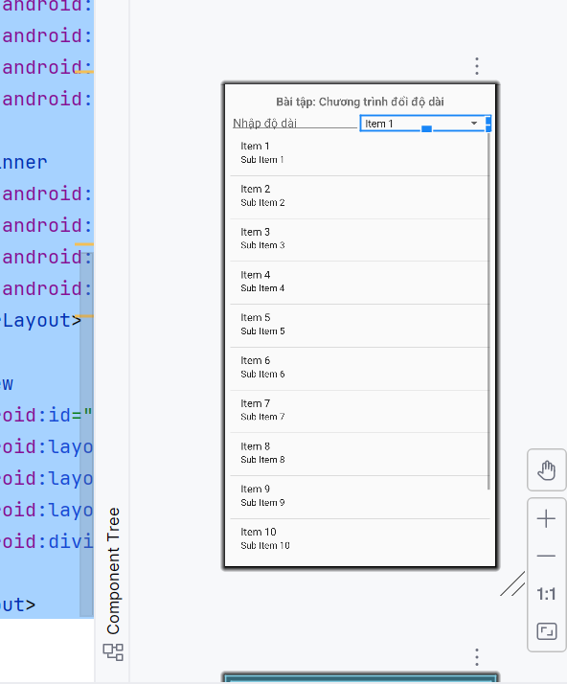

Bước 2: Thiết kế item cho ListView

Tạo file item_length.xml để quy định 1 dòng kết quả.

Một dòng gồm:

* tvUnit: tên đơn vị (km, m, cm,…)
* tvValue: giá trị sau khi quy đổi

Sử dụng LinearLayout ngang.

*<?*xml version="1.0" encoding="utf-8"*?>*<LinearLayout xmlns:android="http://schemas.android.com/apk/res/android"  
 android:orientation="horizontal"  
 android:layout_width="match_parent"  
 android:layout_height="wrap_content"  
 android:padding="6dp">  
  
 <TextView  
 android:id="@+id/tvUnit"  
 android:layout_width="80dp"  
 android:layout_height="wrap_content"  
 android:textStyle="bold"  
 android:text="km" />  
  
 <TextView  
 android:id="@+id/tvValue"  
 android:layout_width="wrap_content"  
 android:layout_height="wrap_content"  
 android:layout_marginStart="10dp"  
 android:text="1000" />  
  
</LinearLayout>

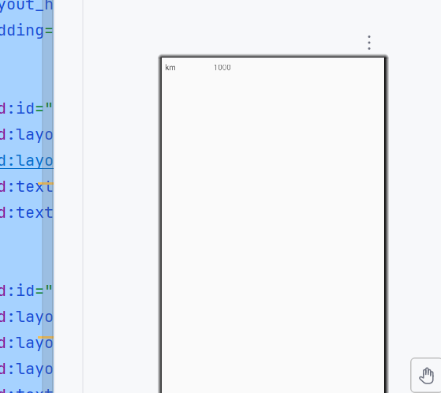

Bước 3: Tạo Activity xử lý: LengthActivity.java

Vai trò của LengthActivity:

* Lấy dữ liệu người dùng nhập
* Lấy đơn vị đã chọn
* Tính quy đổi sang các đơn vị khác
* Đưa kết quả vào ListView bằng BaseAdapter

package com.example.caoxuanmai_lab3;  
  
import androidx.appcompat.app.AppCompatActivity;  
  
import android.os.Bundle;  
import android.text.Editable;  
import android.text.TextWatcher;  
import android.view.LayoutInflater;  
import android.view.View;  
import android.view.ViewGroup;  
import android.widget.ArrayAdapter;  
import android.widget.BaseAdapter;  
import android.widget.EditText;  
import android.widget.ListView;  
import android.widget.Spinner;  
import android.widget.TextView;  
  
import java.util.ArrayList;  
  
public class LengthActivity extends AppCompatActivity {  
  
 EditText edtNumber;  
 Spinner spUnit;  
 ListView lvResult;  
  
 String[] units = {"km", "m", "cm", "mm", "inch", "ft", "yd", "mile"};  
  
 double[] toMeter = {  
 1000,  
 1,  
 0.01,  
 0.001,  
 0.0254,  
 0.3048,  
 0.9144,  
 1609.344  
 };  
  
 ArrayList<RowLength> rows = new ArrayList<>();  
 LengthAdapter adapter;  
  
 @Override  
 protected void onCreate(Bundle savedInstanceState) {  
 super.onCreate(savedInstanceState);  
 setContentView(R.layout.*activity_length*);  
  
 edtNumber = findViewById(R.id.*edtNumber*);  
 spUnit = findViewById(R.id.*spUnit*);  
 lvResult = findViewById(R.id.*lvResult*);  
  
 ArrayAdapter<String> spAdapter = new ArrayAdapter<>(  
 this,  
 android.R.layout.*simple_spinner_item*,  
 units  
 );  
 spAdapter.setDropDownViewResource(android.R.layout.*simple_spinner_dropdown_item*);  
 spUnit.setAdapter(spAdapter);  
  
 adapter = new LengthAdapter();  
 lvResult.setAdapter(adapter);  
  
 edtNumber.addTextChangedListener(new TextWatcher() {  
 @Override  
 public void onTextChanged(CharSequence s, int start, int before, int count) {  
 updateList();  
 }  
 @Override  
 public void beforeTextChanged(CharSequence s, int start, int count, int after) {}  
 @Override  
 public void afterTextChanged(Editable s) {}  
 });  
  
 spUnit.setOnItemSelectedListener(new android.widget.AdapterView.OnItemSelectedListener() {  
 @Override  
 public void onItemSelected(android.widget.AdapterView<?> parent, View view, int position, long id) {  
 updateList();  
 }  
 @Override  
 public void onNothingSelected(android.widget.AdapterView<?> parent) {}  
 });  
 }  
  
 private void updateList() {  
 String s = edtNumber.getText().toString().trim();  
 rows.clear();  
  
 if (s.isEmpty()) {  
 adapter.notifyDataSetChanged();  
 return;  
 }  
  
 double number = Double.*parseDouble*(s);  
 int base = spUnit.getSelectedItemPosition();  
  
 double numberInMeter = number * toMeter[base];  
  
 for (int i = 0; i < units.length; i++) {  
 double value = numberInMeter / toMeter[i];  
 rows.add(new RowLength(units[i], value));  
 }  
  
 adapter.notifyDataSetChanged();  
 }  
  
 private static class RowLength {  
 String unit;  
 double value;  
  
 RowLength(String unit, double value) {  
 this.unit = unit;  
 this.value = value;  
 }  
 }  
  
 private class LengthAdapter extends BaseAdapter {  
  
 @Override  
 public int getCount() {  
 return rows.size();  
 }  
  
 @Override  
 public Object getItem(int position) {  
 return rows.get(position);  
 }  
  
 @Override  
 public long getItemId(int position) {  
 return position;  
 }  
  
 @Override  
 public View getView(int position, View convertView, ViewGroup parent) {  
 ViewHolder h;  
  
 if (convertView == null) {  
 convertView = LayoutInflater.*from*(LengthActivity.this)  
 .inflate(R.layout.*item_length*, parent, false);  
 h = new ViewHolder();  
 h.tvUnit = convertView.findViewById(R.id.*tvUnit*);  
 h.tvValue = convertView.findViewById(R.id.*tvValue*);  
 convertView.setTag(h);  
 } else {  
 h = (ViewHolder) convertView.getTag();  
 }  
  
 RowLength r = rows.get(position);  
 h.tvUnit.setText(r.unit);  
 h.tvValue.setText(String.*valueOf*(r.value));  
  
 return convertView;  
 }  
  
 class ViewHolder {  
 TextView tvUnit, tvValue;  
 }  
 }  
}

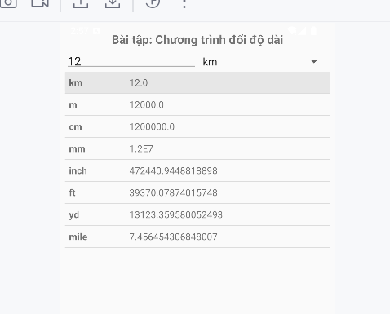

## Custom controls

I. Chuẩn bị project

* Tạo project Android mới:
* Name: `caoxuanmai_lab7`
* Package: `com.example.caoxuanmai_lab7`
* Activity mặc định: `MainActivity` (Empty Activity).

Trong `AndroidManifest.xml` chỉ cần có:

<application  
android:allowBackup="true"  
android:icon="@mipmap/ic_launcher"  
android:label="@string/app_name"  
android:roundIcon="@mipmap/ic_launcher_round"  
android:supportsRtl="true"  
android:theme="@style/Theme.AppCompat.Light.NoActionBar">  
  
<activity  
 android:name=".ColorActivity"  
 android:exported="false" />  
  
<activity  
 android:name=".MainActivity"  
 android:exported="true">  
 <intent-filter>  
 <action android:name="android.intent.action.MAIN" />  
 <category android:name="android.intent.category.LAUNCHER" />  
 </intent-filter>  
</activity>  
</application>

### Bài 1 – Custom Button

1. Thiết kế giao diện giống hình mẫu

Mục tiêu: tạo màn hình đúng bố cục:

Tiêu đề đỏ “Custom Button”.

Hai cột “Selectors” và “Shapes”+ “Selectors”.

Các nút:

* Cột trái: COLORED SELECTOR, COLOR SELECTOR DISABLED + icon mặt cười.
* Cột phải: ROUND SHAPE, SHAPE WITH GRADIENT, SELECTOR SHAPE + icon mặt cười trong khung xanh.
* Dòng chữ cuối: “Made by Cao Xuan Mai”.

Bước 1: chuẩn bị icon mặt cười

– Tải 1 hình PNG mặt cười (vuông) → đặt tên `ic_emoji.png` → copy vào thư mục `app/src/main/res/drawable/`.

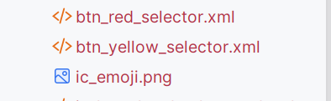

Bước 2: sửa file `activity_main.xml`

File: `app/src/main/res/layout/activity_main.xml`

*<?*xml version="1.0" encoding="utf-8"*?>*<LinearLayout xmlns:android="http://schemas.android.com/apk/res/android"  
android:orientation="vertical"  
android:layout_width="match_parent"  
android:layout_height="match_parent"  
android:background="@android:color/white"  
android:padding="8dp">  
  
<TextView  
 android:id="@+id/tvTitle"  
 android:layout_width="match_parent"  
 android:layout_height="wrap_content"  
 android:text="Custom Button"  
 android:gravity="center"  
 android:textColor="#FF0000"  
 android:textStyle="bold"  
 android:textSize="22sp"  
 android:layout_marginTop="12dp"  
 android:layout_marginBottom="4dp" />  
<LinearLayout  
 android:layout_width="match_parent"  
 android:layout_height="wrap_content"  
 android:orientation="horizontal"  
 android:gravity="center"  
 android:layout_marginBottom="4dp">  
  
 <TextView  
 android:layout_width="0dp"  
 android:layout_height="wrap_content"  
 android:layout_weight="1"  
 android:text="Selectors"  
 android:gravity="center"  
 android:textSize="16sp"  
 android:textStyle="bold" />  
  
 <TextView  
 android:layout_width="0dp"  
 android:layout_height="wrap_content"  
 android:layout_weight="1"  
 android:text="Shapes+Selectors"  
 android:gravity="center"  
 android:textSize="16sp"  
 android:textStyle="bold" />  
</LinearLayout>

<LinearLayout  
 android:layout_width="match_parent"  
 android:layout_height="wrap_content"  
 android:orientation="horizontal"  
 android:gravity="top"  
 android:layout_marginTop="4dp">  
  
 <LinearLayout  
 android:layout_width="0dp"  
 android:layout_height="wrap_content"  
 android:orientation="vertical"  
 android:layout_weight="1"  
 android:gravity="center_horizontal">  
  
 <Button  
 android:id="@+id/btnColoredSelector"  
 android:layout_width="wrap_content"  
 android:layout_height="wrap_content"  
 android:text="COLORED SELECTOR"  
 android:background="@drawable/btn_green_selector"  
 android:textAllCaps="true"  
 android:textColor="@android:color/black"  
 android:layout_marginTop="8dp" />  
  
 <Button  
 android:id="@+id/btnColorSelectorDisabled"  
 android:layout_width="wrap_content"  
 android:layout_height="wrap_content"  
 android:text="COLOR SELECTOR DISABLED"  
 android:background="@drawable/btn_yellow_selector"  
 android:textAllCaps="true"  
 android:textColor="@android:color/black"  
 android:enabled="false"  
 android:layout_marginTop="8dp" />  
  
 <ImageView  
 android:id="@+id/imgLeftEmoji"  
 android:layout_width="64dp"  
 android:layout_height="64dp"  
 android:src="@drawable/ic_emoji"  
 android:layout_marginTop="16dp" />  
 </LinearLayout>  
  
 <LinearLayout  
 android:layout_width="0dp"  
 android:layout_height="wrap_content"  
 android:orientation="vertical"  
 android:layout_weight="1"  
 android:gravity="center_horizontal">  
  
 <Button  
 android:id="@+id/btnRoundShape"  
 android:layout_width="wrap_content"  
 android:layout_height="wrap_content"  
 android:text="ROUND SHAPE"  
 android:background="@drawable/bg_round_shape"  
 android:textAllCaps="true"  
 android:textColor="@android:color/black"  
 android:layout_marginTop="8dp" />  
  
 <Button  
 android:id="@+id/btnShapeWithGradient"  
 android:layout_width="wrap_content"  
 android:layout_height="wrap_content"  
 android:text="SHAPE WITH GRADIENT"  
 android:background="@drawable/bg_shape_gradient"  
 android:textAllCaps="true"  
 android:textColor="@android:color/black"  
 android:layout_marginTop="8dp" />  
  
 <Button  
 android:id="@+id/btnSelectorShape"  
 android:layout_width="wrap_content"  
 android:layout_height="wrap_content"  
 android:text="SELECTOR SHAPE"  
 android:background="@drawable/btn_red_selector"  
 android:textAllCaps="true"  
 android:textColor="@android:color/white"  
 android:layout_marginTop="8dp" />  
  
 <LinearLayout  
 android:layout_width="wrap_content"  
 android:layout_height="wrap_content"  
 android:layout_marginTop="16dp"  
 android:padding="4dp"  
 android:background="@drawable/bg_emoji_border">  
  
 <ImageView  
 android:id="@+id/imgRightEmoji"  
 android:layout_width="48dp"  
 android:layout_height="48dp"  
 android:src="@drawable/ic_emoji" />  
 </LinearLayout>  
 </LinearLayout>  
</LinearLayout>  
  
<LinearLayout  
 android:layout_width="match_parent"  
 android:layout_height="wrap_content"  
 android:orientation="horizontal"  
 android:gravity="center"  
 android:layout_marginTop="24dp">  
  
 <Button  
 android:id="@+id/btnCustomToast"  
 android:layout_width="0dp"  
 android:layout_height="48dp"  
 android:layout_weight="1"  
 android:text="TOAST"  
 android:textAllCaps="true"  
 android:textColor="@android:color/white"  
 android:background="@drawable/btn_bottom_blue"  
 android:layout_marginEnd="8dp" />  
  
 <Button  
 android:id="@+id/btnCustomDialog"  
 android:layout_width="0dp"  
 android:layout_height="48dp"  
 android:layout_weight="1"  
 android:text="DIALOG"  
 android:textAllCaps="true"  
 android:textColor="@android:color/white"  
 android:background="@drawable/btn_bottom_blue"  
 android:layout_marginStart="8dp" />  
</LinearLayout>  
  
<TextView  
 android:id="@+id/tvFooter"  
 android:layout_width="match_parent"  
 android:layout_height="wrap_content"  
 android:text="Made by Thai Duy Quy"  
 android:gravity="center"  
 android:textColor="#0000FF"  
 android:textSize="14sp"  
 android:layout_marginTop="16dp"  
 android:layout_marginBottom="8dp" />  
  
</LinearLayout>

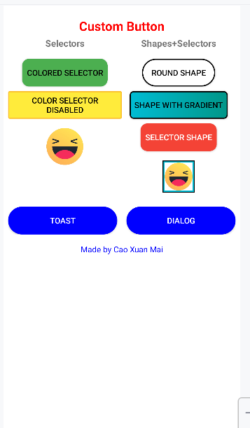

3. Tạo các file `shape` và `selector`

Dưới đây là những file quan trọng trong `res/drawable/`:

3.1. Nút xanh lá có hiệu ứng nhấn – `btn_green_selector.xml`

File `btn_green_selector.xml`:

*<?*xml version="1.0" encoding="utf-8"*?>*<selector xmlns:android="http://schemas.android.com/apk/res/android">  
 <item android:state_pressed="true"  
 android:drawable="@drawable/btn_green_pressed_bg" />  
 <item android:drawable="@drawable/btn_green_bg" />  
</selector>

File `btn_green_bg.xml`:

*<?*xml version="1.0" encoding="utf-8"*?>*<shape xmlns:android="http://schemas.android.com/apk/res/android"  
 android:shape="rectangle">  
 <corners android:radius="12dp" />  
 <solid android:color="#4CAF50" />  
 <padding  
 android:left="8dp"  
 android:top="8dp"  
 android:right="8dp"  
 android:bottom="8dp" />  
</shape>

File `btn_green_pressed_bg.xml` (màu đậm hơn):

*<?*xml version="1.0" encoding="utf-8"*?>*<shape xmlns:android="http://schemas.android.com/apk/res/android"  
 android:shape="rectangle">  
 <corners android:radius="12dp" />  
 <solid android:color="#388E3C" />  
 <padding  
 android:left="8dp"  
 android:top="8dp"  
 android:right="8dp"  
 android:bottom="8dp" />  
</shape>

>Logic: selector sẽ tự chọn drawable khác nhau khi nút ở trạng thái nhấn (`state_pressed=true`) hoặc bình thường.

3.2. Nút vàng bị disabled – `btn_yellow_selector.xml`

*<?*xml version="1.0" encoding="utf-8"*?>*<shape xmlns:android="http://schemas.android.com/apk/res/android"  
 android:shape="rectangle">  
 <solid android:color="#FFEB3B" />  
 <stroke  
 android:width="2dp"  
 android:color="#FBC02D" />  
 <corners android:radius="2dp" />  
 <padding  
 android:left="8dp"  
 android:top="4dp"  
 android:right="8dp"  
 android:bottom="4dp" />  
</shape>

Trong layout, nút này có `android:enabled="false"` nên hiển thị giống trong hình: màu vàng nhưng không bấm được.

3.3. Nút “ROUND SHAPE” – `bg_round_shape.xml`

*<?*xml version="1.0" encoding="utf-8"*?>*<shape xmlns:android="http://schemas.android.com/apk/res/android">  
 <solid android:color="@android:color/white" />  
 <stroke  
 android:width="2dp"  
 android:color="#000000" />  
 <corners android:radius="24dp" />  
 <padding  
 android:left="16dp"  
 android:top="6dp"  
 android:right="16dp"  
 android:bottom="6dp" />  
</shape>

> Logic: radius lớn làm nút bo tròn như viên thuốc – minh họa cho “round shape”.

3.4. Nút gradient – `bg_shape_gradient.xml`

*<?*xml version="1.0" encoding="utf-8"*?>*<shape xmlns:android="http://schemas.android.com/apk/res/android"  
 android:shape="rectangle">  
  
 <gradient  
 android:startColor="#00BCD4"  
 android:endColor="#009688"  
 android:angle="0" />  
 <stroke  
 android:width="2dp"  
 android:color="#000000" />  
 <corners android:radius="6dp" />  
 <padding  
 android:left="8dp"  
 android:top="4dp"  
 android:right="8dp"  
 android:bottom="4dp" />  
</shape>

> Logic: dùng `<gradient>` để chuyển màu từ xanh dương sang xanh lá → tạo cảm giác nổi.

3.5. Nút đỏ có selector – `btn_red_selector.xml`

Tương tự nút xanh lá, nhưng dùng màu đỏ:

`*<?*xml version="1.0" encoding="utf-8"*?>*<selector xmlns:android="http://schemas.android.com/apk/res/android">  
 <item android:state_pressed="true"  
 android:drawable="@drawable/btn_red_pressed_bg" />  
 <item android:drawable="@drawable/btn_red_bg" />  
</selector>

`btn_red_bg.xml`:

*<?*xml version="1.0" encoding="utf-8"*?>*<shape xmlns:android="http://schemas.android.com/apk/res/android"  
 android:shape="rectangle">  
  
 <corners android:radius="12dp" />  
 <solid android:color="#F44336" />  
 <padding  
 android:left="8dp"  
 android:top="8dp"  
 android:right="8dp"  
 android:bottom="8dp" />  
</shape>

`btn_red_pressed_bg.xml` màu đậm hơn.

*<?*xml version="1.0" encoding="utf-8"*?>*<shape xmlns:android="http://schemas.android.com/apk/res/android"  
 android:shape="rectangle">  
  
 <corners android:radius="12dp" />  
 <solid android:color="#D32F2F" />  
 <padding  
 android:left="8dp"  
 android:top="8dp"  
 android:right="8dp"  
 android:bottom="8dp" />  
</shape>

3.6. Khung emoji bên phải – `bg_emoji_border.xml`

*<?*xml version="1.0" encoding="utf-8"*?>*<shape xmlns:android="http://schemas.android.com/apk/res/android">  
 <solid android:color="#00BCD4" />  
 <stroke  
 android:width="2dp"  
 android:color="#000000" />  
</shape>

3.7. Nút tròn dưới cùng – `btn_bottom_blue.xml`

*<?*xml version="1.0" encoding="utf-8"*?>*<shape xmlns:android="http://schemas.android.com/apk/res/android">  
 <solid android:color="#0000FF" />  
 <corners android:radius="50dp" />  
 <padding  
 android:left="24dp"  
 android:top="8dp"  
 android:right="24dp"  
 android:bottom="8dp" />  
</shape>

4. Logic trong `MainActivity.java` cho Bài 1

File: `app/src/main/java/com/example/caoxuanmai_lab7/MainActivity.java`

public class MainActivity extends AppCompatActivity {  
  
 private Button btnColoredSelector;  
 private Button btnColorSelectorDisabled;  
 private Button btnRoundShape;  
 private Button btnShapeWithGradient;  
 private Button btnSelectorShape;  
  
 private Button btnCustomToast;  
 private Button btnCustomDialog;  
  
 @Override  
 protected void onCreate(Bundle savedInstanceState) {  
 super.onCreate(savedInstanceState);  
 setContentView(R.layout.*activity_main*);  
   
 btnColoredSelector = findViewById(R.id.*btnColoredSelector*);  
 btnColorSelectorDisabled = findViewById(R.id.*btnColorSelectorDisabled*);  
 btnRoundShape = findViewById(R.id.*btnRoundShape*);  
 btnShapeWithGradient = findViewById(R.id.*btnShapeWithGradient*);  
 btnSelectorShape = findViewById(R.id.*btnSelectorShape*);  
 btnCustomToast = findViewById(R.id.*btnCustomToast*);  
 btnCustomDialog = findViewById(R.id.*btnCustomDialog*);  
   
 View.OnClickListener demoListener = new View.OnClickListener() {  
 @Override  
 public void onClick(View v) {  
 if (v instanceof Button) {  
 Button b = (Button) v;  
 Toast.*makeText*(MainActivity.this,  
 "Bạn bấm: " + b.getText(),  
 Toast.*LENGTH_SHORT*).show();  
 }  
 }  
 };  
  
 btnColoredSelector.setOnClickListener(demoListener);  
 btnRoundShape.setOnClickListener(demoListener);  
 btnShapeWithGradient.setOnClickListener(demoListener);  
 btnSelectorShape.setOnClickListener(demoListener);  
   
 btnCustomToast.setOnClickListener(v ->  
 showCustomToast("Custom Toast, made by Xuan Mai"));  
  
 btnCustomDialog.setOnClickListener(v -> showCustomDialog());  
 }  
  
   
}

> Logic: dùng một listener chung giúp code gọn, dễ bảo trì; nút nào bấm cũng thông báo lại tên nút cho người dùng.

### Bài 2 – Custom Toast & Custom Dialog

1. Thiết kế Custom Toast

Bước 1: tạo layout cho Toast: `res/layout/custom_toast.xml`

*<?*xml version="1.0" encoding="utf-8"*?>*<LinearLayout xmlns:android="http://schemas.android.com/apk/res/android"  
 android:layout_width="wrap_content"  
 android:layout_height="wrap_content"  
 android:orientation="horizontal"  
 android:padding="12dp"  
 android:background="@drawable/bg_toast"  
 android:gravity="center_vertical">  
  
 <ImageView  
 android:id="@+id/imgToast"  
 android:layout_width="24dp"  
 android:layout_height="24dp"  
 android:src="@android:drawable/ic_dialog_info"  
 android:layout_marginEnd="8dp" />  
  
 <TextView  
 android:id="@+id/txtToast"  
 android:layout_width="wrap_content"  
 android:layout_height="wrap_content"  
 android:text="Đây là Custom Toast"  
 android:textColor="@android:color/white"  
 android:textSize="16sp" />  
</LinearLayout>

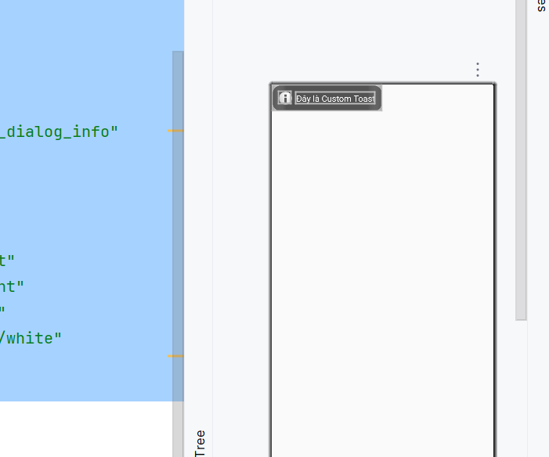

Bước 2: background của Toast – `bg_toast.xml`

*<?*xml version="1.0" encoding="utf-8"*?>*<shape xmlns:android="http://schemas.android.com/apk/res/android"  
 android:shape="rectangle">  
  
 <corners android:radius="16dp" />  
 <solid android:color="#AA000000" />  
 <padding  
 android:left="12dp"  
 android:top="8dp"  
 android:right="12dp"  
 android:bottom="8dp" />  
</shape>

Bước 3: hàm `showCustomToast` trong `MainActivity`

private void showCustomToast(String message) {  
 LayoutInflater inflater = getLayoutInflater();  
 View layout = inflater.inflate(R.layout.*custom_toast*, null);  
  
 TextView txtToast = layout.findViewById(R.id.*txtToast*);  
 txtToast.setText(message);  
  
 Toast toast = new Toast(getApplicationContext());  
 toast.setDuration(Toast.*LENGTH_SHORT*);  
 toast.setView(layout);  
 toast.setGravity(Gravity.*BOTTOM*, 0, 100);  
 toast.show();  
}

> Logic: thay vì dùng Toast mặc định, mình tự inflate một layout để có icon, màu nền và bo góc theo ý; sau đó set view đó vào Toast.

Khi người dùng bấm nút TOAST, hàm `showCustomToast` được gọi, hiển thị thông báo “Custom Toast, made by Xuan Mai”.

2. Thiết kế Custom Dialog (hộp thoại đăng nhập)

Bước 1: layout Dialog – `res/layout/custom_dialog.xml`

*<?*xml version="1.0" encoding="utf-8"*?>*<LinearLayout xmlns:android="http://schemas.android.com/apk/res/android"  
 android:layout_width="match_parent"  
 android:layout_height="wrap_content"  
 android:orientation="vertical"  
 android:padding="16dp">  
  
 <TextView  
 android:id="@+id/tvDialogTitle"  
 android:layout_width="match_parent"  
 android:layout_height="wrap_content"  
 android:text="Thông báo"  
 android:textSize="18sp"  
 android:textStyle="bold"  
 android:gravity="center"  
 android:layout_marginBottom="8dp" />  
  
 <TextView  
 android:id="@+id/tvDialogMessage"  
 android:layout_width="match_parent"  
 android:layout_height="wrap_content"  
 android:text="Đây là nội dung custom dialog."  
 android:textSize="16sp"  
 android:layout_marginBottom="16dp" />  
  
 <LinearLayout  
 android:layout_width="match_parent"  
 android:layout_height="wrap_content"  
 android:orientation="horizontal"  
 android:gravity="end">  
  
 <Button  
 android:id="@+id/btnDialogCancel"  
 android:layout_width="wrap_content"  
 android:layout_height="wrap_content"  
 android:text="Hủy" />  
  
 <Button  
 android:id="@+id/btnDialogOK"  
 android:layout_width="wrap_content"  
 android:layout_height="wrap_content"  
 android:text="OK"  
 android:layout_marginStart="8dp" />  
 </LinearLayout>  
</LinearLayout>

Bước 2: hàm `showCustomDialog` trong `MainActivity`

private void showCustomDialog() {  
 AlertDialog.Builder builder = new AlertDialog.Builder(this);  
 LayoutInflater inflater = getLayoutInflater();  
 View view = inflater.inflate(R.layout.*custom_dialog*, null);  
  
 builder.setView(view);  
 AlertDialog dialog = builder.create();  
  
 TextView tvTitle = view.findViewById(R.id.*tvDialogTitle*);  
 TextView tvMessage = view.findViewById(R.id.*tvDialogMessage*);  
 Button btnCancel = view.findViewById(R.id.*btnDialogCancel*);  
 Button btnOK = view.findViewById(R.id.*btnDialogOK*);  
  
 tvTitle.setText("Đăng nhập");  
 tvMessage.setText("Tài khoản: admin\nMật khẩu: ********");  
  
 btnCancel.setOnClickListener(v -> dialog.dismiss());  
  
 btnOK.setOnClickListener(v -> {  
 showCustomToast("Đăng nhập thành công!");  
 dialog.dismiss();  
 });  
  
 dialog.show();  
}

> Logic:

* Dùng `AlertDialog.Builder` + `setView()` để gắn layout tự thiết kế.
* Hai nút “ĐỒNG Ý” / “THOÁT” tự xử lý bằng `setOnClickListener`.
* Khi Đồng ý, hiển thị thêm Custom Toast để báo thành công.

Khi người dùng bấm nút DIALOG ở màn hình chính, hộp thoại xuất hiện đúng như hình minh họa trong đề.

### Bài 3 – SeekBar chọn màu RGB & CMY (Custom SeekBar)

1. Thiết kế layout `activity_color.xml`

File: `res/layout/activity_color.xml`

*<?*xml version="1.0" encoding="utf-8"*?>*<ScrollView xmlns:android="http://schemas.android.com/apk/res/android"  
 android:layout_width="match_parent"  
 android:layout_height="match_parent">  
  
 <LinearLayout  
 android:layout_width="match_parent"  
 android:layout_height="wrap_content"  
 android:orientation="vertical"  
 android:padding="16dp">  
  
 <TextView  
 android:layout_width="match_parent"  
 android:layout_height="wrap_content"  
 android:text="Chọn màu RGB &amp; CMY"  
 android:textSize="20sp"  
 android:textStyle="bold"  
 android:gravity="center"  
 android:layout_marginBottom="16dp" />  
  
 <TextView  
 android:id="@+id/tvColorRGB"  
 android:layout_width="match_parent"  
 android:layout_height="80dp"  
 android:background="#000000"  
 android:gravity="center"  
 android:text="Màu RGB"  
 android:textColor="@android:color/white"  
 android:textStyle="bold"  
 android:layout_marginBottom="8dp" />  
  
 <TextView  
 android:id="@+id/tvColorCMY"  
 android:layout_width="match_parent"  
 android:layout_height="80dp"  
 android:background="#FFFFFF"  
 android:gravity="center"  
 android:text="Màu CMY"  
 android:textColor="@android:color/black"  
 android:textStyle="bold"  
 android:layout_marginBottom="16dp" />  
  
 <TextView  
 android:layout_width="wrap_content"  
 android:layout_height="wrap_content"  
 android:text="R:"  
 android:textStyle="bold" />  
  
 <SeekBar  
 android:id="@+id/seekR"  
 android:layout_width="match_parent"  
 android:layout_height="wrap_content"  
 android:max="255"  
 android:progressDrawable="@drawable/seek_red_progress"  
 android:thumb="@drawable/seek_thumb" />  
  
 <TextView  
 android:id="@+id/tvRValue"  
 android:layout_width="match_parent"  
 android:layout_height="wrap_content"  
 android:text="R = 0" />  
  
 <TextView  
 android:layout_width="wrap_content"  
 android:layout_height="wrap_content"  
 android:text="G:"  
 android:textStyle="bold"  
 android:layout_marginTop="8dp" />  
  
 <SeekBar  
 android:id="@+id/seekG"  
 android:layout_width="match_parent"  
 android:layout_height="wrap_content"  
 android:max="255"  
 android:progressDrawable="@drawable/seek_green_progress"  
 android:thumb="@drawable/seek_thumb" />  
  
 <TextView  
 android:id="@+id/tvGValue"  
 android:layout_width="match_parent"  
 android:layout_height="wrap_content"  
 android:text="G = 0" />  
  
 <TextView  
 android:layout_width="wrap_content"  
 android:layout_height="wrap_content"  
 android:text="B:"  
 android:textStyle="bold"  
 android:layout_marginTop="8dp" />  
  
 <SeekBar  
 android:id="@+id/seekB"  
 android:layout_width="match_parent"  
 android:layout_height="wrap_content"  
 android:max="255"  
 android:progressDrawable="@drawable/seek_blue_progress"  
 android:thumb="@drawable/seek_thumb" />  
  
 <TextView  
 android:id="@+id/tvBValue"  
 android:layout_width="match_parent"  
 android:layout_height="wrap_content"  
 android:text="B = 0" />  
  
 <TextView  
 android:layout_width="match_parent"  
 android:layout_height="wrap_content"  
 android:text="CMY (màu bù):"  
 android:textStyle="bold"  
 android:layout_marginTop="16dp" />  
  
 <TextView  
 android:id="@+id/tvCMYValue"  
 android:layout_width="match_parent"  
 android:layout_height="wrap_content"  
 android:text="C = 255, M = 255, Y = 255" />  
  
 </LinearLayout>  
</ScrollView>

> Lưu ý: trong XML phải ghi `&amp;` chứ không được viết `&` thẳng.

2. Custom SeekBar (progress + thumb)

Các file trong `res/drawable`:

`seek_red_progress.xml`:

*<?*xml version="1.0" encoding="utf-8"*?>*<layer-list xmlns:android="http://schemas.android.com/apk/res/android">  
  
 <item android:id="@android:id/background">  
 <shape android:shape="rectangle">  
 <size android:height="6dp" />  
 <solid android:color="#DDDDDD" />  
 </shape>  
 </item>  
  
 <item android:id="@android:id/progress">  
 <shape android:shape="rectangle">  
 <size android:height="6dp" />  
 <solid android:color="#F44336" />  
 </shape>  
 </item>  
</layer-list>

Tương tự `seek_green_progress.xml`, `seek_blue_progress.xml` chỉ thay màu.

`seek_thumb.xml`:

*<?*xml version="1.0" encoding="utf-8"*?>*<shape xmlns:android="http://schemas.android.com/apk/res/android"  
 android:shape="oval">  
 <size  
 android:width="24dp"  
 android:height="24dp" />  
 <solid android:color="#FFFFFF" />  
 <stroke  
 android:width="2dp"  
 android:color="#888888" />  
</shape>

> Logic: dùng `layer-list` để vẽ thanh nền xám + thanh progress màu; dùng shape oval làm núm kéo.

3. Code trong `ColorActivity.java`

File: `app/src/main/java/com/example/caoxuanmai_lab7/ColorActivity.java`

public class ColorActivity extends AppCompatActivity {  
  
 private SeekBar seekR, seekG, seekB;  
 private TextView tvRValue, tvGValue, tvBValue;  
 private TextView tvCMYValue, tvColorRGB, tvColorCMY;  
  
 private int r = 0, g = 0, b = 0;  
  
 @Override  
 protected void onCreate(Bundle savedInstanceState) {  
 super.onCreate(savedInstanceState);  
 setContentView(R.layout.*activity_color*);  
  
 seekR = findViewById(R.id.*seekR*);  
 seekG = findViewById(R.id.*seekG*);  
 seekB = findViewById(R.id.*seekB*);  
  
 tvRValue = findViewById(R.id.*tvRValue*);  
 tvGValue = findViewById(R.id.*tvGValue*);  
 tvBValue = findViewById(R.id.*tvBValue*);  
 tvCMYValue = findViewById(R.id.*tvCMYValue*);  
 tvColorRGB = findViewById(R.id.*tvColorRGB*);  
 tvColorCMY = findViewById(R.id.*tvColorCMY*);  
  
 SeekBar.OnSeekBarChangeListener listener = new SeekBar.OnSeekBarChangeListener() {  
 @Override  
 public void onProgressChanged(SeekBar seekBar, int progress, boolean fromUser) {  
 if (seekBar.getId() == R.id.*seekR*) {  
 r = progress;  
 tvRValue.setText("R = " + r);  
 } else if (seekBar.getId() == R.id.*seekG*) {  
 g = progress;  
 tvGValue.setText("G = " + g);  
 } else if (seekBar.getId() == R.id.*seekB*) {  
 b = progress;  
 tvBValue.setText("B = " + b);  
 }  
 updateColors();  
 }  
  
 @Override  
 public void onStartTrackingTouch(SeekBar seekBar) {}  
 @Override  
 public void onStopTrackingTouch(SeekBar seekBar) {}  
 };  
  
 seekR.setOnSeekBarChangeListener(listener);  
 seekG.setOnSeekBarChangeListener(listener);  
 seekB.setOnSeekBarChangeListener(listener);  
  
 updateColors(); *// gọi lần đầu* }  
  
 private void updateColors() {  
 int c = 255 - r;  
 int m = 255 - g;  
 int y = 255 - b;  
  
 tvCMYValue.setText("C = " + c + ", M = " + m + ", Y = " + y);  
  
 int colorRGB = Color.*rgb*(r, g, b);  
 tvColorRGB.setBackgroundColor(colorRGB);  
  
 int colorCMY = Color.*rgb*(c, m, y);  
 tvColorCMY.setBackgroundColor(colorCMY);  
 }  
}

> Logic:

* Giữ 3 biến r, g, b.
* Mỗi khi người dùng kéo bất kỳ SeekBar nào, cập nhật giá trị tương ứng và gọi `updateColors()`.
* Trong `updateColors`, tính màu bù `c = 255 - r`… rồi hiển thị cả RGB và CMY bằng cách đổi `backgroundColor` của 2 TextView trên cùng.

## KẾT QUẢ 3 BÀI

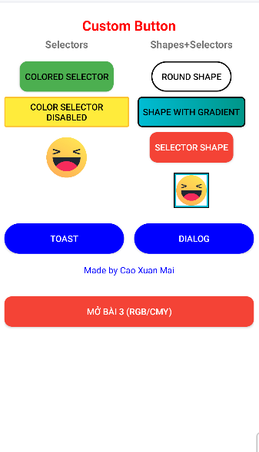

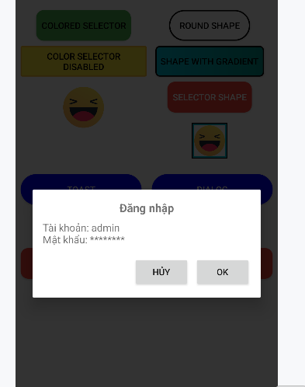

Bấm OK

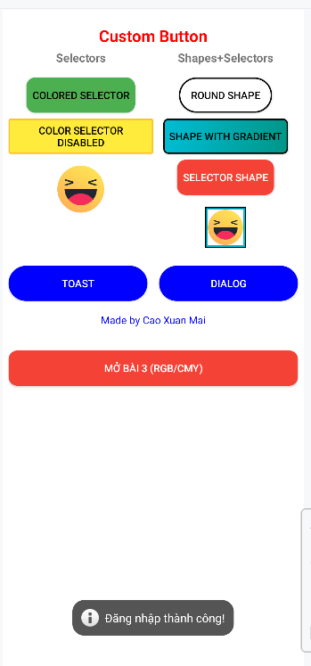

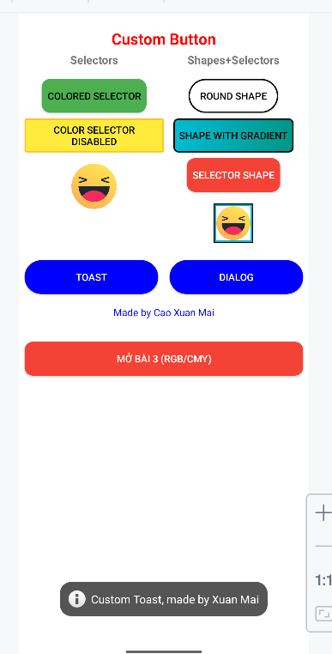

BẤM NÚT BÀI 3

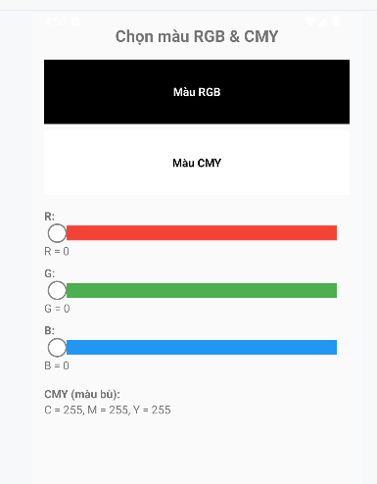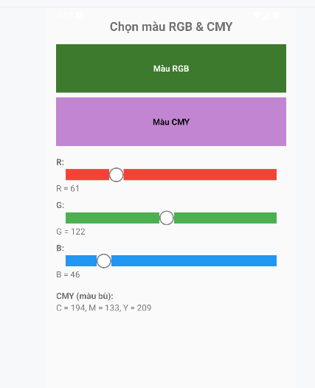

# LAB4

## Ứng Dụng Truyện Cười

**1. Chuẩn bị dự án**

• Tạo project Android Studio – Empty Views Activity.

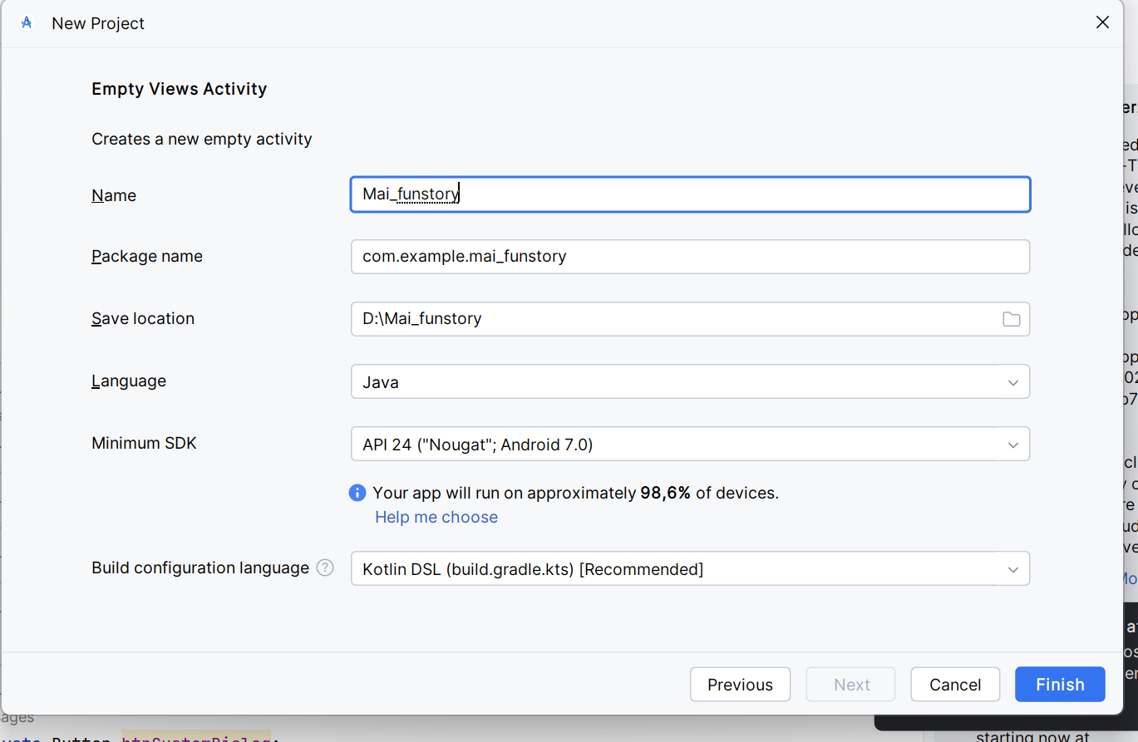

• Tạo thư mục assets/photo và assets/story.

• Tạo file assets/story/trangquynh.txt

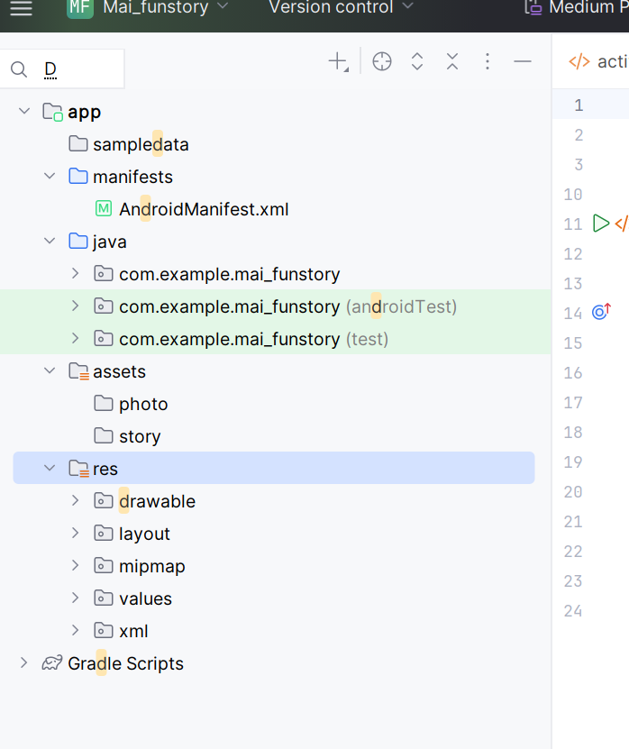

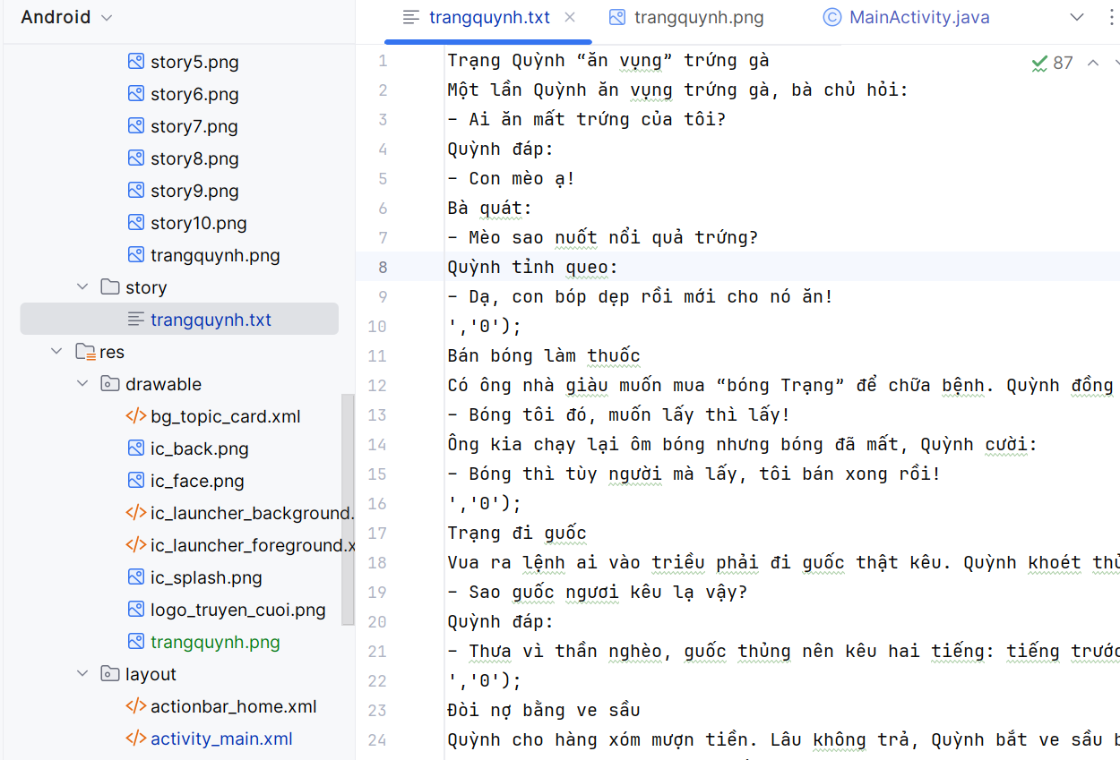

1. **Chuẩn bị tài nguyên** (DRAWABLE – STRING – COLORS – THEMES)  
   res/values/strings.xml

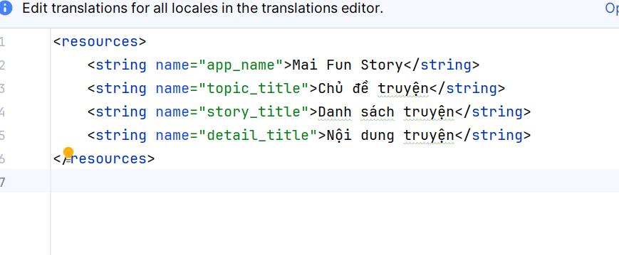

res/values/themes.xml

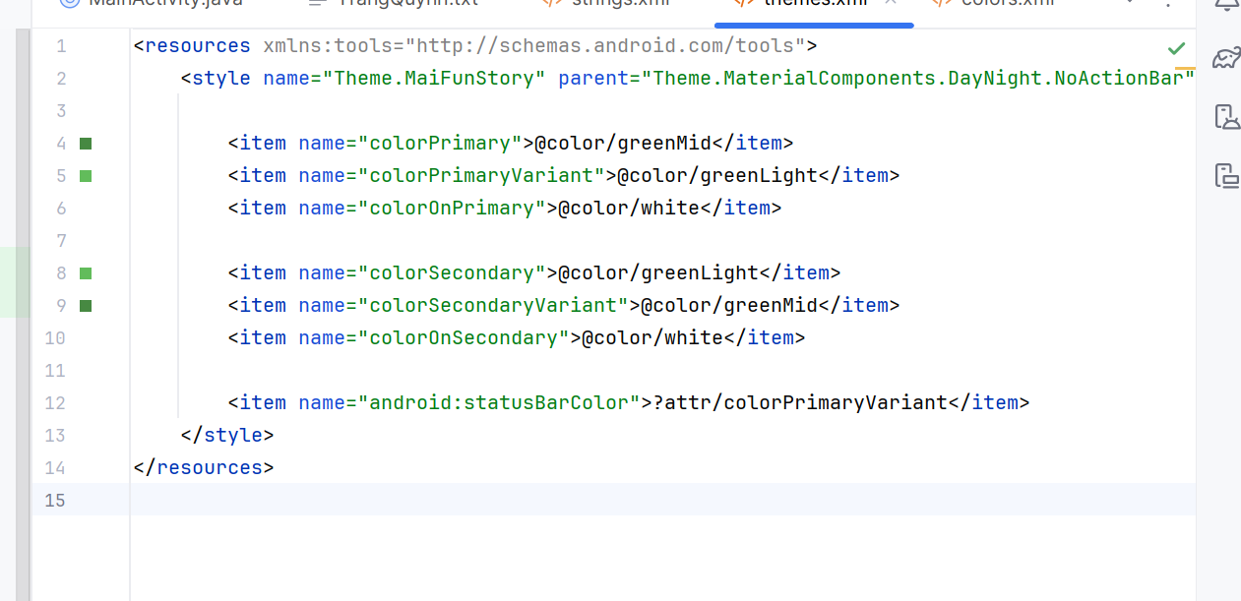

res/values/colors.xml

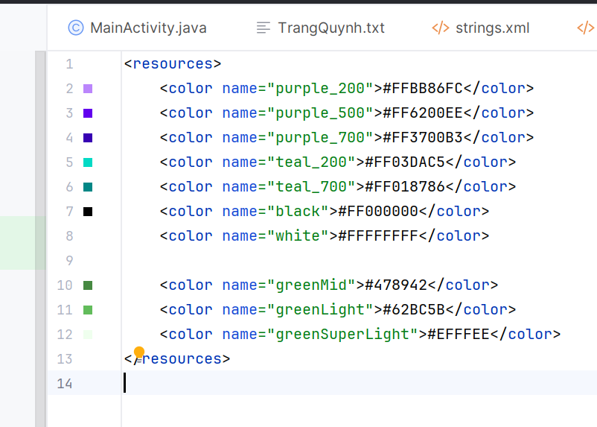

**3. Giao diện (XML)**

**file item_story.xml:**

*<?*xml version="1.0" encoding="utf-8"*?>*<LinearLayout ... >  
<LinearLayout ... >  
<ImageView  
android:id="@+id/iv_icon"  
android:layout_width="60dp"  
android:layout_height="60dp"/>  
<TextView  
android:id="@+id/tv_story"  
android:layout_width="match_parent"  
android:layout_height="match_parent"/>  
 </LinearLayout>  
 </LinearLayout>

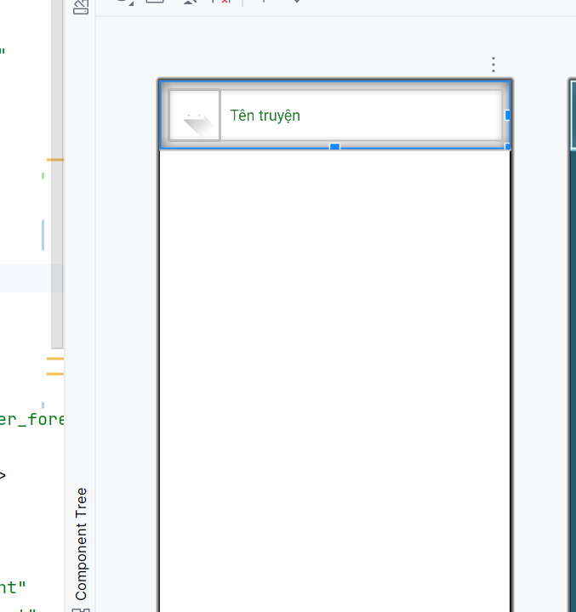**4. Adapter hiển thị danh sách truyện**

StoryAdapter.java dùng để load icon 1.png, 2.png, ..., 10.png tuỳ theo vị trí:

String fileName = (pos + 1) + ".png";  
InputStream is = context.getAssets().open("photo/" + fileName);  
Bitmap bitmap = BitmapFactory.decodeStream(is);  
h.iv.setImageBitmap(bitmap);

**5. File MainActivity.java**

Hàm chuyển sang màn đọc truyện M003:

public void gotoM003Screen(ArrayList<StoryEntity> list, StoryEntity s) {  
 M003DetailStoryFrg frg = new M003DetailStoryFrg();  
 frg.setData(topicName, list, s);  
 showFrg(frg);  
}

**6. M003DetailStoryFrg**

Dùng ViewPager để vuốt trái-phải chuyển truyện:

vp.setAdapter(new DetailStoryAdapter(list, context));  
 vp.setCurrentItem(list.indexOf(current), true);

**Sau đây là toàn bộ code hoàn chỉnh:**

**1. Tạo giao diện XML**

**1.1 activity_main.xml**

Container chứa fragment:

*<?*xml version="1.0" encoding="utf-8"*?>*<LinearLayout xmlns:android="http://schemas.android.com/apk/res/android"  
android:id="@+id/ln_main"  
android:layout_width="match_parent"  
android:layout_height="match_parent"  
android:orientation="vertical" />

**1.2 actionbar_home.xml**

<?xml version="1.0" encoding="utf-8"?><LinearLayout xmlns:android="http://schemas.android.com/apk/res/android"

android:layout_width="match_parent"

android:layout_height="56dp"

android:orientation="horizontal"

android:background="#4CAF50">

<ImageView

android:id="@+id/iv_back"

android:layout_width="56dp"

android:layout_height="56dp"

android:padding="12dp"

android:src="@drawable/ic_back"

android:visibility="gone"

android:tint="@android:color/white"/>

<TextView

android:id="@+id/tv_name"

android:layout_width="match_parent"

android:layout_height="match_parent"

android:paddingLeft="10dp"

android:gravity="center_vertical"

android:text="Truyện cười"

android:textSize="20sp"

android:textColor="@android:color/white"/>

</LinearLayout>

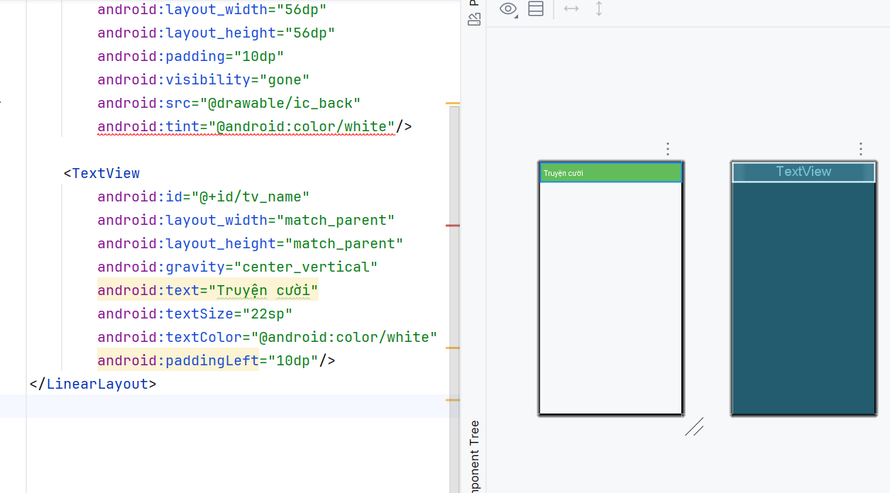

**1.3 item_story.xml**

<?xml version="1.0" encoding="utf-8"?><LinearLayout xmlns:android="http://schemas.android.com/apk/res/android"

android:layout_width="match_parent"

android:layout_height="wrap_content"

android:background="@android:color/white"

android:orientation="vertical">

<LinearLayout

android:layout_width="match_parent"

android:layout_height="wrap_content"

android:orientation="horizontal"

android:padding="10dp">

<ImageView

android:id="@+id/iv_icon"

android:layout_width="60dp"

android:layout_height="60dp"

android:scaleType="centerCrop"

android:src="@drawable/ic_launcher_foreground"/>

<TextView

android:id="@+id/tv_story"

android:layout_width="match_parent"

android:layout_height="match_parent"

android:paddingLeft="12dp"

android:text="Tên truyện"

android:textSize="18sp"

android:textColor="#2E7D32"

android:gravity="center_vertical"/>

</LinearLayout>

<View

android:layout_width="match_parent"

android:layout_height="1dp"

android:background="#EEEEEE"/>

</LinearLayout>

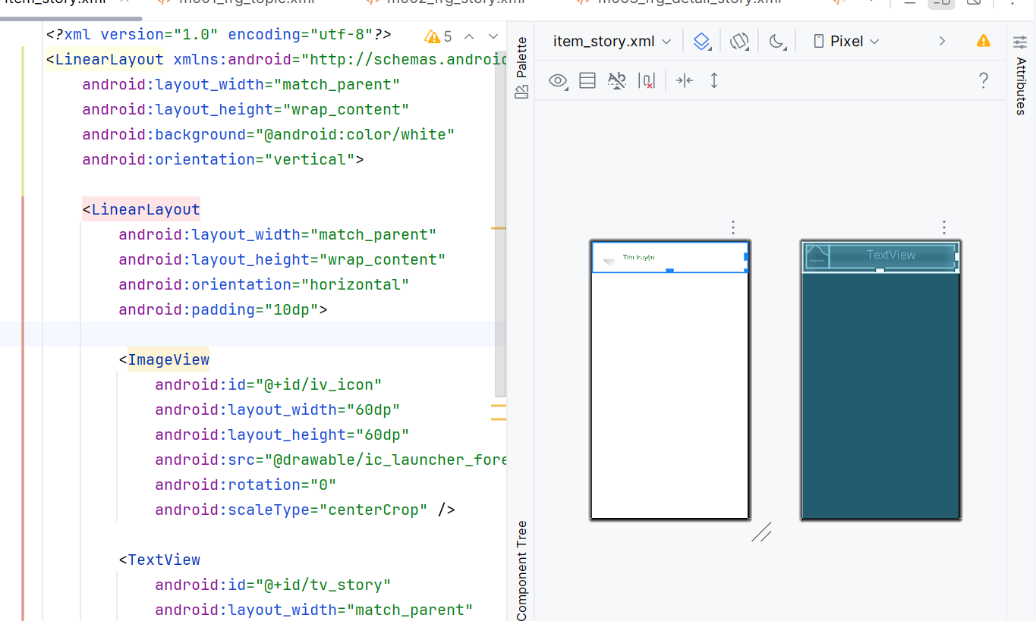

**2. Code Java**

**2.1 MainActivity.java**

public class MainActivity extends AppCompatActivity {

private String topicName = "Trạng Quỳnh";

@Override

protected void onCreate(Bundle savedInstanceState) {

super.onCreate(savedInstanceState);

setContentView(R.layout.activity_main);

showFrg(new M000SplashFrg());

}

public void showFrg(Fragment frg) {

getSupportFragmentManager()

.beginTransaction()

.replace(R.id.ln_main, frg)

.commit();

}

public void gotoM001Screen() {

showFrg(new M001TopicFrg());

}

public void gotoM002Screen() {

M002StoryFrg frg = new M002StoryFrg();

frg.setTopicName(topicName);

showFrg(frg);

}

public void backToM001Screen() {

gotoM001Screen();

}

public void gotoM003Screen(ArrayList<StoryEntity> list, StoryEntity s) {

M003DetailStoryFrg frg = new M003DetailStoryFrg();

frg.setData(topicName, list, s);

showFrg(frg);

}

**2.2 StoryAdapter.java**

public class StoryAdapter extends RecyclerView.Adapter<StoryAdapter.Holder> {

private final ArrayList<StoryEntity> list;

private final Context context;

public StoryAdapter(ArrayList<StoryEntity> list, Context context) {

this.list = list;

this.context = context;

}

@Override

public Holder onCreateViewHolder(ViewGroup parent, int viewType) {

return new Holder(LayoutInflater.from(context)

.inflate(R.layout.item_story, parent, false));

}

@Override

public void onBindViewHolder(Holder h, int pos) {

StoryEntity s = list.get(pos);

h.tv.setText(s.getName());

String fileName = (pos + 1) + ".png";

try {

InputStream is = context.getAssets().open("photo/" + fileName);

Bitmap bitmap = BitmapFactory.decodeStream(is);

h.iv.setImageBitmap(bitmap);

} catch (Exception e) {

e.printStackTrace();

}

h.itemView.setOnClickListener(v ->

((MainActivity) context).gotoM003Screen(list, s)

);

}

@Override

public int getItemCount() {

return list.size();

}

public static class Holder extends RecyclerView.ViewHolder {

TextView tv;

ImageView iv;

public Holder(View itemView) {

super(itemView);

tv = itemView.findViewById(R.id.tv_story);

iv = itemView.findViewById(R.id.iv_icon);

}

}

}

**2.3 M002StoryFrg.java – Load truyện từ assets**

private ArrayList<StoryEntity> readStory() {

ArrayList<StoryEntity> list = new ArrayList<>();

try {

BufferedReader br = new BufferedReader(

new InputStreamReader(mContext.getAssets()

.open("story/trangquynh.txt"), "UTF-8")

);

String line;

while ((line = br.readLine()) != null) {

String title = line.trim();

if (title.isEmpty()) continue;

StringBuilder content = new StringBuilder();

while ((line = br.readLine()) != null && !line.contains("','0');")) {

content.append(line).append("\n");

}

list.add(new StoryEntity(topicName, title, content.toString()));

}

br.close();

} catch (Exception e) {

e.printStackTrace();

}

return list;

}

**2.4 M003DetailStoryFrg.java**

package com.example.mai_funstory;  
  
import android.content.Context;  
import android.os.Bundle;  
import android.view.*;  
import android.widget.TextView;  
import androidx.fragment.app.Fragment;  
import androidx.viewpager.widget.ViewPager;  
  
import com.example.mai_funstory.adapter.DetailStoryAdapter;  
import com.example.mai_funstory.model.StoryEntity;  
  
import java.util.ArrayList;  
  
public class M003DetailStoryFrg extends Fragment {  
  
 private Context context;  
 private ArrayList<StoryEntity> list;  
 private StoryEntity current;  
 private String topicName;  
  
 @Override  
 public View onCreateView(LayoutInflater inflater, ViewGroup container, Bundle savedInstanceState) {  
 View v = inflater.inflate(R.layout.m003_frg_detail_story, container, false);  
  
 v.findViewById(R.id.iv_back).setVisibility(View.VISIBLE);  
 v.findViewById(R.id.iv_back).setOnClickListener(v1 ->  
 ((MainActivity)getActivity()).gotoM002Screen()  
 );  
  
 ((TextView)v.findViewById(R.id.tv_name)).setText(topicName);  
  
 ViewPager vp = v.findViewById(R.id.vp_story);  
 DetailStoryAdapter adapter = new DetailStoryAdapter(list, context);  
 vp.setAdapter(adapter);  
  
 vp.setCurrentItem(list.indexOf(current), true);  
  
 return v;  
 }  
  
 @Override  
 public void onAttach(Context ctx) {  
 super.onAttach(ctx);  
 context = ctx;  
 }  
  
 public void setData(String topic, ArrayList<StoryEntity> list, StoryEntity current) {  
 this.topicName = topic;  
 this.list = list;  
 this.current = current;  
 }  
}

**3. Logic hoạt động của ứng dụng**

Khi mở app → Splash → chuyển sang M001.

M001 hiển thị chủ đề Trạng Quỳnh.

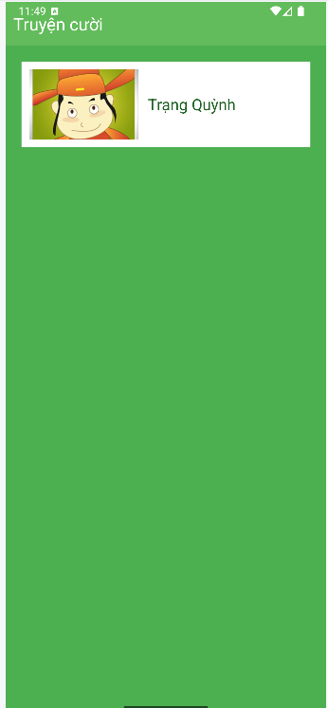

Bấm vào chủ đề → M002 đọc file truyện trong assets.

RecyclerView hiển thị danh sách 10 truyện kèm icon 1–10.

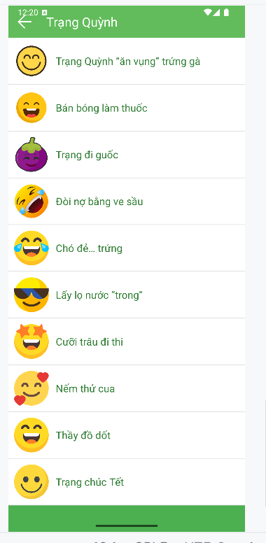

Bấm 1 truyện → M003 hiển thị tiêu đề + nội dung.

Vuốt trái/phải để xem truyện tiếp theo.

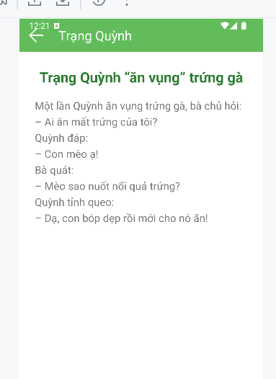

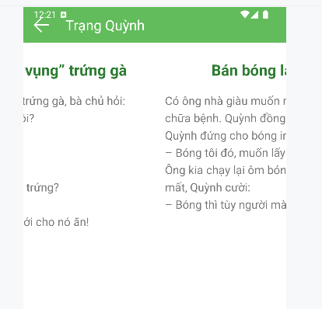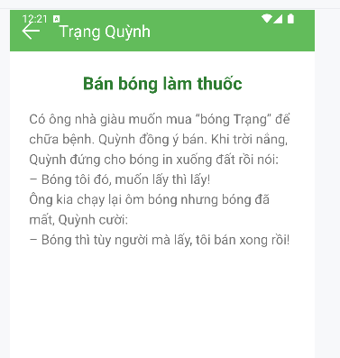

## Ứng dụng 12 cung hoàng đạo

**1. Tạo project mới**

Tên: Mai12Cung

Package: com.example.mai12cung

**2. Tạo 12 ảnh cung hoàng đạo cho drawable**

1. **res/values/strings.xml**

<resources>

<string name="app_name">12 Cung Hoàng Đạo</string>

</resources>

1. **res/values/colors.xml**

<?xml version="1.0" encoding="utf-8"?>

<resources>

<color name="greenMid">#478942</color>

<color name="greenLight">#62BC5B</color>

<color name="greenSuperLight">#EFFFEE</color>

</resources>

**5. res/layout/m001_act_menu.xml**

<?xml version="1.0" encoding="utf-8"?>  
<LinearLayout xmlns:android="http://schemas.android.com/apk/res/android"  
 xmlns:app="http://schemas.android.com/apk/res-auto"  
 android:layout_width="match_parent"  
 android:layout_height="match_parent"  
 android:orientation="vertical"  
 android:background="#E3F2FD">  
  
 <TextView  
 android:layout_width="match_parent"  
 android:layout_height="wrap_content"  
 android:text="@string/app_name"  
 android:textSize="28sp"  
 android:textStyle="bold"  
 android:gravity="center"  
 android:padding="16dp"  
 android:textColor="#1976D2" />  
  
 <androidx.constraintlayout.widget.ConstraintLayout  
 android:layout_width="match_parent"  
 android:layout_height="0dp"  
 android:layout_weight="1">  
  
 <View  
 android:id="@+id/center_guide"  
 android:layout_width="0dp"  
 android:layout_height="0dp"  
 app:layout_constraintTop_toTopOf="parent"  
 app:layout_constraintBottom_toBottomOf="parent"  
 app:layout_constraintStart_toStartOf="parent"  
 app:layout_constraintEnd_toEndOf="parent" />  
   
 <ImageView android:id="@+id/iv_aries" android:src="@drawable/aries" android:tag="0" app:layout_constraintCircle="@id/center_guide" app:layout_constraintCircleRadius="150dp" app:layout_constraintCircleAngle="0" android:layout_width="70dp" android:layout_height="70dp"/>  
 <ImageView android:id="@+id/iv_taurus" android:src="@drawable/taurus" android:tag="1" app:layout_constraintCircle="@id/center_guide" app:layout_constraintCircleRadius="150dp" app:layout_constraintCircleAngle="30" android:layout_width="70dp" android:layout_height="70dp"/>  
 <ImageView android:id="@+id/iv_gemini" android:src="@drawable/gemini" android:tag="2" app:layout_constraintCircle="@id/center_guide" app:layout_constraintCircleRadius="150dp" app:layout_constraintCircleAngle="60" android:layout_width="70dp" android:layout_height="70dp"/>  
 <ImageView android:id="@+id/iv_cancer" android:src="@drawable/cancer" android:tag="3" app:layout_constraintCircle="@id/center_guide" app:layout_constraintCircleRadius="150dp" app:layout_constraintCircleAngle="90" android:layout_width="70dp" android:layout_height="70dp"/>  
 <ImageView android:id="@+id/iv_leo" android:src="@drawable/leo" android:tag="4" app:layout_constraintCircle="@id/center_guide" app:layout_constraintCircleRadius="150dp" app:layout_constraintCircleAngle="120" android:layout_width="70dp" android:layout_height="70dp"/>  
 <ImageView android:id="@+id/iv_virgo" android:src="@drawable/virgo" android:tag="5" app:layout_constraintCircle="@id/center_guide" app:layout_constraintCircleRadius="150dp" app:layout_constraintCircleAngle="150" android:layout_width="70dp" android:layout_height="70dp"/>  
 <ImageView android:id="@+id/iv_libra" android:src="@drawable/libra" android:tag="6" app:layout_constraintCircle="@id/center_guide" app:layout_constraintCircleRadius="150dp" app:layout_constraintCircleAngle="180" android:layout_width="70dp" android:layout_height="70dp"/>  
 <ImageView android:id="@+id/iv_scorpio" android:src="@drawable/scorpio" android:tag="7" app:layout_constraintCircle="@id/center_guide" app:layout_constraintCircleRadius="150dp" app:layout_constraintCircleAngle="210" android:layout_width="70dp" android:layout_height="70dp"/>  
 <ImageView android:id="@+id/iv_sagittarius" android:src="@drawable/sagittarius" android:tag="8" app:layout_constraintCircle="@id/center_guide" app:layout_constraintCircleRadius="150dp" app:layout_constraintCircleAngle="240" android:layout_width="70dp" android:layout_height="70dp"/>  
 <ImageView android:id="@+id/iv_capricorn" android:src="@drawable/capricorn" android:tag="9" app:layout_constraintCircle="@id/center_guide" app:layout_constraintCircleRadius="150dp" app:layout_constraintCircleAngle="270" android:layout_width="70dp" android:layout_height="70dp"/>  
 <ImageView android:id="@+id/iv_aquarius" android:src="@drawable/aquarius" android:tag="10" app:layout_constraintCircle="@id/center_guide" app:layout_constraintCircleRadius="150dp" app:layout_constraintCircleAngle="300" android:layout_width="70dp" android:layout_height="70dp"/>  
 <ImageView android:id="@+id/iv_pisces" android:src="@drawable/pisces" android:tag="11" app:layout_constraintCircle="@id/center_guide" app:layout_constraintCircleRadius="150dp" app:layout_constraintCircleAngle="330" android:layout_width="70dp" android:layout_height="70dp"/>  
  
 </androidx.constraintlayout.widget.ConstraintLayout>  
   
 <LinearLayout  
 android:id="@+id/ll_info"  
 android:layout_width="match_parent"  
 android:layout_height="wrap_content"  
 android:orientation="vertical"  
 android:padding="20dp"  
 android:background="#FFFFFF"  
 android:elevation="8dp">  
  
 <ImageView  
 android:id="@+id/iv_selected"  
 android:layout_width="130dp"  
 android:layout_height="130dp"  
 android:layout_gravity="center_horizontal"  
 android:src="@drawable/aries" />  
  
 <TextView  
 android:id="@+id/tv_name"  
 android:layout_width="match_parent"  
 android:layout_height="wrap_content"  
 android:text="Bạch Dương"  
 android:textSize="26sp"  
 android:textStyle="bold"  
 android:gravity="center"  
 android:layout_marginTop="12dp"  
 android:textColor="#1976D2" />  
  
 <ScrollView  
 android:layout_width="match_parent"  
 android:layout_height="160dp"  
 android:layout_marginTop="12dp">  
 <TextView  
 android:id="@+id/tv_content"  
 android:layout_width="match_parent"  
 android:layout_height="wrap_content"  
 android:text="@string/content_default"  
 android:textSize="16sp"  
 android:lineSpacingExtra="6dp" />  
 </ScrollView>  
  
 <Button  
 android:id="@+id/btn_detail"  
 android:layout_width="match_parent"  
 android:layout_height="56dp"  
 android:text="Xem Thêm"  
 android:layout_marginTop="16dp"  
 android:backgroundTint="#1976D2"  
 android:textColor="#FFFFFF"  
 android:textStyle="bold" />  
  
 </LinearLayout>  
</LinearLayout>

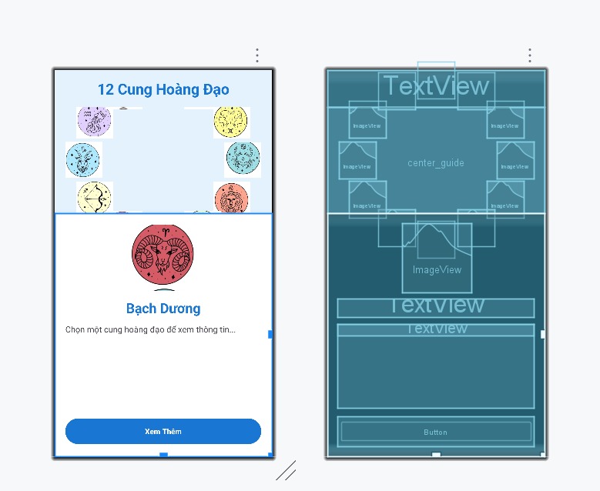

**6. res/layoutm002_act_detail.xml**

<?xml version="1.0" encoding="utf-8"?>  
<LinearLayout xmlns:android="http://schemas.android.com/apk/res/android"  
 android:layout_width="match_parent"  
 android:layout_height="match_parent"  
 android:orientation="vertical"  
 android:background="#E3F2FD"  
 android:padding="20dp">  
  
 <Button  
 android:id="@+id/btn_back"  
 android:layout_width="wrap_content"  
 android:layout_height="wrap_content"  
 android:text="QUAY LẠI"  
 android:backgroundTint="#1976D2"  
 android:textColor="#FFFFFF" />  
  
 <ImageView  
 android:id="@+id/iv_detail"  
 android:layout_width="180dp"  
 android:layout_height="180dp"  
 android:layout_gravity="center_horizontal"  
 android:layout_marginTop="20dp"  
 android:src="@drawable/aries" />  
  
 <TextView  
 android:id="@+id/tv_detail_name"  
 android:layout_width="match_parent"  
 android:layout_height="wrap_content"  
 android:text="Bạch Dương"  
 android:textSize="28sp"  
 android:textStyle="bold"  
 android:gravity="center"  
 android:layout_marginTop="16dp"  
 android:textColor="#1976D2" />  
  
 <ScrollView  
 android:layout_width="match_parent"  
 android:layout_height="match_parent"  
 android:layout_marginTop="16dp">  
 <TextView  
 android:id="@+id/tv_detail_content"  
 android:layout_width="match_parent"  
 android:layout_height="wrap_content"  
 android:textSize="17sp"  
 android:lineSpacingExtra="8dp" />  
 </ScrollView>  
</LinearLayout>

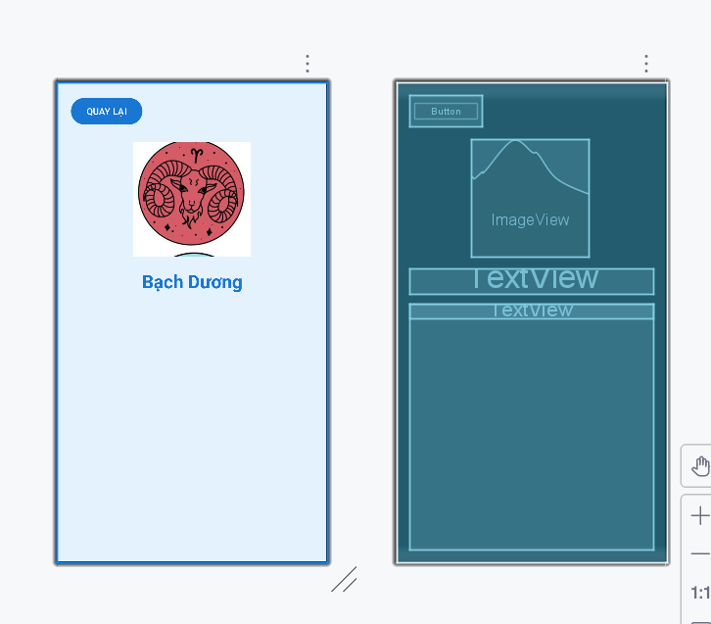

7. M001MenuActivity.java

package com.example.mai12cung;  
  
import android.content.Intent;  
import android.os.Bundle;  
import android.widget.Button;  
import android.widget.ImageView;  
import android.widget.TextView;  
import androidx.appcompat.app.AppCompatActivity;  
  
public class M001MenuActivity extends AppCompatActivity {  
  
 private final int[] zodiacImages = {  
 R.drawable.*aries*, R.drawable.*taurus*, R.drawable.*gemini*, R.drawable.*cancer*,  
 R.drawable.*leo*, R.drawable.*virgo*, R.drawable.*libra*, R.drawable.*scorpio*,  
 R.drawable.*sagittarius*, R.drawable.*capricorn*, R.drawable.*aquarius*, R.drawable.*pisces* };  
  
 private final int[] zodiacIds = {  
 R.id.*iv_aries*, R.id.*iv_taurus*, R.id.*iv_gemini*, R.id.*iv_cancer*,  
 R.id.*iv_leo*, R.id.*iv_virgo*, R.id.*iv_libra*, R.id.*iv_scorpio*,  
 R.id.*iv_sagittarius*, R.id.*iv_capricorn*, R.id.*iv_aquarius*, R.id.*iv_pisces* };  
  
 private final String[] zodiacNames = {  
 "Bạch Dương", "Kim Ngưu", "Song Tử", "Cự Giải", "Sư Tử", "Xử Nữ",  
 "Thiên Bình", "Thiên Yết", "Nhân Mã", "Ma Kết", "Bảo Bình", "Song Ngư"  
 };  
  
 private final int[] contentRes = {  
 R.string.*aries_content*, R.string.*taurus_content*, R.string.*gemini_content*, R.string.*cancer_content*,  
 R.string.*leo_content*, R.string.*virgo_content*, R.string.*libra_content*, R.string.*scorpio_content*,  
 R.string.*sagittarius_content*, R.string.*capricorn_content*, R.string.*aquarius_content*, R.string.*pisces_content* };  
  
 private ImageView ivSelected;  
 private TextView tvName, tvContent;  
 private Button btnDetail;  
 private int currentIndex = 0;  
  
 @Override  
 protected void onCreate(Bundle savedInstanceState) {  
 super.onCreate(savedInstanceState);  
 setContentView(R.layout.*m001_act_menu*);  
 if (getSupportActionBar() != null) getSupportActionBar().hide();  
  
 ivSelected = findViewById(R.id.*iv_selected*);  
 tvName = findViewById(R.id.*tv_name*);  
 tvContent = findViewById(R.id.*tv_content*);  
 btnDetail = findViewById(R.id.*btn_detail*);  
  
 for (int i = 0; i < 12; i++) {  
 final int index = i;  
 findViewById(zodiacIds[i]).setOnClickListener(v -> showInfo(index));  
 }  
  
 btnDetail.setOnClickListener(v -> {  
 Intent intent = new Intent(M001MenuActivity.this, M002DetailActivity.class);  
 intent.putExtra("image", zodiacImages[currentIndex]);  
 intent.putExtra("name", zodiacNames[currentIndex]);  
 intent.putExtra("content", getString(contentRes[currentIndex]));  
 startActivity(intent);  
 });  
  
 showInfo(0);  
 }  
  
 private void showInfo(int index) {  
 currentIndex = index;  
 ivSelected.setImageResource(zodiacImages[index]);  
 tvName.setText(zodiacNames[index]);  
 tvContent.setText(contentRes[index]);  
 }  
}

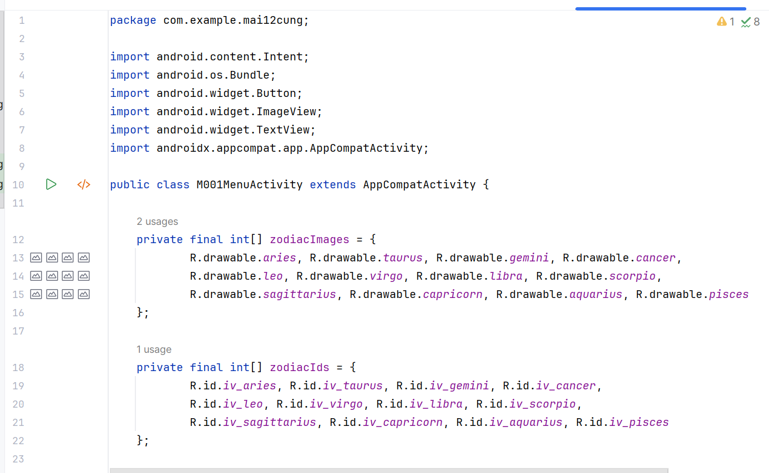

1. M002DetailActivity.java

package com.example.mai12cung;  
  
import android.os.Bundle;  
import android.widget.Button;  
import android.widget.ImageView;  
import android.widget.TextView;  
import androidx.appcompat.app.AppCompatActivity;  
  
public class M002DetailActivity extends AppCompatActivity {  
 @Override  
 protected void onCreate(Bundle savedInstanceState) {  
 super.onCreate(savedInstanceState);  
 setContentView(R.layout.m002_act_detail);  
 if (getSupportActionBar() != null) getSupportActionBar().hide();  
  
 ImageView iv = findViewById(R.id.iv_detail);  
 TextView tvName = findViewById(R.id.tv_detail_name);  
 TextView tvContent = findViewById(R.id.tv_detail_content);  
 Button btnBack = findViewById(R.id.btn_back);  
  
 iv.setImageResource(getIntent().getIntExtra("image", R.drawable.aries));  
 tvName.setText(getIntent().getStringExtra("name"));  
 tvContent.setText(getIntent().getStringExtra("content"));  
  
 btnBack.setOnClickListener(v -> finish());  
 }  
}

**KẾT QUẢ**

Giao diện vòng tròn với mặc định là cung Bạch Dương

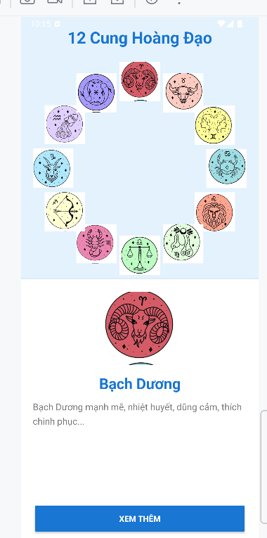

Bấm xem thêm ra giao diện chi tiết cung Bạch dương

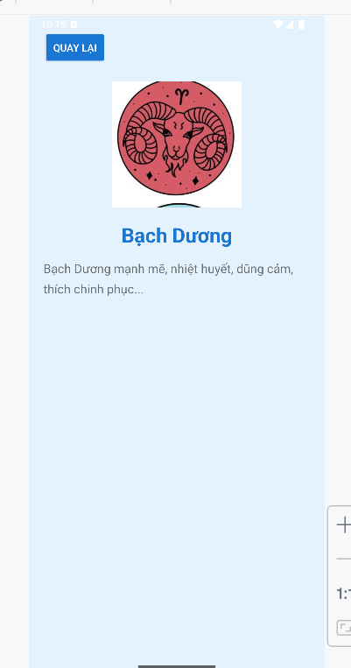

Bấm quay lại ra trang chủ, chọn cung khác vd cung ma kết

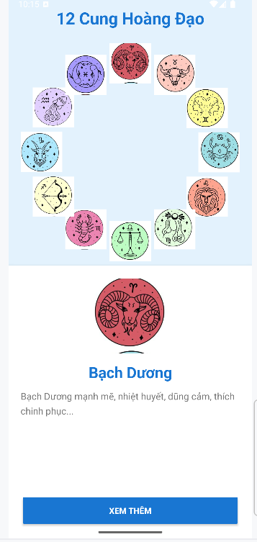

Chi tiết cung ma kết

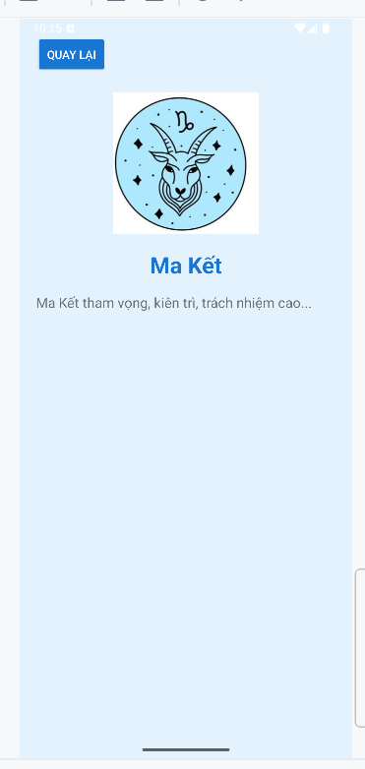

# **LAB5**

## I. TẠO DỰ ÁN MỚI TÊN MaiLab5

**Mở Android Studio → Tạo dự án mới**

* Chọn: **Empty Activity**
* Name: MaiLab5
* Package name: com.mai.mailab5
* Language: **Java**
* Minimum API: API 21
* Use AndroidX: ✓ → Nhấn Finish

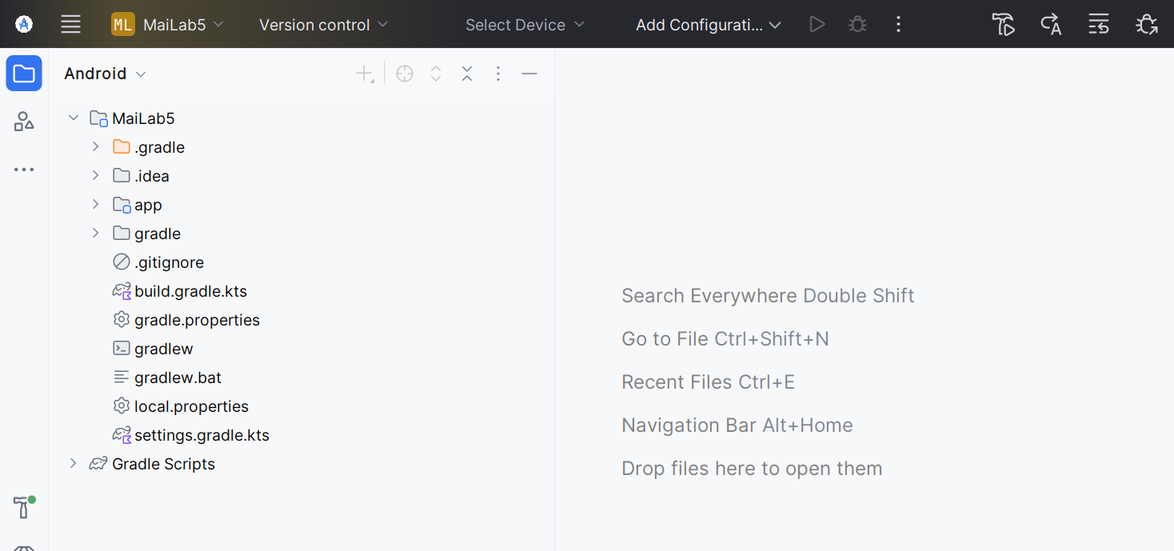

## II. CHUẨN BỊ TÀI NGUYÊN (Drawable, Color, String)

**Tạo các file drawable cần thiết**

**Tạo bg_login** (nền gradient cam) → Chuột phải res/drawable → New → Drawable Resource File → tên: bg_login →

*<?*xml version="1.0" encoding="utf-8"*?>*<layer-list xmlns:android="http://schemas.android.com/apk/res/android">  
 <item android:bottom="3dp">  
 <shape>  
 <corners android:radius="20dp" />  
 <gradient android:angle="180" android:endColor="@color/orange" android:startColor="@color/orangeMid"/>  
 </shape>  
 </item>  
</layer-list>

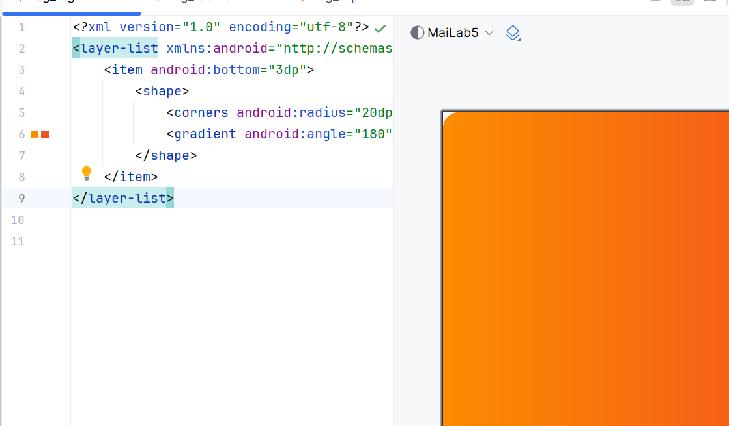

colors.xml

Định nghĩa màu sắc dùng chung trong toàn ứng dụng, giúp các thành phần có phong cách đồng nhất.

<resources>  
<color name="purple_200">#FFBB86FC</color>  
<color name="purple_500">#FF6200EE</color>  
<color name="purple_700">#F4511E</color>  
<color name="teal_200">#FF03DAC5</color>  
<color name="teal_700">#FF018786</color>  
<color name="black">#FF000000</color>  
<color name="white">#FFFFFFFF</color>  
<color name="orange">#FB8C00</color>  
<color name="gray">#EAE5E3</color>  
<color name="orangeMid">#F4511E</color>  
</resources>

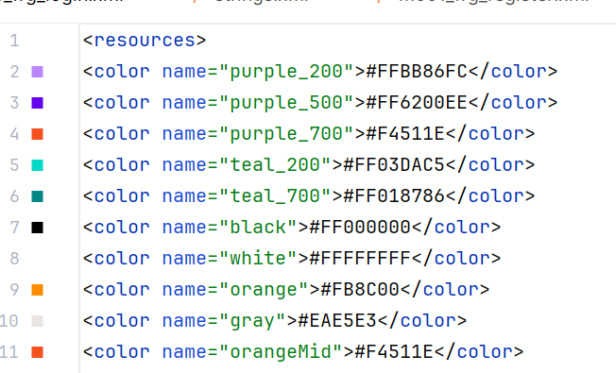

Dùng cho màu nền, nút, ô input.

bg_radius.xml

Dùng để bo góc cho ô nhập liệu.

<shape xmlns:android="http://schemas.android.com/apk/res/android">  
 <corners android:radius="20dp"/>  
 <solid android:color="@android:color/white"/>  
</shape>

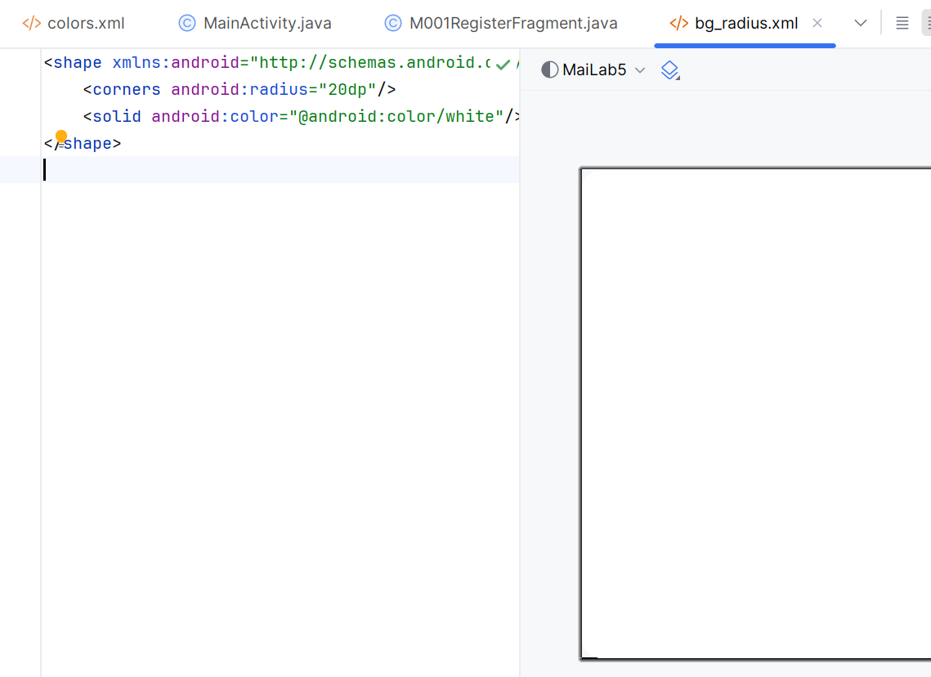

bg_login.xml (nút Login)

<shape xmlns:android="http://schemas.android.com/apk/res/android">  
 <corners android:radius="20dp"/>  
 <gradient  
 android:angle="0"  
 android:startColor="@color/orangeMid"  
 android:endColor="@color/orange"/>  
</shape>

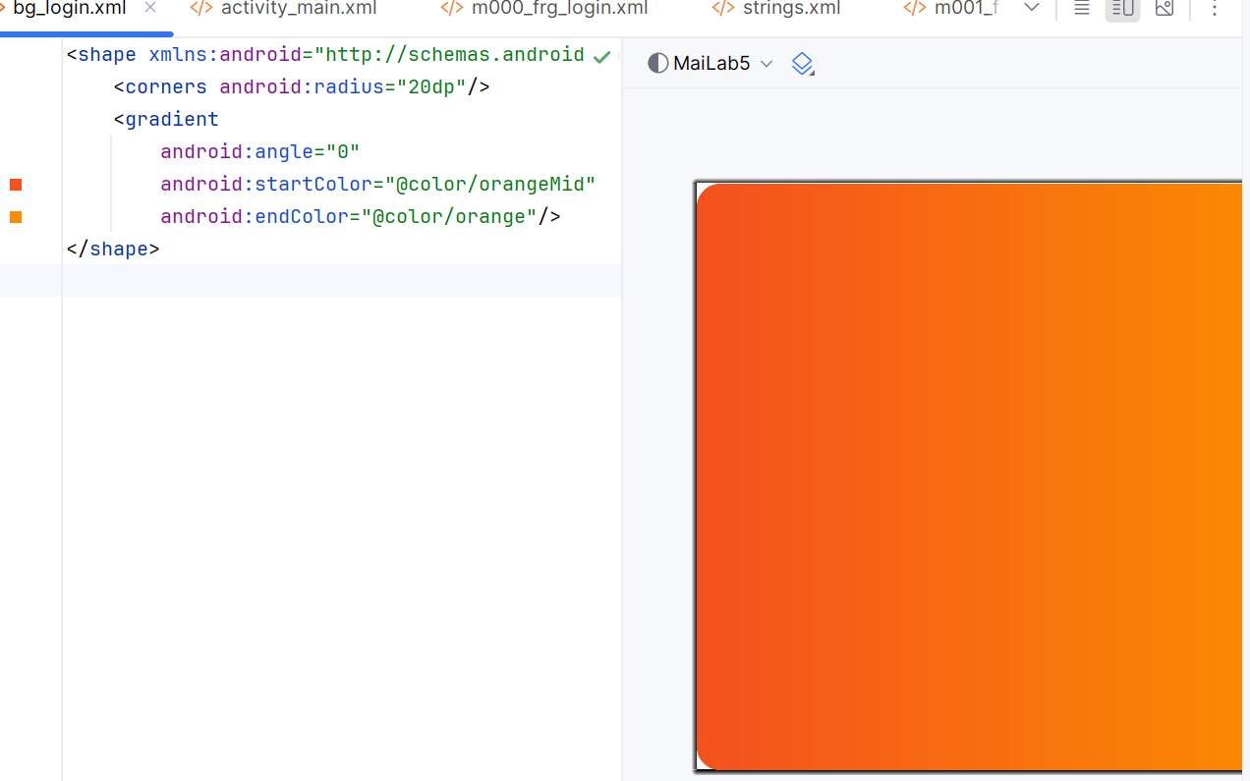

Strings.xml

<resources>  
<string name="app_name">Login</string>  
<string name="txt_login">Login</string>  
<string name="hint_email">Email</string>  
<string name="hint_password">Password</string>  
<string name="txt_forgot_pass">Forgot password?</string>  
<string name="txt_no_account">Don’t have an account?</string>  
<string name="txt_register">Register</string>  
</resources>

## III. THIẾT KẾ GIAO DIỆN (LAYOUT XML)

Layout Login (m000_frg_login.xml)

*<?*xml version="1.0" encoding="utf-8"*?>*<LinearLayout xmlns:android="http://schemas.android.com/apk/res/android"  
 android:layout_width="match_parent"  
 android:layout_height="match_parent"  
 android:background="@color/gray"  
 android:orientation="vertical">  
  
 <FrameLayout  
 android:layout_width="match_parent"  
 android:layout_height="260dp">  
  
 <View  
 android:layout_width="match_parent"  
 android:layout_height="260dp"  
 android:background="@drawable/bg_top" />  
  
 <TextView  
 android:id="@+id/tv_title"  
 android:layout_width="wrap_content"  
 android:layout_height="wrap_content"  
 android:layout_gravity="end|bottom"  
 android:layout_marginEnd="32dp"  
 android:layout_marginBottom="32dp"  
 android:text="@string/txt_login"  
 android:textColor="@color/white"  
 android:textSize="22sp"  
 android:textStyle="bold" />  
 </FrameLayout>

<EditText  
 android:id="@+id/edt_email"  
 android:layout_width="match_parent"  
 android:layout_height="50dp"  
 android:layout_marginHorizontal="30dp"  
 android:layout_marginTop="35dp"  
 android:background="@drawable/bg_radius"  
 android:drawableStart="@drawable/ic_email"  
 android:drawablePadding="15dp"  
 android:hint="@string/hint_email"  
 android:inputType="textEmailAddress"  
 android:paddingStart="48dp"  
 android:textSize="16sp" />  
  
 <EditText  
 android:id="@+id/edt_pass"  
 android:layout_width="match_parent"  
 android:layout_height="50dp"  
 android:layout_marginHorizontal="30dp"  
 android:layout_marginTop="15dp"  
 android:background="@drawable/bg_radius"  
 android:drawableStart="@drawable/ic_key"  
 android:drawablePadding="15dp"  
 android:hint="@string/hint_password"  
 android:inputType="textPassword"  
 android:paddingStart="48dp"  
 android:textSize="16sp" />  
  
 <TextView  
 android:id="@+id/tv_forgot"  
 android:layout_width="wrap_content"  
 android:layout_height="wrap_content"  
 android:layout_marginEnd="32dp"  
 android:layout_marginTop="10dp"  
 android:gravity="end"  
 android:layout_gravity="end"  
 android:text="Forgot password?"  
 android:textSize="14sp"  
 android:textColor="@color/black" />  
  
<TextView  
 android:id="@+id/tv_login"  
 android:layout_width="match_parent"  
 android:layout_height="50dp"  
 android:layout_marginHorizontal="30dp"  
 android:layout_marginTop="25dp"  
 android:gravity="center"  
 android:background="@drawable/bg_login"  
 android:text="@string/txt_login"  
 android:textColor="@color/white"  
 android:textSize="18sp"  
 android:textStyle="bold" />  
<LinearLayout  
 android:layout_width="match_parent"  
 android:layout_height="wrap_content"  
 android:gravity="center"  
 android:orientation="horizontal"  
 android:layout_marginTop="20dp">  
  
 <TextView  
 android:id="@+id/tv_no_account"  
 android:layout_width="wrap_content"  
 android:layout_height="wrap_content"  
 android:text="Don't have an account?"  
 android:textColor="@color/black"  
 android:textSize="14sp" />  
  
 <TextView  
 android:id="@+id/tv_register"  
 android:layout_width="wrap_content"  
 android:layout_height="wrap_content"  
 android:layout_marginStart="6dp"  
 android:text="Register"  
 android:textColor="@color/orange"  
 android:textSize="14sp"  
 android:textStyle="bold" />  
 </LinearLayout>  
  
</LinearLayout>

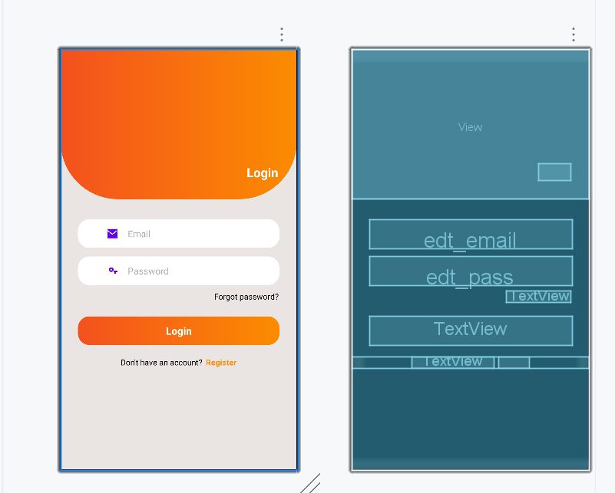

3. Layout Register (m001_frg_register.xml)

Giống màn Login nhưng thêm:

Nhập lại password

Icon quay lại

Nút Register

*<?*xml version="1.0" encoding="utf-8"*?>*<LinearLayout xmlns:android="http://schemas.android.com/apk/res/android"  
 xmlns:app="http://schemas.android.com/apk/res-auto"  
 android:layout_width="match_parent"  
 android:layout_height="match_parent"  
 android:orientation="vertical"  
 android:background="@color/gray">  
  
 <FrameLayout  
 android:layout_width="match_parent"  
 android:layout_height="wrap_content">  
  
 <View  
 android:layout_width="match_parent"  
 android:layout_height="300dp"  
 android:background="@drawable/bg_top" />  
  
 <ImageView  
 android:id="@+id/iv_back"  
 android:layout_width="56dp"  
 android:layout_height="56dp"  
 android:padding="10dp"  
 android:src="@drawable/ic_back"  
 app:tint="@color/white"  
 android:contentDescription="@string/txt_register" />  
  
 <TextView  
 android:layout_width="wrap_content"  
 android:layout_height="wrap_content"  
 android:layout_gravity="end"  
 android:layout_marginTop="220dp"  
 android:layout_marginEnd="30dp"  
 android:text="@string/txt_register"  
 android:textColor="@color/white"  
 android:textSize="20sp" />  
 </FrameLayout>  
  
 <EditText  
 android:id="@+id/edt_email"  
 android:layout_width="match_parent"  
 android:layout_height="50dp"  
 android:layout_marginHorizontal="30dp"  
 android:layout_marginTop="50dp"  
 android:background="@drawable/bg_radius"  
 android:drawableLeft="@drawable/ic_email"  
 android:drawablePadding="10dp"  
 android:hint="@string/hint_email"  
 android:textSize="18sp" />  
  
 <EditText  
 android:id="@+id/edt_pass"  
 android:layout_width="match_parent"  
 android:layout_height="50dp"  
 android:layout_marginHorizontal="30dp"  
 android:layout_marginTop="10dp"  
 android:background="@drawable/bg_radius"  
 android:drawableLeft="@drawable/ic_key"  
 android:drawablePadding="10dp"  
 android:hint="@string/hint_password"  
 android:textSize="18sp" />  
  
 <EditText  
 android:id="@+id/edt_re_pass"  
 android:layout_width="match_parent"  
 android:layout_height="50dp"  
 android:layout_marginHorizontal="30dp"  
 android:layout_marginTop="10dp"  
 android:background="@drawable/bg_radius"  
 android:drawableLeft="@drawable/ic_key"  
 android:drawablePadding="10dp"  
 android:hint="@string/hint_password"  
 android:textSize="18sp" />  
  
 <TextView  
 android:id="@+id/tv_register"  
 android:layout_width="match_parent"  
 android:layout_height="50dp"  
 android:layout_marginHorizontal="30dp"  
 android:layout_marginTop="20dp"  
 android:background="@drawable/bg_login"  
 android:gravity="center"  
 android:text="@string/txt_register"  
 android:textColor="@color/white"  
 android:textSize="18sp" />  
  
</LinearLayout>

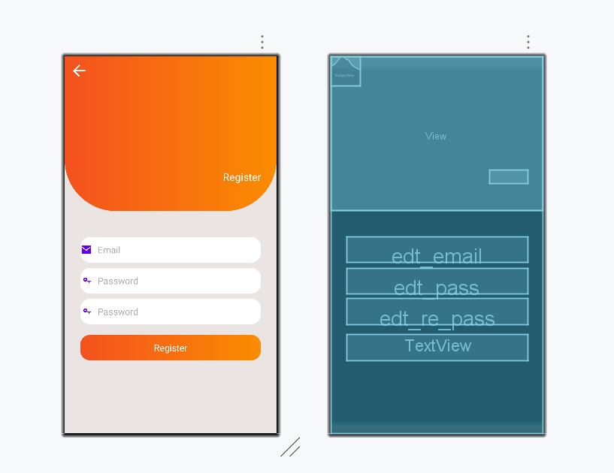

## IV. THỰC HIỆN XỬ LÝ LOGIC ĐĂNG NHẬP / ĐĂNG KÝ BẰNG SHAREDPREFERENCES

**MainActivity.java**

Điều hướng giữa Login và Register

package com.example.mailab5;  
import android.os.Bundle;  
import androidx.appcompat.app.AppCompatActivity;  
  
public class MainActivity extends AppCompatActivity{  
 public static final String *SAVE_PREF*="save_pref";  
  
 @Override  
 protected void onCreate(Bundle b){  
 super.onCreate(b);  
 setContentView(R.layout.*activity_main*);  
 gotoLoginScreen();  
 }  
  
 public void gotoRegisterScreen(){  
 getSupportFragmentManager().beginTransaction().replace(R.id.*ln_main*,new M001RegisterFragment()).commit();  
 }  
  
 public void gotoLoginScreen(){  
 getSupportFragmentManager().beginTransaction().replace(R.id.*ln_main*,new M000LoginFragment()).commit();  
 }  
}

MainActivity đóng vai trò điều hướng giữa hai Fragment đăng nhập và đăng ký. Giúp ứng dụng linh hoạt, không cần chuyển Activity.

**M000LoginFragment.java**

package com.example.mailab5;  
  
import android.content.Context;  
import android.content.SharedPreferences;  
import android.os.Bundle;  
import android.view.LayoutInflater;  
import android.view.View;  
import android.view.ViewGroup;  
import android.widget.EditText;  
import android.widget.Toast;  
  
import androidx.fragment.app.Fragment;  
  
public class M000LoginFragment extends Fragment implements View.OnClickListener {  
  
 EditText edtEmail, edtPass;  
 Context mContext;  
  
 @Override  
 public View onCreateView(LayoutInflater inflater, ViewGroup container, Bundle savedInstanceState){  
 View v = inflater.inflate(R.layout.*m000_frg_login*, container,false);  
 edtEmail = v.findViewById(R.id.*edt_email*);  
 edtPass = v.findViewById(R.id.*edt_pass*);  
 v.findViewById(R.id.*tv_login*).setOnClickListener(this);  
 v.findViewById(R.id.*tv_register*).setOnClickListener(this);  
 return v;  
 }  
  
 @Override  
 public void onAttach(Context c){  
 super.onAttach(c);  
 mContext = c;  
 }  
  
 @Override  
 public void onClick(View v){  
 if(v.getId() == R.id.*tv_login*){  
 login(edtEmail.getText().toString(), edtPass.getText().toString());  
 }else{  
 ((MainActivity)mContext).gotoRegisterScreen();  
 }  
 }  
  
 private void login(String m, String p){  
 if(m.isEmpty() || p.isEmpty()){  
 Toast.*makeText*(mContext, "Empty value", Toast.*LENGTH_SHORT*).show();  
 return;  
 }  
 SharedPreferences pref = mContext.getSharedPreferences(MainActivity.*SAVE_PREF*, Context.*MODE_PRIVATE*);  
 String saved = pref.getString(m, null);  
 if(saved == null){  
 Toast.*makeText*(mContext, "Email not exist", Toast.*LENGTH_SHORT*).show();  
 return;  
 }  
 if(!saved.equals(p)){  
 Toast.*makeText*(mContext, "Wrong pass", Toast.*LENGTH_SHORT*).show();  
 return;  
 }  
 Toast.*makeText*(mContext, "Login OK", Toast.*LENGTH_SHORT*).show();  
 }  
}

**GIẢI THÍCH LOGIC ĐĂNG NHẬP**

1. onCreateView()

* Phương thức onCreateView() chịu trách nhiệm nạp giao diện của màn hình đăng nhập từ file m000_frg_login.xml.
* Tại đây, hệ thống ánh xạ các thành phần giao diện gồm hai EditText (email và mật khẩu) và hai TextView tương ứng với nút Login và nút chuyển sang màn hình đăng ký. Đồng thời fragment gán sự kiện click cho các View này.

2. onAttach()

* Fragment nhận Context từ Activity cha (MainActivity).
* Context này được sử dụng cho hai mục đích chính:
* Hiển thị thông báo bằng Toast
* Truy cập vào SharedPreferences để kiểm tra tài khoản

3. onClick()

* Khi người dùng nhấn vào một trong hai nút:
* Nếu nhấn “Login”, hệ thống gọi hàm login() với hai tham số là email và mật khẩu mà người dùng nhập vào.
* Nếu nhấn “Register”, hệ thống yêu cầu Activity chuyển sang màn hình đăng ký thông qua gotoRegisterScreen().

4. Quy trình xử lý đăng nhập trong hàm login()

* Hàm login() thực hiện đầy đủ các bước kiểm tra và xác thực như sau:

Bước 1 – Kiểm tra dữ liệu rỗng

Nếu người dùng để trống email hoặc mật khẩu, hệ thống dừng xử lý và báo lỗi “Empty value”.

Bước 2 – Mở SharedPreferences

Ứng dụng mở file SharedPreferences dùng chung trong toàn bộ hệ thống thông qua tên file SAVE_PREF.

Bước 3 – Lấy mật khẩu đã lưu

Ứng dụng tìm mật khẩu được lưu tương ứng với email người dùng nhập.

Nếu không tìm thấy key, nghĩa là email chưa tồn tại trong hệ thống.

Bước 4 – Kiểm tra email hợp lệ

Nếu giá trị nhận được là null, hệ thống thông báo “Email not exist” và dừng xử lý.

Bước 5 – So sánh mật khẩu

Nếu email tồn tại nhưng mật khẩu không trùng khớp với mật khẩu đã lưu, hệ thống thông báo “Wrong pass”.

Bước 6 – Đăng nhập thành công

Nếu cả email tồn tại và mật khẩu chính xác, hệ thống thông báo “Login OK” cho người dùng.

**M001RegisterFragment.java**

package com.example.mailab5;  
import android.content.*;  
import android.os.Bundle;  
import android.view.*;  
import android.widget.*;  
import androidx.fragment.app.Fragment;  
  
public class M001RegisterFragment extends Fragment implements View.OnClickListener {  
  
 EditText edtEmail,edtPass,edtRe;  
 Context mContext;  
  
 @Override  
 public View onCreateView(LayoutInflater inf, ViewGroup c, Bundle b){  
 View v=inf.inflate(R.layout.*m001_frg_register*,c,false);  
 edtEmail=v.findViewById(R.id.*edt_email*);  
 edtPass=v.findViewById(R.id.*edt_pass*);  
 edtRe=v.findViewById(R.id.*edt_re_pass*);  
 v.findViewById(R.id.*tv_register*).setOnClickListener(this);  
 v.findViewById(R.id.*iv_back*).setOnClickListener(this);  
 return v;  
 }  
  
 @Override  
 public void onAttach(Context c){super.onAttach(c);mContext=c;}  
  
 @Override  
 public void onClick(View v){  
 if(v.getId()==R.id.*iv_back*){  
 ((MainActivity)mContext).gotoLoginScreen();  
 }else{  
 register(edtEmail.getText().toString(),edtPass.getText().toString(),edtRe.getText().toString());  
 }  
 }  
  
 private void register(String m,String p,String r){  
 if(m.isEmpty()||p.isEmpty()||r.isEmpty()){Toast.*makeText*(mContext,"Empty",Toast.*LENGTH_SHORT*).show();return;}  
 if(!p.equals(r)){Toast.*makeText*(mContext,"Mismatch",Toast.*LENGTH_SHORT*).show();}  
 SharedPreferences pref=mContext.getSharedPreferences(MainActivity.*SAVE_PREF*,Context.*MODE_PRIVATE*);  
 if(pref.getString(m,null)!=null){Toast.*makeText*(mContext,"Exist",Toast.*LENGTH_SHORT*).show();return;}  
 pref.edit().putString(m,p).apply();  
 Toast.*makeText*(mContext,"Register OK",Toast.*LENGTH_SHORT*).show();  
 ((MainActivity)mContext).gotoLoginScreen();  
 }  
}

GIẢI THÍCH LOGIC ĐĂNG KÝ

1. onCreateView()

* Phương thức này chịu trách nhiệm nạp giao diện của màn hình đăng ký từ file m001_frg_register.xml.
* Tại đây, hệ thống ánh xạ các thành phần giao diện như EditText email, password và re-password, đồng thời gán sự kiện click cho nút “Register” và nút quay lại.

2. onAttach()

* Fragment nhận được Context từ Activity cha (MainActivity).
* Context này được dùng để hiển thị Toast và truy cập SharedPreferences.

3. onClick()

* Khi người dùng bấm vào một trong hai nút:
* Nếu bấm nút Back (iv_back) → quay lại màn hình đăng nhập.
* Nếu bấm nút Register → gọi hàm register() để thực hiện việc kiểm tra và lưu tài khoản.

4. register() – Quy trình xử lý đăng ký

* Hàm register() thực hiện đầy đủ các bước xử lý dữ liệu đăng ký:

Bước 1 – Kiểm tra dữ liệu trống

Nếu một trong ba ô nhập liệu (email, mật khẩu, nhập lại mật khẩu) bị trống, hệ thống sẽ từ chối thao tác và hiển thị thông báo lỗi.

Bước 2 – Kiểm tra mật khẩu khớp nhau

Nếu mật khẩu và mật khẩu nhập lại khác nhau, hệ thống thông báo lỗi “Mismatch”.

Bước 3 – Mở SharedPreferences

Fragment mở file SharedPreferences dùng chung trong toàn bộ ứng dụng, thông qua tên file SAVE_PREF.

Bước 4 – Kiểm tra email trùng

Ứng dụng kiểm tra xem email đã tồn tại trong SharedPreferences chưa.

Nếu tồn tại, thông báo lỗi “Exist” và dừng đăng ký.

Bước 5 – Lưu tài khoản

Nếu email chưa tồn tại, tài khoản sẽ được lưu vào SharedPreferences với cặp:

key = email

value = password

Bước 6 – Hoàn tất đăng ký

Hệ thống thông báo “Register OK”, sau đó tự động điều hướng người dùng quay về màn hình đăng nhập.

**Giải thích kết nối giữa Login–Register**

* M000LoginFragment cho phép chuyển sang M001RegisterFragment khi người dùng chưa có tài khoản.
* M001RegisterFragment sau khi đăng ký thành công sẽ gọi gotoLoginScreen() để quay về trang đăng nhập.
* Cả hai fragment chia sẻ cùng một SharedPreferences thông qua MainActivity.SAVE_PREF.

## V. TÌM HIỂU SHAREDPREFERENCES

SharedPreferences là cơ chế lưu trữ dữ liệu dạng key–value nằm trong bộ nhớ trong của thiết bị Android.  
Loại dữ liệu này phù hợp với:

* Lưu thông tin tài khoản đơn giản
* Lưu trạng thái đăng nhập
* Lưu cài đặt ứng dụng

Các đặc điểm nổi bật:

* Dữ liệu được lưu trong file XML
* Không cần tạo database
* Dễ sử dụng
* Dung lượng nhỏ

## VI. RUN

Trường hợp 1 — Bỏ trống email hoặc mật khẩu

Hệ thống hiển thị: “Empty value

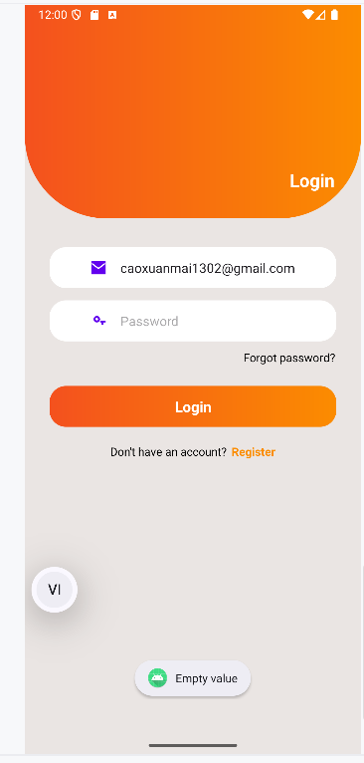

Trường hợp 2 — Mật khẩu và nhập lại mật khẩu không trùng

Hệ thống hiển thị thông báo: “Mismatch”

→ Kết luận: kiểm tra khớp mật khẩu hoạt động đúng.

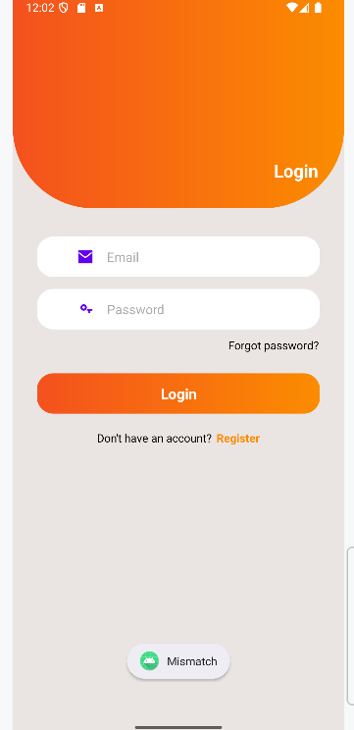

Trường hợp 3 — Email đã tồn tại

Hệ thống hiển thị: “Exist”

→ Kết luận: kiểm tra email trùng hoạt động đúng.

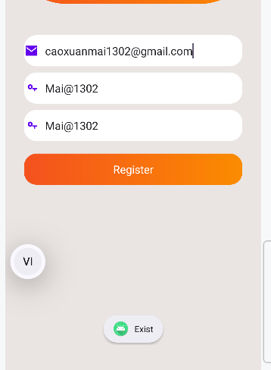

Trường hợp 4 — Đăng ký hợp lệ

Hệ thống hiển thị: “Register OK”

Ứng dụng tự động quay lại màn hình đăng nhập

→ Đây là kết quả đúng yêu cầu.

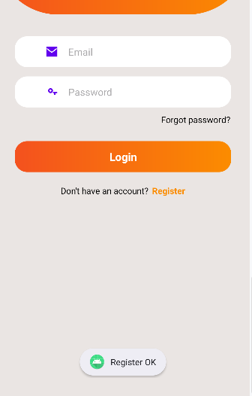

Xác nhận rằng dữ liệu đã được lưu

Dữ liệu được thêm vào SharedPreferences với:

Key = email người dùng

Value = password

Trường hợp 5 — Email chưa từng đăng ký

Hệ thống hiển thị: “Email not exist”

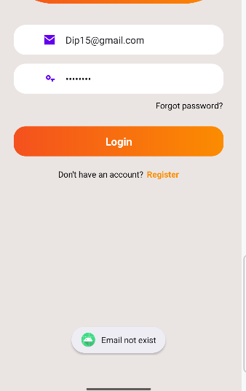

Trường hợp 6 — Đăng nhập thành công

Hệ thống hiển thị: “Login OK”

→ Đây là kết quả chính xác theo yêu cầu của Lab.

